UFO Talking Alarm Clock ES5020 & ES5021

Product Instructions

General description
UFO shaped alarm clock with digital LCD display on the base and time shown in 12/24 hour clock format. Press the round head of the clock and the clock will announce the current time. The time and clock can be set on the bottom. Comes with alarm and snooze functions. Available in the following colours: blue or silver.

Functions
- LCD display time
- Press the round head of the clock, the clock will announce the current time
- Alarm and snooze functions: The snooze interval is 10 minutes and the alarming frequency is mostly 6 times.
- Time display can be switched to 12-hour system or 24-hour system.
- Press "[MIN/ALM]" button when the clock runs normally, you can select one of the varied alarm rings as the alarm prompt. For example:
(1) "Di-Di-Di" (2) cuckoo + time-announcing voice (3) Three pieces of music
- There are two kinds of hour-announcing functions for option:
- "Hour Striking 1": in the 24 hours of a day, the clock will automatically strike the hour.
- "Hour Striking 2": the clock will automatically strike the hour from 7:00 a.m. to 9:00 p.m., but won't in the remained period.

Button Allocation

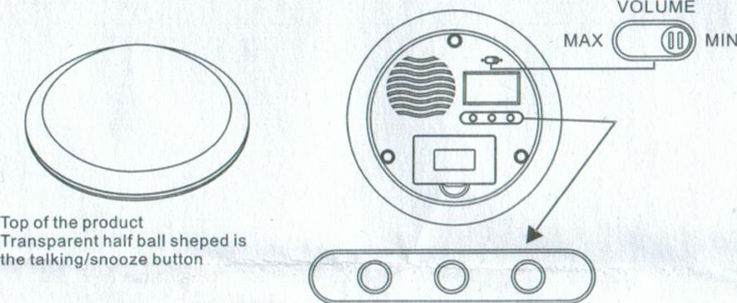

Description of Button Functions
[MODE] button: In the normal display status, press "MODE" button and this clock will enter the corresponding modes in the following order: (Normal Time Display-Time Setting Mode*Alarm Setting Mode*Alarm, Hour Striking 1 and 2. ON/OFF Setting Mode--0.1)

[HR 12124] button:
- In the status of normal time display, press "[HR 12/24]" button for switch between 12-hour system and 24-hour system.
- In the mode of time or alarm setting, press "[HR 12124]" button and you can adjust the number of hours upward; press and hold this button two seconds and you can quickly adjust the number of hours upward.
- In the ON/OFF setting mode of "Alarm, Hour Striking 1 and 2" , press "[HR 12/24]" button to start or stop "Hour Striking 1" and "Hour Striking 2" alternatively.

[MIN/ALM] button:
- In the status of normal time display, press "[MIN/ALM]" button to select one of the following rings as the alarm sound:
I "Di-Di-Di", c2 cuckoo + time-announcing voice three pieces of music.
- In the mode of time or alarm setting, press "[MIN/ALM]" button and you can adjust the number of minutes upward; press and hold this button two seconds and you can quickly adjust the number of minutes upward.
- In the ON/OFF setting mode of "Alarm, Hour Striking 1 and 2", press "[MIN/ALM]" button to start or stop the alarm function.

[TALKING] button:
- In the status of normal time display, mode of time setting and the ON/OFF setting mode of "Alarm, Hour Striking 1 and 2" , press "[TALKING]" button to announce the current time promptly.
- In the mode of alarm setting, press "[TALKING]" button to announce the alarm time on the screen promptly.
- When the alarm rings, press "[TALKING]" button so that the clock can pause and enter the snooze status. At this time the alarm icon will flicker.
[VOLUME] Move the switch to "[MAX]" for the maximal voice, and move the switch to "[MIN]" for the minimal voice.

Operating Instructions

1. Initial Operation
(1) The clock will automatically start as soon as you complete installation of batteries by opening the battery cover. Afterwards it will display in full screen for 3 seconds first and then enter the "status of normal time display" and play a piece of starting music;
(2) The initial value on the display screen is: 00:00 a.m. (12-hour system).
(3) The clock doesn't show Hour Striking 1 and 2 as well as the clock icon because it is in off position.
(4) The alarm default is: "Di- Di- Di".

2. Time Setting
(1) In the status of normal time display, press "[MODE J" button once and the clock can enter the time setting mode. The indicators of hour and minute will flicker at the same time.
(2) Press "[HR 12/241" button to adjust the number of hours upward; press and hold "[HR 12/24]" button for two seconds quickly to adjust the number of hours upward.
(3) Press "[MIN/AL]" button to adjust the number of minutes upward; press and hold "[MIN/ALM]" button for two seconds quickly to adjust the number of minutes upward.
(4) On adjusting the number of minutes, adjustment of each numerical value will make the number of seconds return to zero.
(5) On adjusting each numerical value, if no buttons are pressed within 10 seconds, this machine will automatically save the changed numerical value and jump out of this mode to return to the state of normal time display.

3. Alarm Setting
(1) In the status of normal time display, press "[MODE]" button twice or in the mode of time setting, press "[MODE]" button once and the clock will enter the mode of alarm setting. Between the hour indicator and minute indicator on the screen, a mark like a small bell will appear. The indictors separately for hour and minute will flicker at the same time.
(2) Press "[HR 12/24]" button to adjust the number of hours upward; press and hold "[HR 12/24]" button for two seconds quickly to adjust the number of minutes upward.
(3) Press "[MIN/ALM button to adjust the number of minutes upward; press and hold "MIN/ALM"
button for two seconds quickly to adjust the number of minutes upward.
(4) On adjusting the number of minutes, adjustment of each numerical value will make the number of seconds return to zero.
(5) On adjusting each numerical value, where no buttons are pressed within 10 seconds, this machine will automatically save the changed numerical value and jump out of this mode to return to the state of normal time display.

4. The ON/OFF Setting Mode of "Alarm, Hour Striking 1 and 2"
(1) In the status of normal time display, press "[ MODE ]" button for three times or in the mode of alarm setting, press "[ MODE ]" button once and the clock will enter the ON/OFF setting mode of "Alarm, Hour Striking 1 and 2" . The indictors separately for Alarm, Hour Striking 1 and 2 will flicker at the same time.
(2) Press "[ HR 12/24 ]" button to select Hour Striking 1 or 2 or close the hour-striking function, of which the order goes as follows: Hour Striking 1 starts ' Hour Striking 2 starts and meanwhile Hour Striking 1 ends ) Hour Striking ends –0.1
THE Hour Striking starting, its icon will appear; the Hour Striking ending, its icon will not come out. When the Hour Striking 1 starts according to 24-hour system, the clock will automatically alarm on the hour; when the Hour Striking 2 starts and functions from 7:00 a.m. to 9:00 p.m., it will not give the time in the other time; when the icon of the Hour Striking disappears from the screen, all Hour Striking functions will stop.
(3) Press "[MIN/ALM]" button repeatedly and you can start or stop alarm function. When the alarm starts, its icon will come out; when it doesn't start, its icon will not appear.
(4) On adjusting each numerical value, if no buttons are pressed within 10 seconds, this machine will automatically save the changed numerical value and jump out of this mode to return to the state of normal time display.

5. Alarm and Snooze
(1) When it's the setting alarm time, the alarm will ring for one minute, during which you can stop alarm ringing by pressing "[TALKING]" button. The alarm will pause and enter the snooze alarm status after announcing the current time. Meanwhile the alarm icon will flicker.
(2) Once the alarm rings, press "[TALKING]" button and the alarm will stop ringing and its icon flicker. The alarm will ring again after ten minutes; if continue pressing "[TALKING]" button, the alarm will ring again every ten minutes. Such an action can repeat at most for six times. Press "[TALKING]" button once again and the snooze function will stop.
(3) When the alarm rings each time, it will stop after one minute if you don't press any buttons; it can stop the snooze function at once if you press any buttons except for "[TALKING]" button.

6. 12/24 Hour System Conversion
In the state of normal time display, press "[HR 12/24]" button to realize the switch between the 12-hour system and the 24-hour system.

7. Volume control
Move the switch to "[MAX]" for the maximal voice, and move the switch to "[MIN]" for the minimal voice.

8. Alarm Sound Selection
In the state of normal time display, press "[MIN/ALM J" button to select one of the following alarm rings:
- "Di-Di-Di": the volume of "Di- Di- Di" will go larger and larger and its frequency from slow to fast. Such aringeing can totally last for one minute.
- cuckoo + time-announcing voice
- Three pieces of music

Application and Precautions of Battery
1. Please purchase the choice alkali dry batteries according to the model shown in the battery compartment. Attention must be paid to the polarity of battery when the battery is fixed in the compartment.
2. When the content on LCD screen goes lighter as well as the sound and speed of announcing language and music abnormal, such a case means the battery will fail immediately. Please change the battery. Remember: please don't use the old and new batteries together or those of different brands or models together.
3. When the machine stands idle for a long time, please take out the batteries in case of damages from leakage of battery.
4. If the machine doesn't function, pleas re-install the battery.

