Envoy Connect

User Guide

November 2022

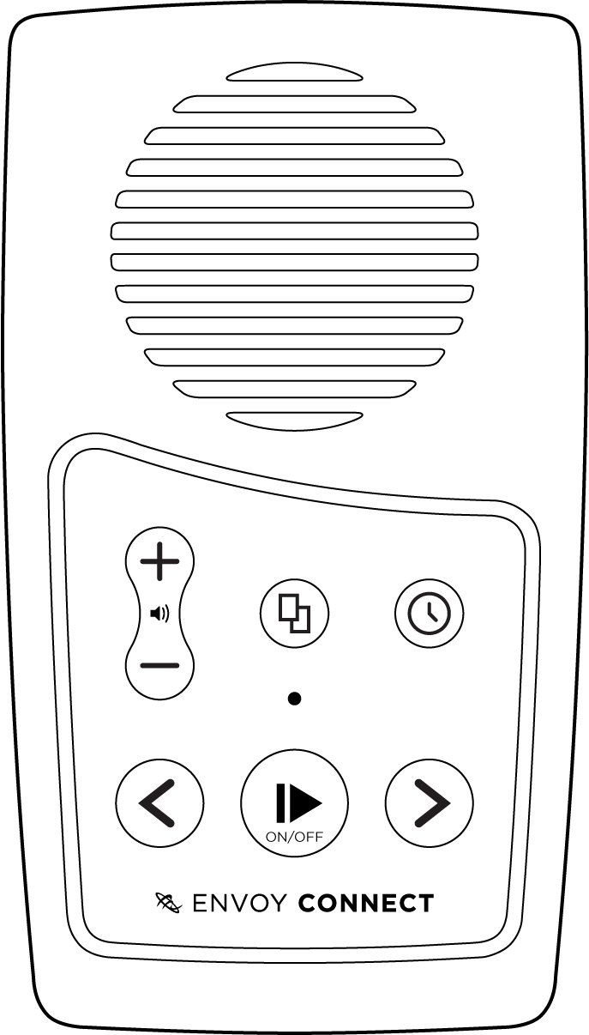

Envoy Connect Player

NOTE: This User Guide applies to Player Version T19. Refer to the ‘Player Version and Serial Number’ section within this Guide to check the version of your player.

Envoy Connect

Quick Start Guide

Back
Bookshelf
Sleep Timer
Speaker
Micro USB
Forward
LED
Volume
Power
& Play
Micro SD
Headphones

Player Description:
On the front face of the Envoy Connect Player is the speaker. Below that is the keypad with raised buttons. The keypad has two rows of buttons. Upper left is the volume up and down buttons. Upper middle is the Bookshelf button. Upper right is the Sleep Timer button. At the lower left of the keypad is the Back button. Lower middle is the large round Power and Play button. Lower right is the Forward button.
Underneath the Player is the headphone socket on the left. The micro USB port is in the middle, and the micro SD card slot is on the bottom right. On the back of the Player is a solar panel and a printed label that contains the serial number.

Definitions:
- Press: means to briefly, but firmly, press the button down and then release it immediately.

- Press and Hold: means to firmly press the button down and then continue to hold it for a period (e.g. press and hold the button for 3 seconds).

Button Descriptions:

Power and Play Button (Lower Middle):
- Power On: Press and hold for 3 seconds. Release the button when you hear the chime and the LED turns on. Note that the Player will announce the current book title each time it is turned on.

- Play/Pause: Press the same button to start playback. Press again to pause playback.

- Power Off: The Player will turn itself off after 2 minutes when playback is paused. When the Player is paused you can also press and hold for 5 seconds to turn it off manually. Note that the Player will remember your last reading position.
Bookshelf Button (Upper Middle): Press to hear the title of a book. Press again to choose a different book. Press Play to begin listening to the chosen book. Note that the Bookshelf button will only operate when playback is paused.

Volume Up/Down Buttons (Upper Left): Press the upper Volume button to increase volume. Press the lower Volume button to decrease volume.

Back Button (Lower Left):
When playing a book:
- Back: Press to skip to previous heading/section.

- Rewind: Press and hold to move backwards through the audio file in 30-second intervals. A beep will sound to indicate that you are moving backwards.

Forward Button (Lower Right):
When playing a book:
- Forward: Press to skip to next heading/section.

- Fast Forward: Press and hold to move forward through the audio file in 30-second intervals. A beep will sound to indicate that you are moving forward.
Note: The Back and Forward buttons will not operate when playback is paused.

Sleep Timer Button (Upper Right):
When playback is paused:
Press once to select 15-minute sleep timer. Press again to select 30 minutes. Press a third time to select 60 minutes. Press a fourth time to turn Sleep Timer off. A chime will sound to provide confirmation of each selection.
Note: The Sleep Timer button will not operate during playback.

Other Features:
- Speaker (Front): Note that the internal speaker has a small magnet inside. Avoid placing the Player close to objects that could be affected by magnetism.
- Stereo Headphone Jack (Bottom Edge, Left): Plug headphones or external speaker into the bottom left 3.5mm audio jack. This will mute the speaker.

Micro USB Port (Bottom Edge, Middle)

Micro SD Card Slot (Bottom Edge, Right)

Charging:
When shipped, the battery may only be partially charged. Please fully charge the Player before the first use. To charge the player, use the supplied USB cable to plug the Player into a computer or a USB Wall Charger (not supplied) for up to 4 hours.
A chime will sound when you connect the Player to the charger and the LED will blink while charging. The LED will stop blinking when the player is fully charged.
Note: We recommend to charge the player via USB. However, to supplement charging you can expose the solar panel on the back of the Player to direct sunlight. This will trickle charge the player over a longer period.
The battery will provide up to 10 hours playback time.

Suitable USB Wall Chargers:
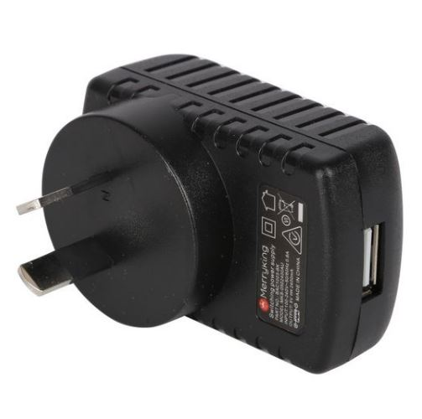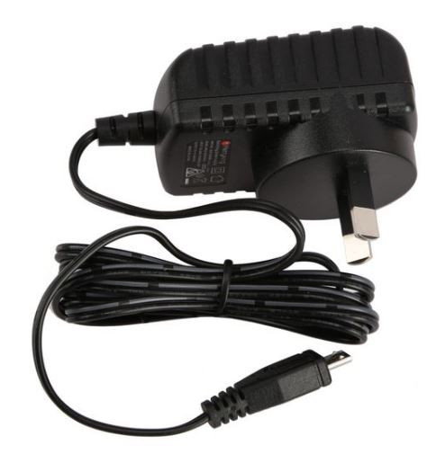
USB Plug
USB Slot

Image 1: Charger with USB slot (use a separate USB cable).
Image 2: Charger with inbuilt cable with micro USB plug.

Book Loading:
Each player is shipped with a Windows software utility called ‘i-access Kiosk’.
This utility can be found on the Player within a folder called ‘System’. If you or someone you know has a computer, you can use the Kiosk software to download books from the Vision Australia Library onto the player.
For more information on how to use this software, see the Additional Features section of this User Guide.

Envoy Connect

User Guide - Additional Features

The following features are additional to those listed in the Quick Start Guide.
- Volume Up: Press and hold to increase volume rapidly. A double beep will sound when maximum volume is reached.
- Volume Down: Press and hold to decrease volume rapidly. A double beep will sound when minimum volume is reached. Note that it is not possible to turn the volume off completely.
- Volume Memory: The Player will remember your volume setting, even if the Player is turned off.
- Bookmark: The Player will automatically remember where playback stopped, even if the Player is turned off. It will resume playback from that position when pressing the Play button.
- Skip to Beginning: If you press the Back button when playing the first section of a book, it will skip back to the beginning of the book and resume playback.
- Skip to End: If you press the Forward button when playing the last section of a book, a chime will sound to let you know there is no ‘next section’ and playback will resume.
- To Delete a Book: Press and hold the Bookshelf and Volume Up buttons together for 5 seconds. You will hear a single beep each second, followed by a final series of beeps in quick succession to confirm the deletion.
Note: If you release the buttons before the final confirmation beeps, the book will not be deleted.
- Turn Off Sleep Timer: Press and hold the Sleep Timer button for 2 seconds until you hear the confirmation chime.
- Auto Power Off: If playback is paused for more than 2 minutes, the Player will turn itself off. This saves battery life and avoids the need to turn off the player manually. Note that the Player will remember your last reading position.
- Battery Status Indicator: When the Player is in Pause mode, you can press and hold the Back button to hear beeps that indicate battery level. If the Player emits one beep, the battery level is low and should be recharged. If the Player emits two beeps, the battery is at medium level and you can continue to use it. If the player emits three beeps, the battery is fully charged (over 75%).
- Low Battery Warning: The Player will emit a ‘Low Battery’ warning chime when battery capacity is critically low. It is important to charge the player at this point. The Player will continue to chime every minute until it turns itself off. The Player will remember your last reading position.
- Audio Indicator: The Player will emit various beeps or chimes to provide audible confirmation of a button press, player action or warning. For example:
- Power on and off (except for Sleep Timer off)
- Battery level, including low battery warning
- Volume minimum and maximum
- Rewinding or Fast-forwarding
- Last section in book
- Book deletion
- No books on the Player
- Sleep Timer settings
- Unable to play book
- Connecting or disconnecting from a wall charger
- Connecting or disconnecting from a computer
- Micro SD card insertion or removal

- LED Indicator: The green light above the Play button provides visual information about the Player’s current operational state. For example:
- Green light means the Power is on
- Blinks quickly when playback is paused
- Blinks slowly when charging via USB cable
- The light will flash continuously if the Battery level is low
- Blinking during playback means the Sleep Timer is on. It will also blink while rewinding or fast-forwarding

- Micro SD Card: You can add to the 8GB internal memory capacity by inserting a micro SD card (up to 128GB, FAT32 file format) into the slot on the bottom right. Ensure the micro SD card is inserted correctly. The card is inserted correctly when it is turned over so that the ridge on the top face of the card is facing down. The long straight edge of the card will be facing to the right, and the ‘jagged’ edge facing to the left. Do not use excessive force; it will insert easily when it is the right way around. Be careful when ejecting the card as it may ‘spring out’ quickly and be lost.
- Switch Memory: The Player will sequentially scroll through the content of the internal memory followed by the micro SD card with each press of the Bookshelf button. When playback is paused, you can switch between internal memory and SD card. To do this, press and hold the Sleep Timer and Forward buttons together for 2 seconds.
- USB Computer Connection: Connect to a computer by inserting the supplied micro USB plug into the middle port on the bottom edge of the Player. Use this connection for loading books and charging the Player.
Note, to load books the Player must be turned off before it is connected to your computer. You can plug it in while the player is on, but the player will not be detected by the computer and will charge only. You cannot load and play books at the same time.
Ensure the micro USB plug is inserted correctly with the two small ‘prongs’ on the plug facing down. Do not use excessive force; it will insert easily the right way around. The Player will appear as an external drive on your computer. If the Player has a micro SD card inserted, this will also appear as a second external drive.
Note, before unplugging the Player from your computer, ‘eject’ it using the Windows ‘Eject USB’ feature. Unplugging it before ejecting it from within Windows could cause the player to crash.
- Manually Loading Books: Audio content can be copied onto the Player from a computer using the micro USB port. When preparing content for the Player on a computer, place all the audio files for a book into a single folder. You must have one separate folder for each book. You may have up to 999 different folders (books) and 999 audio files in each folder. The audio files are played in the order that they are loaded onto the Player; it does not re-order or play them according to the file names. For this reason, when preparing books on your computer, ensure the audio files within each folder are pre-sorted by name. For example, the first file within a folder could be named 001.mp3, the second file would be 002.mp3 and so on. Finally, load your pre-prepared book folders onto the Player in the order that you want them listed on the Players bookshelf.
Note that the player has these requirements:
- Maximum Folder Name length is 58 characters
- Maximum File Name length is 185 characters

- Book Loading Software: Each player is shipped with a Windows software utility called ‘i-access Kiosk’. If you or someone you know has a computer, this utility can simplify downloading of books from the Vision Australia Library and correctly load them onto the Player for you. This software is contained within the System folder when you view the Player in Windows Explorer. Select the ‘KioskSetup.exe’ or ‘i-access Kiosk.exe’ file to install it on your computer. When you install it, the software will provide further instructions. A detailed i-access Kiosk user guide can also be found in the Help menu of the software.
- Player Version and Serial Number: The Serial Number is printed on the back of the player. To hear the Serial Number, press and hold both the Back and Forward buttons together when playback is paused. The following information will be voiced:
- Serial Number (e.g. 111000123)
- Player Type Number (e.g. Envoy Connect 123456)
- Firmware Version (e.g. T19)

Troubleshooting:
- Player Will Not Turn On: Use the supplied USB cable to plug the Player into an active USB port or USB Wall Charger for up to 4 hours. The internal rechargeable battery is not user replaceable and the Player should be returned to the place of purchase if it still will not charge.
- Player ‘Crashes’ or ‘Freezes’: When unplugging the Player from your computer, ‘Eject’ it using the Windows ‘Eject USB’ feature.
- Player Reboot: If the Player is not responding to any buttons, restart the Player by Pressing and holding the Power/Play button for 10 seconds. The Player will turn itself off and restart.
- Hardware Reset: If rebooting the Player does not restart the Player, gently insert the end of a paperclip into the small pinhole on the back of the Player (at lower left of the label) to press the internal Hardware Reset button.
- Cannot Play Book: Ensure that there are no empty book folders. Check that all the audio files that make up a book are contained within one folder. Check that Folder Name lengths do not exceed 58 characters, and File Name lengths do not exceed 185 characters. Ensure the audio files are supported and that no copy protection (DRM) is applied. The Player supports the following formats: wav, mp3, wma, ogg, flac, ape and aac-lc. Unplug the player from the computer - you cannot load and play books at the same time.
- Cannot Remember Last Reading Position: Ensure that Folder Name lengths do not exceed 58 characters and File Name lengths do not exceed 185 characters.
- The Book Plays Out of Order: Check that the audio files in each folder are sorted by name, and have been loaded in the order they are to be played.
- Warning Chime: If the Player encounters a problem, it will emit a warning chime. Try playing a different book. Check the format of the audio files.
- Player Won’t Connect to Computer: Use the supplied USB cable. If you are using an alternative USB cable, ensure that your cable is a ‘data-transfer’ USB cable and not a ‘charge-only’ USB cable. Also, ensure that the player is turned off when connecting. You can plug it in while the player is on, but the player will not be detected by the computer and will charge only.
- Cannot Insert USB Cable: Ensure you are using a micro USB type-B plug, as supplied with the Player. Ensure the micro USB plug is inserted correctly with the two small ‘prongs’ on the plug facing down. Do not use excessive force; it will insert easily the right way around.
- Cannot Insert Micro SD Card: Ensure the ridge on the top face of the card is facing down. The long straight edge of the card will be facing to the right, and the ‘jagged’ edge facing to the left. Do not use excessive force; it will insert easily the right way around.

If Problems Persist:
- This User Guide refers to Player Version T19 or newer. To update your Player to the latest version, please contact Vision Australia.
- If you have any questions or comments, please contact the Vision Australia Library on 1300 654 656 or email: library@visionaustralia.org .

End of document

