CLOVER 10

Handheld Video Magnifier

User Guide

Contents
Precaution 1
Quick Start 3
Overview 3
Compositions 5
Accessories 8
Battery Charging 9
Stand 11
Operation 13
Power Button 13
Beep Type 14
Camera Switch 14
Magnification 15
Color Mode 16
Brightness 19
Lighting 20
Focus Control 21
Image Freeze 22
Image Storage 23
Image Playback 24
Line & Mask 26
Find 28
Live Panning 29
Memory 30
HDMI Output 32
Auto Power Saving 33
Restore 33
Hardware Restore 34
Troubleshooting 35
The unit does not turn on 35
Black screen or White screen 35
The image does not change 6
Smudges or blemishes on the screen 36
Specifications 37

Precaution
Before using CLOVER 5 for the first time, you must charge its battery. Refer to Charging the battery section for more details.
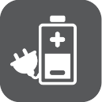

Al ways operate the unit in a place where the temperature is between 10°and 35°C(50°and 95°F).

Keep the unit away from wet areas, rain, and other sources of liquids. Do not submerge the unit.

Do not attempt to repair the unit. Any unauthorized attempt will void the product warranty. Contact your distributor to service.

Use the supplied power adapter.

Quick Start
Overview
Thank you for purchasing CLOVER 10.

Thank you for purchasing Clover 10.

Clover 10 is a portable 10-inch video magnifier with excellent Full HD image quality, which assures the real-time crisp image while moving or changing magnification continuously from 2.5X to 18X. The integrated dual camera system provides three viewing ways to fulfill the daily use. For example, Near View to read books or newspapers; Far View to see posters or blackboards; Mirror View to dress up.
Besides the common zooming and color mode function, there are also various practical functions such as Reading Line & Mask, Image Freeze and Storage, Find and Navigation.

Compositions
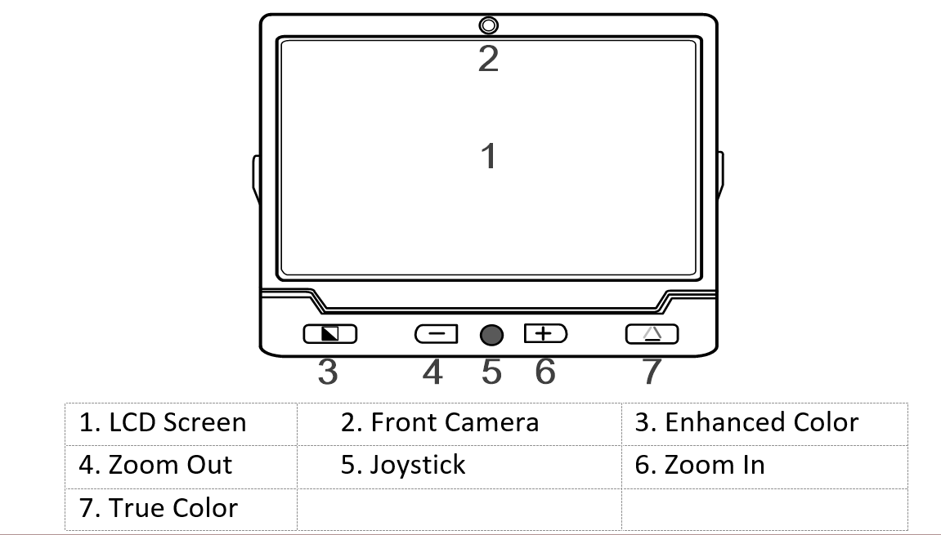

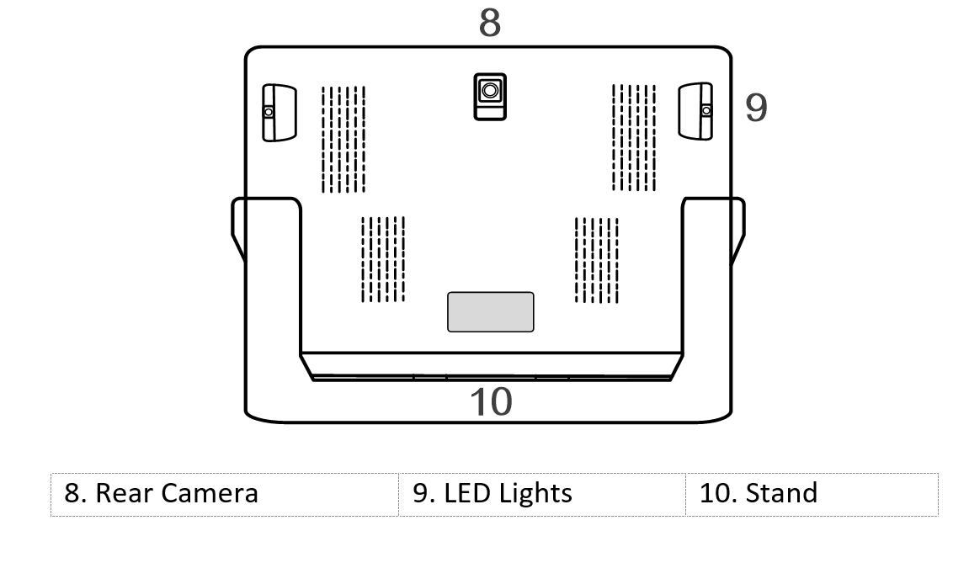
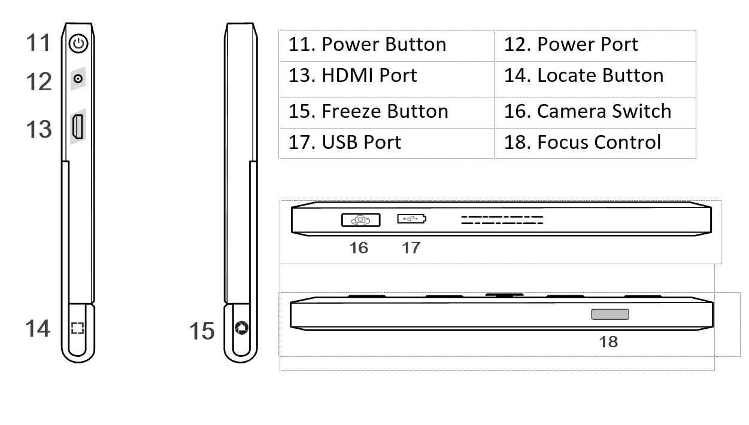

Accessories
- User Manual
- Power Adapter
- HDMI Cable
- Cleaning Cloth
- Carrying Case

Battery Charging
- Connect the supplied power cable to the power adapter.
- Connect the supplied power cable to the unit’s power port.
- Plug the power adapter into an AC outlet and start charging.

The status of Power LED indicator
- Charging when the unit is off, the power LED will be green, and then auto turn off when fully charged. A fully Charging will take about 5.5 hours, and will support the unit working for about 3 hours 15 minutes.
- Charging when the unit is on, the power LED will be green
- When the unit is on without charging, the power LED will be green when the battery level is high and will be red when the battery is dying. As long as the red light starts to flash, it is a signal to charge the battery.
- You can also check the battery status by pressing the power button; refer to the following instructions for more details

Stand
With integrated fold-away writing stand at an ergonomic viewing angle, clover 10 can satisfy users’ desire to read more and for a long time in a comfortable position. Also, there’s enough space under the camera to work the pen. Unfold the stand as the following figure shows.

The rear camera is designed to auto rotate according to the status of the stand, so that both the Near View and Far View are supported on this unit.

Power Button
- Press and hold the Power button for 3 seconds to turn on/off the unit.
- When the unit is on, press the power button to check the current status of battery capacity, freeze mode, focus, status, and beep
- Press other button when holding the power button will make combo function, refer to the following instructions for more details

Beep Type
- Unit on/off beep
- Button beep
- Threshold beep
- Low battery beep

Beep Control
- Press and hold the Power button and press the True Colour button to turn on/off the beep.

Camera Switch
- Turn the Camera Switch left to open the rear camera for Near View and Far View.
- Turn the Camera Switch right to open the front camera for Mirror View.

Magnification
- Press the Zoom in button to increase magnification, holding the Zoom In button for continuous increasing.
- Press the Zoom Out button to decrease magnification, and holding the Zoom Out button for continues decreasing
- Magnification range when standing on table:
- Back/Front Camera: 2.5x – 18x

Colour Mode
A color mode is a predefined color combination. Full-color mode is suitable for viewing pictures or maps.
Enhanced Color mode is combined with different foreground and background colors which can help to read more clearly.
- Press the Enhanced Colour button to go through the Enhanced-colour combination list.
- Press the True Colour button to return to the Full-colour mode.

- While in the Enhanced Colour Mode, long press the colour mode button for 3 seconds, a red heart icon appears with two beeps which indicates the current colour mode is added to your Favorite Enhanced Colour Combination List.

- Short press the color mode button to switch among “White on Black”, “Black on White”, “Favorite front color on Favorite back colour”, “Favorite back colour on Favorite front colour”.

- Long press the colour mode for 3 seconds, the full view icon appears with one beep which indicates that you have changed to the Integrated Enhanced Colour Combination List

The Integrated Color Combination List
- White on Black
- Black on White
- Yellow on Black
- Black on Yellow
- White on Blue
- Blue on White
- Yellow on Blue
- Blue on Yellow
- Green on Black
- Black on Green
- Violet on Black
- Black on Violet
- Blue on Black
- Black on Blue
- White on Green
- Green on White
- White on Red
- Red on Black

Brightness
Brightness of the screen can be adjusted in both Full-color mode and Enhanced-contrast mode.
- Press and hold the Power button and press the Zoom In button to increase the brightness. Factory default value will be highlighted green.
- Press and hold the Power button and press the Zoom Out button to decrease the brightness.

Lighting
There are four lighting statuses can be applied on the device.
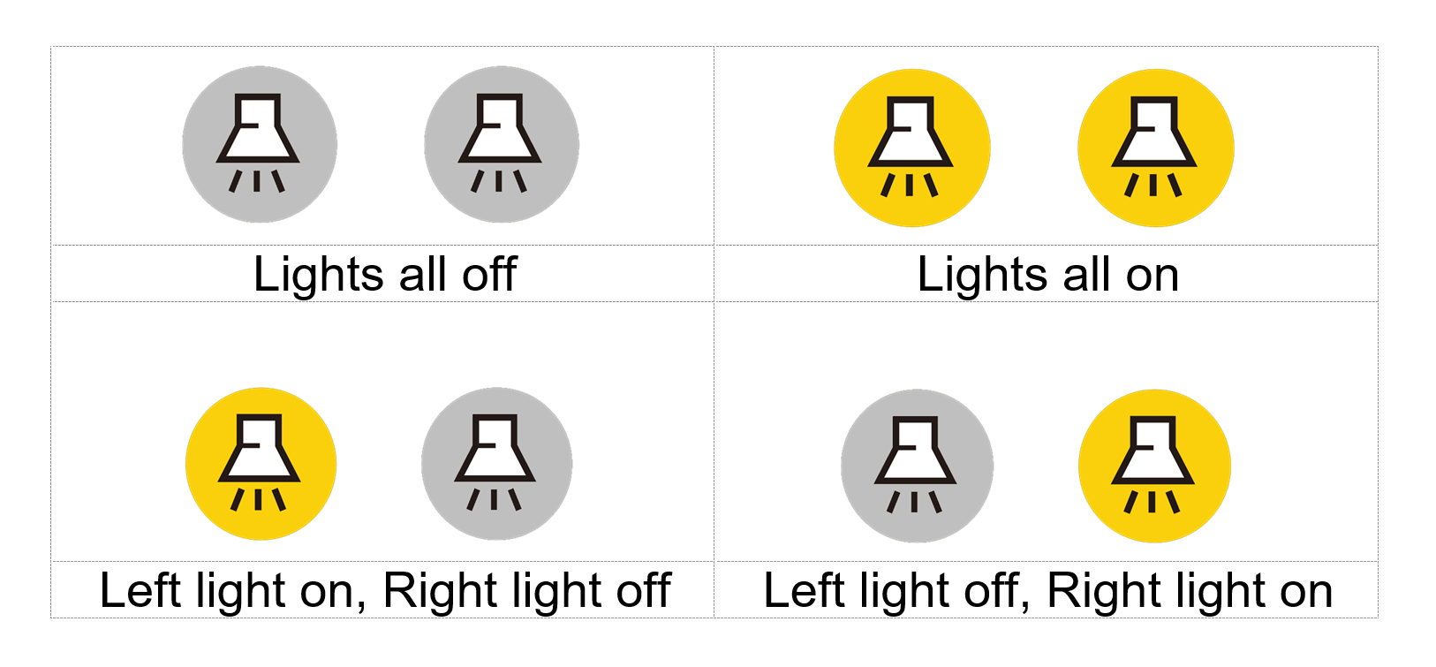
- Press and hold the Power button and the click the Freeze button to turn on/off the two LED lights simultaneously (The operation is compatible for all firmware version)
- Press and hold the Power button and press the Focus Control button to switch from three lighting statuses: Left light on, Right light on and All lights on/off (based on the latest setting).
Focus Control
- Click the Focus Control button to lock the focus, which is especially useful when handwriting.
- Click the button again to unlock the focus

Image Freeze
- Freezing an image on the LCD screen can be useful for further reading. At this status, magnification as well as color change is still allowed for a better experience.
- Press Freeze button to lock the active image.
- Press Freeze button again to unlock
- For the locked image with increased magnification, you can use the Joystick to navigate around freely.

Image Storage
- Long press the Freeze button for 3 seconds to store the current image. You can save up to 18 images.
- Note: When the saved images reach to the maximum value (18 images, Memory Full ICON appears), you will need to delete some pictures first in Playback mode before the next successful saving.
Image Playback
- To enter the Playback mode, long press the True Color button for 3 seconds.
- Slide the Joystick to select the target image from the Nine Grids Thumbnail Image Gallery. Press the True Color button to view the target image. You can view and navigate the image with the same operations described in the Image Freeze section. Press the Freeze button to return to the Nine Grids Thumbnail.
- When in Nine Grids Thumbnail, press the Locate button to select the target Image which needs to be deleted. Press the Locate button again to confirm, or any other buttons to cancel.
- When in Nine Grids Thumbnail, hold the Locate button for 5 seconds to delete all the images. Press the Locate button again to confirm, or any other buttons to cancel.
- Long press the True Color button for 3 seconds to exit the Playback mode.

Line & Mask
- Press the Locate button to switch among different Reading Line & Mask modes.
- One horizontal line - Slide the Joystick up/down to change the position of horizontal reading line. Slide the Joystick left/right to decrease/increase the width of the line.
- One vertical line - Slide the Joystick left/right to change the position of vertical reading line. Slide the Joystick up/down to increase/decrease the width of the line.
- Horizontal mask - Slide the Joystick up/down to change the position of the masks. Slide the Joystick left/right to narrow/enlarge the distance between the masks.
- Vertical mask - Slide the Joystick left/right to change the position of the masks. Slide the Joystick up/down to enlarge/narrow the distance between the masks.
- Normal, no line & mask
- Press the Power button will quickly exit the Line & Mask modes.
Please note that the Live-panning is unusable in this mode.
Find
- Long press the Locate button for 1 second and hold not to release it, a location box would appear.
- Move and change the content in the location box, aiming it at the part you want to view, and then release the Locate button , the image will return back to the previous magnification with the refreshed content.
- For example, you are viewing one part of a map with a certain magnification. Then you want to see another part without changing your favorable magnification. Then the function would be convenient and useful for you.
Live Panning
- In the state of amplification, users can slide the Joystick when in the real-time video mode to navigate the image for seeing more without moving the unit.
- Press the Zoom In and Zoom Out buttons at the same time to help you re-center the image (Red Dot appears).
- Two ways to quickly jump to the start/end point: 1) press and hold the Power button, and slide the Joystick. 2) Quickly push the Joystick in the same direction twice.
- For example, if you have finished reading a horizontal line and want to read from the beginning of the next line, please hold the Power button and slide the Joystick left or just quickly push the Joystick left twice. The start point or end point will be auto recorded and refreshed according to the maximum navigation range when reading.
- The navigation speed can be adjustable in three levels: slow, medium (the factory default) and fast. Push the Joystick to one side and press the Zoom in/out to increase/decrease the reading speed.

Memory
The unit will memorize automatically the most recent settings such as color mode, magnification, beep when power is off normally and apply them when the unit is on next time.

HDMI Output
Connect the unit to your external display device with HDMI cable for a better and larger viewing.

Auto power saving
If no operation and no moving for over 3 minutes, the unit will turn off automatically.
- Press and hold the Power button and click the Enhanced Color button to turn on/off the Auto Power Saving function manually (factory default is on).

Restore
Long press the Freeze button and the Locate button at the same time for 5 seconds to reset to the default factory settings. Auto power off when reset is done.

Hardware Reset
When the unit is hung or can’t be turned off normally, press the Power + Freeze button + True Color button at the same time to trigger the hardware reset.

Troubleshooting

The unit does not turn on
- Connect to the power adapter
- Charge the battery
- Hardware Reset

Black screen or White screen
- If the unit is sitting on a flat pure surface, the screen may be black or white, Lift the unit off to ensure change happens
- Adjust the magnification
- Adjust the color mode
- Restart the unit
- Hardware Reset

The image does not change
- If the unit enter the freeze mode or playback mode, the image will not change
- Press power button to check the current status
- Restart the unit
- Hardware Reset

Smudges or blemished on the screen
- Adjust brightness
- Clean the LCD screen and camera

Please contact your local distributor if problem is not solved

Specifications
- Display: 10 inch wide LCD, HD screen
- Camera Auto Focus, HD
- Size: <=245*200*22mm
- Weight: <710 grams
- Color Mode: True color, favorite user defined mode;
18 Integrated enhanced color modes
- Magnification：2.5x – 18x
- Battery: Integrated rechargeable Li battery;
3 hours and 15 minutes continuous use after 5.5-hour charge
- Power Adapter: Input: 110-240V; Output: 5V/3A

