CLOVER 6
Handheld Video Magnifier
User Guide

Rev B

Contents
Precaution 1
Quick Start 3
Overview 3
Compositions 5
Accessories 8
Stand 12
Handle 13
Operation 15
Power Button 15
Setting Menu 17
Magnification 19
Brightness 20
Color Mode 20
Lighting 22
Freeze 22
Image Storage 23
Playback 26
Multi-Selection 30
Line and Mask 32
Live Panning 35
Focus Control 36
Power Frequency 36
Memory 37
Auto power saving 38
Restore 38
Hardware Reset 39
Troubleshooting 40
The unit does not turn on 40
Black screen or White screen 40
The image does not change 41
Smudges or blemishes on the screen 42
Specifications 43

Precaution
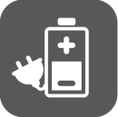
Before using CLOVER 6 for the first time, you must charge its battery. Refer to Battery and Charging section for more details.

Always operate the unit in a place where the temperature is between 10°and 35°C(50°and 95°F).

Keep the unit away from wet areas, rain, and other sources of liquids. Do not submerge the unit.

Do not attempt to repair the unit. Any unauthorized attempt will void the product warranty. Contact your distributor to service.
Use the supplied power adapter and battery.

Quick Start

Overview
Thank you for purchasing CLOVER 6.

CLOVER 6 is a handheld video magnifier, and all operations are supported by the high contrast tactile buttons. Equipped with the 1080P FHD touch screen, hand gesture provides easier and more natural way for certain features.

Dual 13M cameras and fast switch mechanism to fulfill the full-range distance viewing requirement. When stand on the table, amazing details reveal with 2-35 times lossless magnification.

The handle is flexible enough to be rotated to any angles and satisfy all holding requirements, which is also friendly for left hand user. Transform the handle into stand for comfortable desktop reading.

Compositions

1. LCD screen | 2. Freeze | 3. Zoom In
4. Zoom Out | 5. Enhanced Color
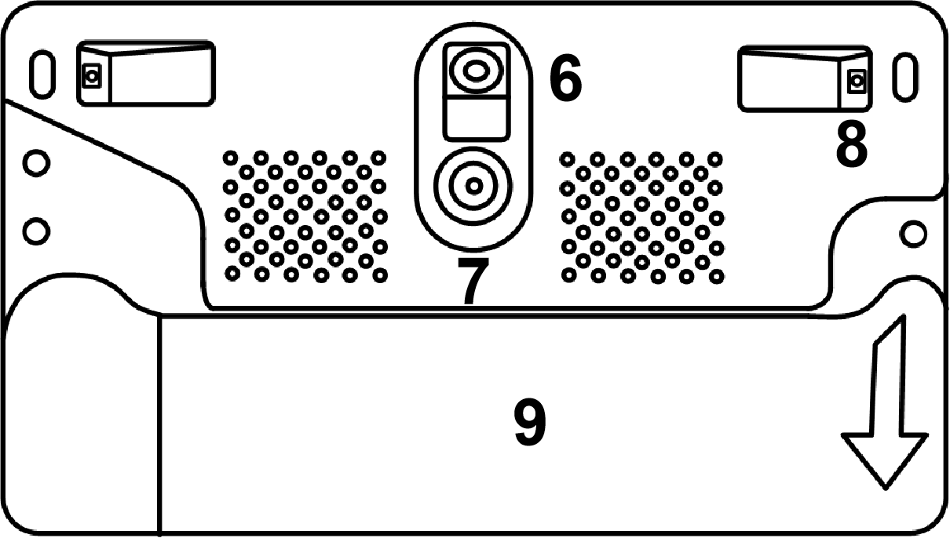

6. Near View Camera | 7. Distance View Camera
8. LED Lights | 9. Handle

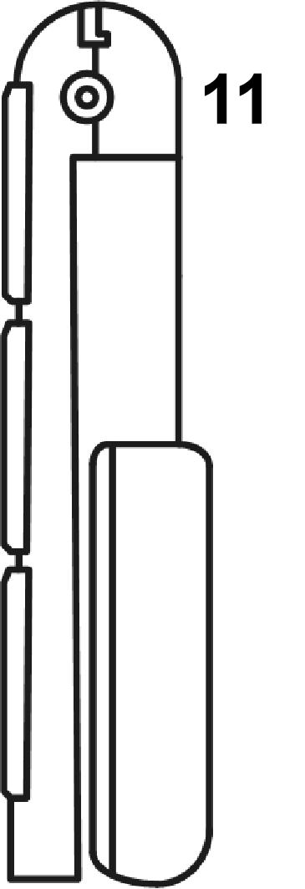

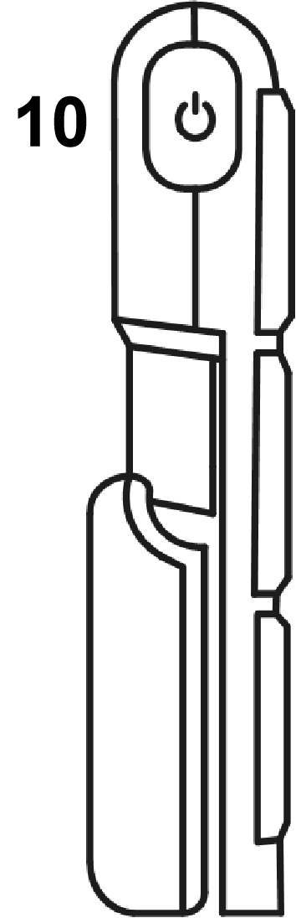

10. Power Button
11. Charging Port
12. Micro SD Card Slot
- USB Port
- HDMI Output

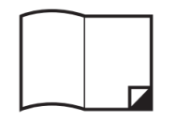
User Manual | Power Adapter | Cleaning Cloth
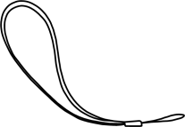
Strap | Pouch | HDMI Cable

Accessories

Charging the battery
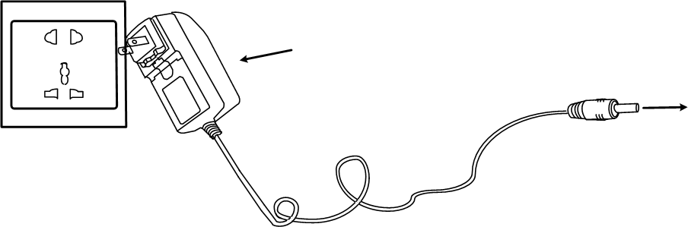
Connect the supplied power cable to the unit’s charging port, and connect the power adapter into an AC outlet to start charging.

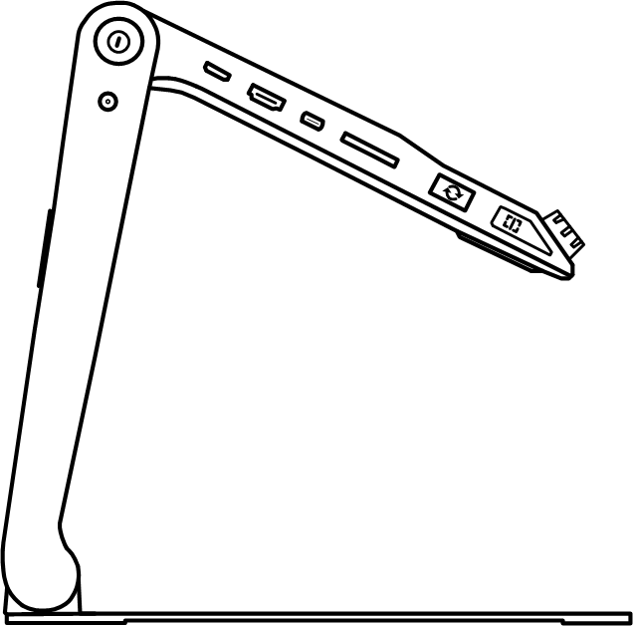

Power LED
- Charging when the unit is off, the power LED will be green, and then auto turn off when fully charged. A fully Charging will take about 2.5 hours, and will support the unit working continuously for about 3 hours
- Charging when the unit is on, the power LED will be green
- When the unit is on and the power adaptor is not connected, the power LED will be green when the battery is high and will be red when the battery is low. When the red light starts to flash, you will need to charge the battery
- When in the standby mode, the LED light will be yellow.
- You can also check the battery status by pressing the power button.

Stand
Unfold the stand as the following figure shows.
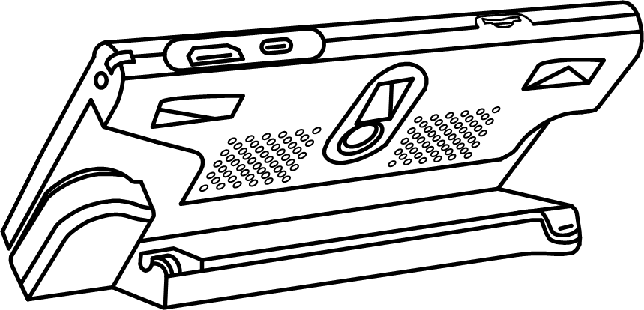

Handle
Rotate the handle as the picture shows and hold it at your most comfortable position.
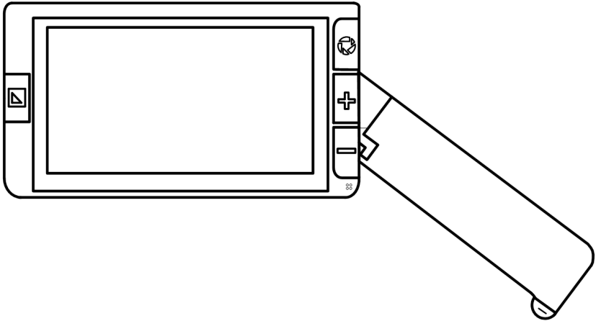

When the handle is open as picture shows, the device will switch automatically from distance camera to near view camera.
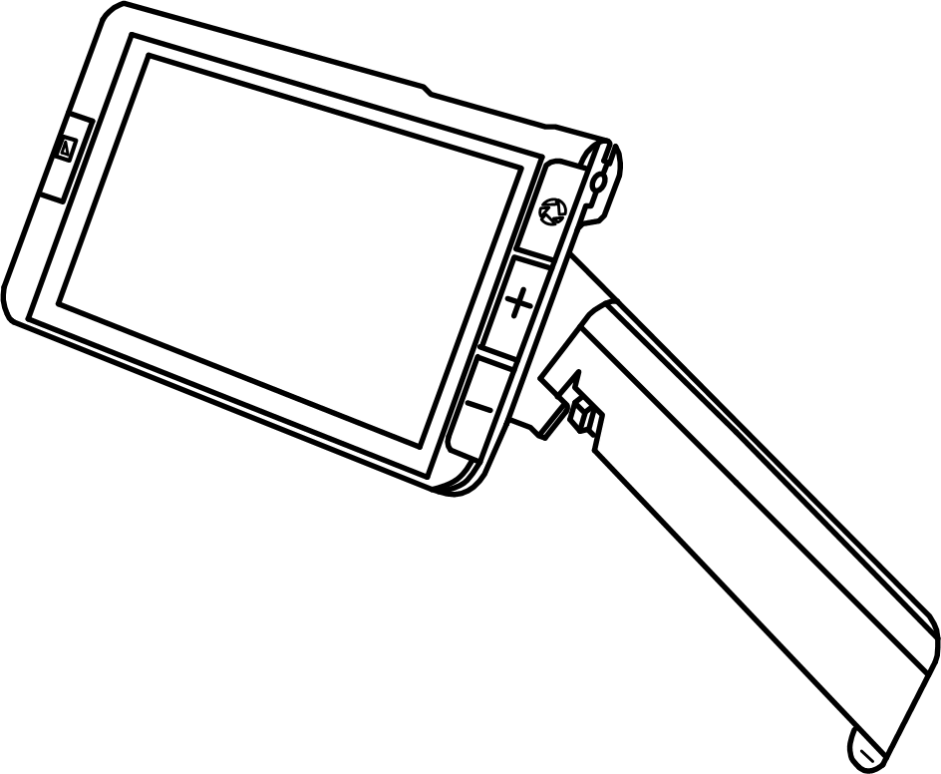

Operation

Power Button
- Press and hold the Power button for 2 seconds to turn on the unit when it is off.
- Press and hold the Power button for 2 seconds when it is on to get into choosing page: Standby Modeor Turn Off . Tap the Sleeping icon or no operation in 3 seconds to get into Standby Mode. When in Standby Mode, long press Power buttonfor 3 seconds to wake up the unit.
- When the unit is on, press the Power button to enter the Setting Menu.
- Press other buttons when holding the Power buttonwill make combo function, refer to the following instructions for more details

Setting Menu
- Slide the corresponding control bar to adjust volume/brightness.
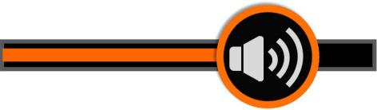
Volume Control Bar | Brightness Control Bar

- Use tap gesture on the specific icon to activate/inactivate the setting.
 |  | 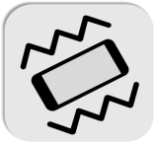
Auto Focus | LED Light | Vibration
Power saving | Line/Mask | Gallery
- No operations for 8 seconds or short press the Power buttonto exit.

Magnification
- Press the Zoom In button/ Zoom Out button to increase/decrease magnification, and hold the button for continuous increasing/decreasing.
- In addition to the Zoom button, use the pinch and zoom gesture on the touchscreen to adjust the zoom level.
- Magnification Range: 2x – 35x (near view)

Brightness
In addition to control bar, hold the Power buttonand press the Zoom In button/Zoom Out buttonto increase/decrease the screen brightness.

Color Mode
A color mode is a pre-defined color combination. Full color mode is suitable for picture, map viewing, and enhanced contrast mode is combined with different foreground and background colors and can help to read clearly.
- Press the Enhanced Color buttonto cycle through the color combination list
- Press and hold the Enhanced Color buttonfor 3 seconds to enter the Customized Color Page, use the tap gesture to activate/inactivate the enhanced color combination.
- No operations for 8 seconds or tap the Exit iconor long press the Enhanced Color button to exit the Customized Color Page.
- Press the Power button+ Enhanced Color buttonto quickly return to the full color mode.

Lighting
In addition to the setting menu, hold the Power buttonand press the Freeze buttonto turn on/off the LED lights.

Freeze
Freezing an image on the LCD screen can be useful for further reading, and also further zooming in or zooming out or changing the color mode for a better view. The brightness adjusting is not allowed when freezing.
- Press Freeze button to lock/unlock the image.
- For the locked image with increased magnification, you can use the gesture to navigate around freely.

Image Storage
- Long press the Freeze buttonfor 3 seconds to store the current image.
- The Voice Record icon will appear after the storage. Tap and hold the Mic icon to begin the recording and release the icon to finish (or press the Locate buttonto record).
- You can replay the recorded voice by pressing the Play Icon (or pressing the Freeze button )
- You can repeat recording the voice but only the latest record will be saved with the image.
- No operations for 5 seconds or tap other inactive area or press the Power buttonto close.
- For a better recording quality, please approach to the Mic as the picture shows and speak aloud.

Note: When the saved images reach to the maximum capacity (2 GB, Memory Full icon appears), you will need to delete some pictures first in Playback mode before the next successful saving.

Playback
- Press the Power buttonget into the Setting menu and tap the Gallery iconto enter the picture gallery. Page up/down the gallery by the slide bar on the right side of the screen.
- Tap the picture to choose (or press Zoom button) . The thumb picture with the voice label can play the recorded voice by tapping the Voice icon on the top-right side. Tap again (or press the Freeze button) to playback the picture.
- You can view and navigate the image with the same operations described in the Image Freeze. Press the Freeze buttonto return to the gallery.
- When in the gallery, select the target image which needs to be deleted, tap the trash iconand the same trash label will appear right on the image. Tap the trash iconagain to delete or Power button/any other places on the screen to cancel.
- When in the galley, tap the trash icon for 5 seconds to delete all the images. Tap the trash iconagain to confirm or Power button /any other places on the screen to cancel.
- Pictures can be transferred to the external SD card when it is inserted. Choose the specific picture first and then tap the Transfer icon 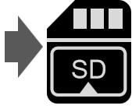 to start.
- Long tap the Transfer icon for 3 seconds, all the pictures will be chosen and transferred to the external SD card.

Multi-Selection
- When in the gallery, long tap on the specific picture(or long press the Freeze button) to activate/inactivate the Multi-selection.
- With Multi-selection enabled,a small box will appear at the lower right corner of each picture. Tap (or use Zoom button and Freeze button) to choose all the target pictures. Then multi-transfer or multi-deletion can be applied accordingly.
- Tap the corresponding the Trash icon/Transfer icon to to pop up the choose box. Tap the icon in the choose box to delete/transfer all the chosen pictures. Tap the Exit iconor press the Power button to back to the multi-selection.
- Long tap on the screen or tap the Exit icon again( press the Power button or long press the Freeze button)to exit the multi-selection mode.

Line and Mask
Press the Locate iconto activate the Line/Mask function. Tap the icon can switch among different Reading Line & Mask modes. The position and width/distance of the line/mask can be adjusted with the Locate iconavailable on the screen. The icon will disappear automatically in 8 seconds or press Power buttontwice.

- One horizontal line
- Use finger to slide up/down on the screen to change the position of horizontal reading line, and slide left/right to decrease/increase the width of the line.
- One vertical line
- Use finger to slide left/right to change the position of vertical reading line, and slide up/down to increase/decrease the width of the line.
- Horizontal mask
- Use finger to slide up/down to change the position of the masks, and slide left/right to narrow/enlarge the distance between the masks.
- Vertical mask
- Use finger to slide left/right to change the position of the masks, and slide up/down to enlarge/narrow the distance between the masks.
Note: The above function can only be achieved with the Locate iconappears. Without the icon, the live panning is usable.

Live Panning
In the higher zoom level, use slide gesture to navigate the image for seeing more without moving the paper.

- Quickly tap the image center twice to re-center the image.
- Quickly tap the image edge twice to jump to the start/end point.

Focus Control
The autofocus system works well in the most situations. In addition, some methods are provided to control the focus.
- Tap on the screen for 2 seconds to trigger the focus manually.

Power Frequency
Power Frequency provides the options of 50HZ and 60HZ power frequency according to customer region. Long press the Power button + Enhanced color button for 3 seconds can adjust the frequency.

Memory
The unit will memorize automatically the most recent settings such as color mode, magnification, beep when power off normally and use them in the next power on

Auto power saving
If no operation and no moving for over 5 minutes, the unit will get into standby mode automatically and will turn off in 10 minutes.

Restore
- Hold the Freeze buttonand the Enhanced Color buttonat the same time for 3 seconds to reset to the default factory settings. Auto power off when resetting is done.

Hardware Reset
When the unit is hung(can’t be turned off), press the Power+Freeze button+Zoom Out buttonat the same time to trigger the hardware reset.

Troubleshooting

The unit does not turn on
- Connect to the power adapter
- Charge the battery

Black screen or White screen
- If the unit is sitting on a flat pure surface, the screen may be black or white, Lift the unit off to ensure change happens.
- Adjust the magnification
- Adjust the color mode
- When the unit is connected to TV, the screen is black
- Restart the unit

The image does not change
- If the unit enter the freeze mode, the image will not change
- Press power button to check the current status
- Restart the unit

Smudges or blemishes on the screen
- Adjust brightness
- Clean the LCD screen and camera

Please contact your local distributor if problem is not solved

Specifications
- Display: | 5.5 inch IPS touch screen, anti-glare  Screen Resolution: 1920*1080
- Camera: | Dual 13M auto-focus Camera  Video Resolution: 1920*1080
- Magnification： | Approximately 2x ~ 35x
- Color Mode： | True color  Up to16 user-defined Enhanced Colors
- Brightness:  - Video Mode: | LCD brightness adjustable  Near-view, Distance-view
- Vibration: | Screen vibration feedback On/Off control
- Snapshot: | Image Storage and Playback  Storage capacity: approximately 2GB
- Locate: | Reading Line/Mask function
- Size: | <= 160*91*21mm (Device folded)
- Weight: | <265 grams (Battery included)
- Battery： | Nearly 3 hours continuous use  Charges in approximately 2.5 hours
- Power Adapter | Input: 110-240V; Output: 5V/3A

