EasyFlip 2

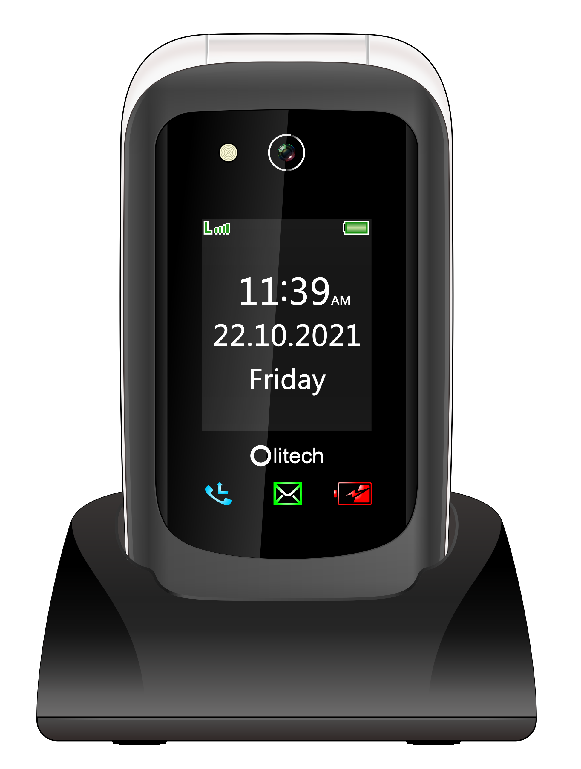

User Manual V1
Model number: OLT2908V2
Please note, the information detailed in this User Manual (V1) reflects information regarding the EasyFlip 2 (OLT2908V2) operating system software and hardware released in January 2022.

This product complies with the electrical safety and/or electromagnetic compatibility (EMC) legislative requirements for Australia and New Zealand.

Table of contents
Contents | Pg | Contents | Pg
Specifications | 4 | Share location | 53
Hardware guide | 5 | Low battery not. | 54
Screen icons | 9 | Auto answer | 55
Phone setup | 10 | Settings | 56
SIM insertion | 10 | Phone settings | 57
Charging | 16 | Time and date | 57
Power on/off | 19 | Language | 57
Calls | 19 | Restore factory set. | 58
Call logs | 21 | Call settings | 59
Phonebook | 22 | Caller ID | 62
Managing contacts | 23 | Display | 65
Message | 26 | Audio settings | 67
Viewing images | 31 | Audio modes | 67
Input method | 32 | Changing ringtone | 68
Photo/speed dial | 35 | Security | 69
Camera | 37 | Blacklist | 71
Organiser | 38 | Network | 72
Alarm | 39 | Voice guidance | 73
Calendar | 39 | Menu Visibility | 73
Calculator | 41 | Amplify rec. vol. | 74
Bluetooth | 41 | Vol. key status | 75
My files | 44 | Torch key status | 75
Connecting to PC | 44 | Loudspeaker | 75
Multimedia | 46 | Notification lights | 76
FM Radio | 47 | Troubleshooting | 76
Recorder | 48 | Safety Information | 82
Safety | 49 | Warranty & Cert. | 84
Emergency key | 50 | Limitation of liability | 85

Specifications
Design | 108 X 57 X 21 mm (closed)  120g incl. battery  2.8 in. main display 1.77 in. sub LCD  Single Nano SIM
Memory | 128MB+RAM 48MB  T-flash card slot (up to 64GB)  500 phonebook capacity  50 SMS capacity
Power | 1000 mAh battery; 5 day standby time; 3-4 hr talk time.  Note: location monitoring functions consume the battery at a higher rate
Camera | 2MP camera
Sound | 100dB ringtone, 95dB amplified earpiece speaker, HAC, M4/T4
Network | 3G: 2100 (B1), 850 (B5) and 900 (B8)  4G: 2100 (B1), 1800 (B3), 850 (B5), 2600 (B7), 900 (B8), 700 (B28: A&B).  Bluetooth V5.0

Hardware Guide
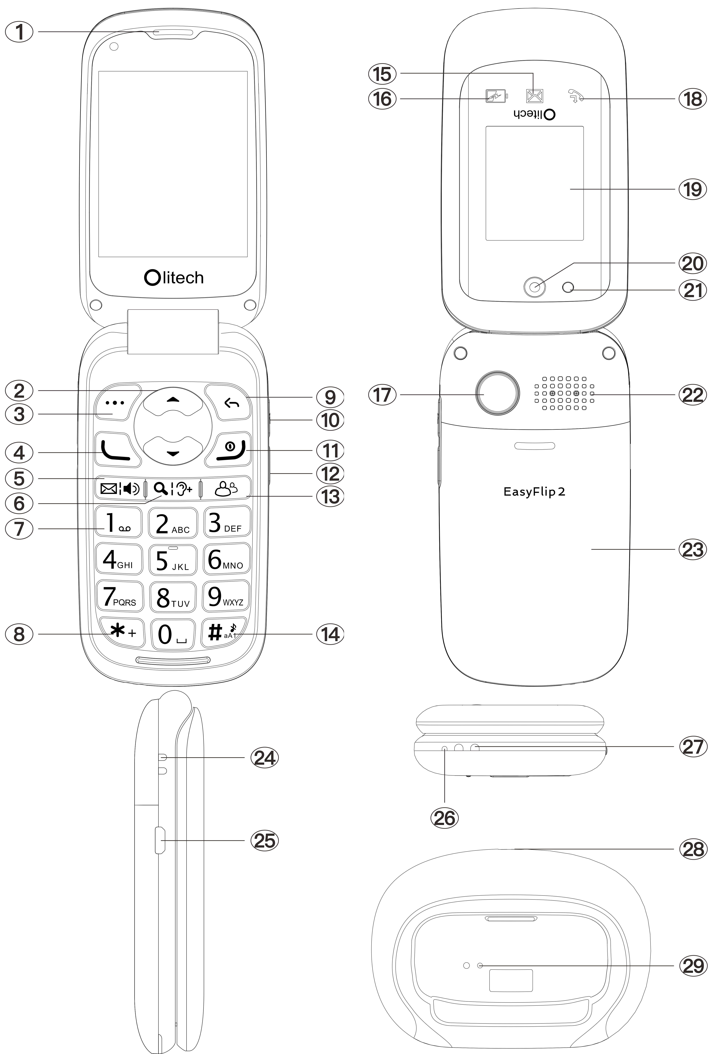

Hardware Description
 | 1. Earpiece speaker
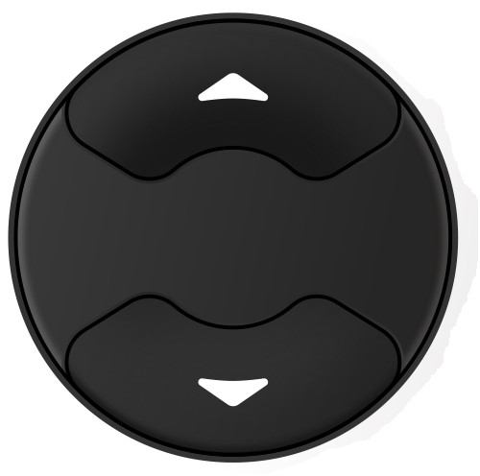 | 2. Navigation keys (up and down)
3. Selection key:
Used to select word written above key on screen e.g.: “Options”.
4. Green call key:
Used to answer or make a call.
5. Message/Loudspeaker key:
Not during active call: Provides direct access to messages (SMS/MMS).
During an active call: activates/
deactivates the loudspeaker.
Note: in some instances, you may be required to navigate left (e.g. move cursor left when typing a text/entering a number). Press the message/ loudspeaker key to do so.
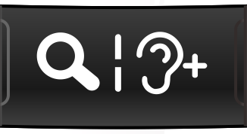 | 6. Magnifier/Amplify receiver volume key:  Not during a call: Press to open magnifier. Zoom is controlled by the up and down keys.  During an active call: Press to activate amplification mode for ear speaker. Amplify receiver volume must be on in the settings for this function to work.  Note: in some instances, three options/actions will appear along the bottom of the screen. To select the middle option, press this key.
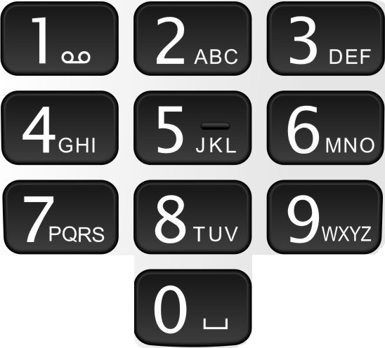 | 7. Number keys:  When pressed (single press), each number key types their designated number/letter as displayed on the key.  When “1” is pressed and held for 3 seconds it dials voicemail.  When 2-9 are pressed and held for 3 seconds they dial their allocated photo speed dial number (if programmed).
8. Star (*) key
When typing, a single press will show symbol options. When dialling a phone number, if * is pressed twice in quick succession (**), a + sign appears (used for international calls).
9. Back key
Used to go back to previous screen OR delete a letter/number when typing.
10. Volume up and Torch key:
Single press turns volume up one increment; press and hold for 3 seconds to turn flashlight on/off. Functions can be deactivated.
11. Power key/End call key:
Single press during an active call will end call;
When pressed and held for 5-6 seconds the phone will power off/on.
12. Volume down key
Single press turns volume down.
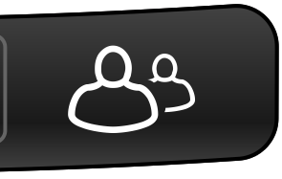 | 13. Photo dial key:  Provides direct access to photo dial contacts.  Note: in some instances, you may be required to navigate right (e.g. move cursor right when typing a text/entering a number). Press the photo dial key to do so.
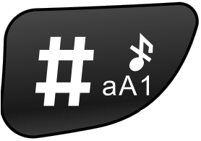 | 14. Hash (#) key:  When on the home screen, if the hash key is pressed and held for 3 seconds it activates/deactivates silent mode. When typing a text/phone number, a single press to the hash key will open the input method options (capital/lower case letter, numbers).
 | 15. Unread message indicator: Flashes green when unread message present. Can be deactivated.
16. Low battery indicator:
Flashes red when battery low or when connected to charger and still charging. Constantly illuminates red when connected to a charger and fully charged. Can be deactivated.
17. Emergency key:
Press and hold red emergency key (on back of phone) for 3 seconds to trigger emergency sequence.
Emergency key requires setup – see Emergency key section of manual for more details.
18. Missed call indicator:
Flashes blue when missed call present. Can be deactivated.
 | 19. Front LCD screen
 | 20. 2MP Camera
 | 21. Torch/Camera flash
 | 22. Primary speaker
 | 23. Removable back cover
 | 24. Lanyard eyelet
 | 25. USB cord port (phone)
 | 26. Microphone
 | 27. Conductors for charging via cradle (phone)
 | 28. USB port (cradle)
 | 29. Conductors for charging via cradle (cradle)

Screen icons
Symbol | Explanation
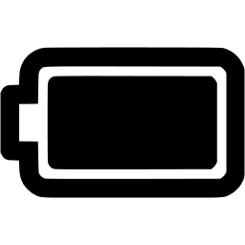 | Indicates charging status and battery level
 | Indicates the mobile phone reception/ service strength
 | Phone is using the 3G network
 | Phone is using the 4G network
 | Bluetooth is activated
 | Silent mode is activated
 | You have a missed call
 | You have an unread text message
 | You have an unread multimedia message
 | An alarm is set
 | Amplify receiver volume is on
 | Flight mode is on
 | Meeting profile is activated
 | Outdoor profile is activated

Phone setup

Instructional video available at www.olitech.com.au/easyflip2videos

Insert SIM card –
Step 1 - Remove the back phone cover Slide the back cover down to remove. It is recommended to hold the phone with two hands, thumbs on the back cover, apply light pressure through the pads of the thumbs and slide down.
Please note it may be difficult to initially remove the back cover. The below images reflect the removal of the back phone cover.

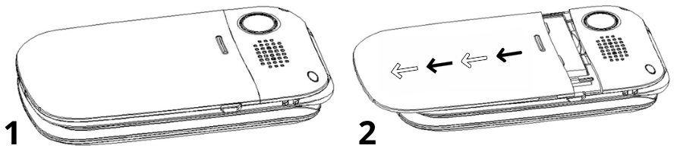

Step 2 – Remove the battery
Using the small cut-out slot above the battery, gently push the battery down and pull it towards you to remove. The SIM slot can now be seen in the top left corner of the exposed phone interior (memory card slot is located next to the SIM slot). The following images reflect the removal of the battery.

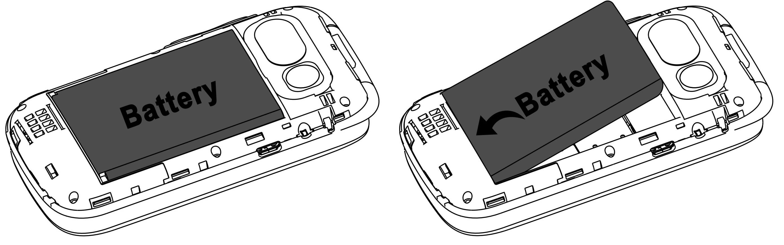

Step 3 - Insert the SIM card (Nano size 8.8 X 12.3 mm)
The silver bracket on the SIM slot does
not move. To insert the nano sized SIM card (8.8 X 12.3 mm), slide the SIM card under the silver bracket. The SIM card should be oriented with the gold chip facing down and the cut out on the top left corner. The SIM card should be slid from the bottom of the SIM | 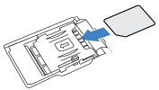
slot towards the top until it reaches the top of the SIM slot. We recommend using the pad of your thumb/finger to slide the SIM card into position.

To remove the SIM card, use the rounded end of the silver tool to slide the SIM downwards in the slot until the top of the SIM reaches the top of the silver bracket. You can then use the pad of your thumb/finger to apply gentle pressure and continue sliding the SIM downwards and out. Do not try to lift/lever the silver bracket.

Please obtain assistance from another individual, consult Olitech’s instructional videos, or call Olitech on 03 9755 8885 if required.

Please note:
Before fixing the phones back cover in place, please insert the memory card (optional) and battery.

Memory card (optional)
A SD card/T-Flash card (memory card) can be inserted into the phone to facilitate additional memory. The memory cards capacity should not exceed 64GB.

Inserting the Memory card:
When the back cover and battery are removed, the memory card slot can be seen to the right of the SIM slot. The memory card slot is a sliding hinge style slot (different style of slot to the SIM slot).

1. Gently slide silver clip up and you will feel a small click. This unlocks the clip from its fixed position.
2. Move silver clip to a vertical position (hinges from the top). If you cannot gently grasp the clip, you can turn the phone upside down to bring it to a vertical position.
3. Position the memory card on the open slot, gold chip facing down.
4. Return silver clip to horizontal position so it rests over the memory card and slide silver clip downwards. You will feel it click into a locked position.

Precautions when inserting SIM/ memory card:
1. Keep the SIM and memory card out of reach of children.
2. Do not touch the gold chip on the SIM or memory card.
3. Keep the SIM and memory card away from magnets.
4. Avoid putting the SIM or memory card under direct heat such as sunlight.
5. Please be gentle with the mechanisms that hold the SIM and memory card. They are delicate and can break if mishandled.

Insert the battery
Step 1 – If present, remove protective tape from conductors on bottom right corner of battery.
Step 2 - Insert the battery so the conductors on the battery line up with the conductors on the phone’s battery port. Once inserted, the battery will sit over the SIM card and memory card (if inserted).
Step 3 - Secure the back cover in place Position the back cover over the battery and slide up until it clicks into place.

Secure lanyard (optional)
The lanyard eyelet is located on the left side of the phone. It can be identified by the two cut-outs in close proximity on the white phone casing. We recommend removing the material from the lanyard (via the black side squeeze buckle) prior to securing it to the phone to simplify the threading process.

Step 1: Thread the black lanyard cord
To thread the lanyard cord, insert the thin black lanyard cord into the top lanyard eyelet cut-out. Use the pointy end of the silver tool to push the black lanyard cord towards the bottom lanyard eyelet cut-out. Insert the pointy end of the silver tool into the bottom lanyard eyelet cut-out and use it to pull the lanyard cord out through the bottom cut-out. Continue pulling the looped end of the lanyard cord through the bottom cut-out until the black side squeeze buckle touches the phone.

Step 2: Secure black lanyard cord
Thread the black side squeeze buckle through the looped black cord and pull side squeeze buckle to tighten.

Step 3: Re-attach lanyard material
Re-connect components of the black side squeeze buckle to attach lanyard material.

Charging the battery
EasyFlip 2 charging components include:
- wall plug (connects to power point)
- micro USB charging/data cable
- charging cradle
Only use the Olitech battery and charging components with this phone. Before using the phone for the first time please charge the battery for at least 4 hours. During the charging process, do not remove the battery from the phone. The phone/charger may be warm during charging. This is normal.

If the battery capacity is exhausted and the phone powers off: 1) when connected to a charger, it may take several minutes for visual indicators relating to charging to appear on the phone; and 2) when the phone has sufficient charge, it must be manually powered back on by pressing and holding the power key for 5-6 seconds. The phone will not automatically power back on.

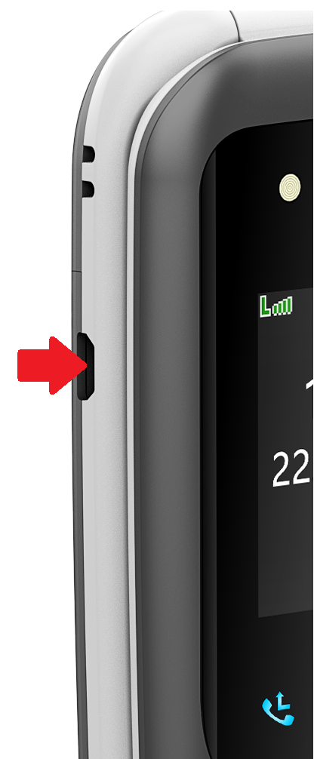
Battery charging options:
Charge with the wall plug
- Insert the larger end of the micro USB charging cable into the USB port on the wall plug.
- Insert the smaller end of the micro USB cable into the charging port on the left side of the phone. Note: the smaller end of the cable is trapezoid shaped and can only be inserted with the short side facing the front of the phone.
- Connect the wall plug to the power point and turn power point on.

Charge with the cradle charger
- Connect the cradle charger to the wall plug via the micro USB cable (smaller end of cable inserts into the cradle with short side facing up).
- Connect the wall charger to the power point and turn power point on.
- Place/sit the phone into the cradle charger (see image on front cover of manual).

Charging with other devices
The phone can be charged by connecting the micro USB charging cable to a computer/car charging port.

Please note: If the phone is connected to a computer via the USB charging cable, you can view/transfer files on the EasyFlip 2. See Connecting to PC on page 44 for additional information.

Important Information:
When connected to a charger, the red battery light on the front of the phone will illuminate. If the battery is charging the light will flash. If the battery is fully charged the light will constantly illuminate. The notification light status must be on for this light to be displayed. If the phone powers off due to insufficient charge, when connected to a charger it will not automatically turn on after it has received sufficient charge. It must be manually powered on.
Powering the phone on/off

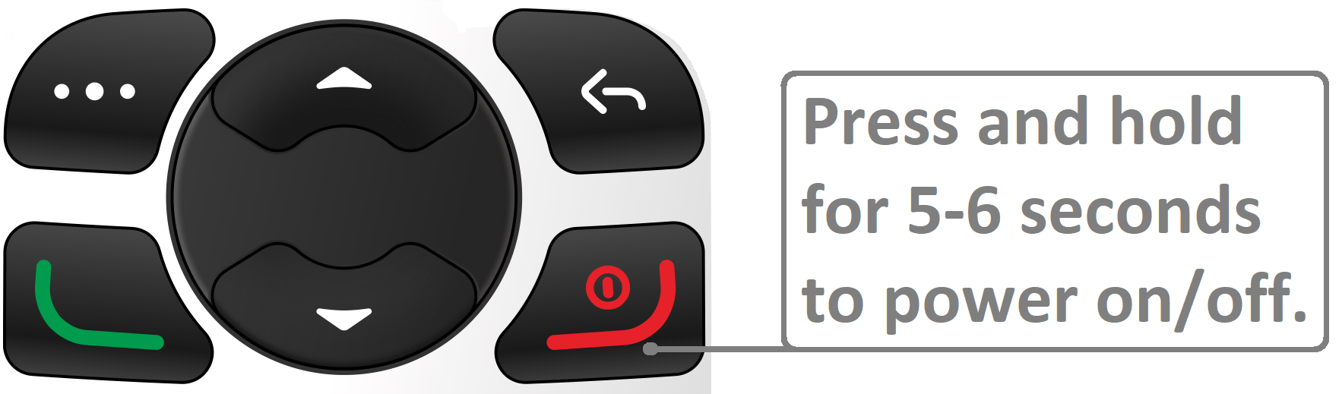

To power the EasyFlip 2 on/off, press and hold the red end call key for 5-6 seconds/until you feel a small vibration. The start-up process takes approximately 10-20 seconds.

Calls

Making a phone call

Standard dialling
- Dial phone number using keypad
- Press Green call key

Phonebook dialling
- Press the top right key to select Phonebook
- Highlight contact you want to call. This can be done by either:
  - Pressing the up navigation key (red cursor will appear in search box) and start typing contact name. Use navigation key to highlight contact; or
  - Use the navigation keys to scroll to and highlight the contact.
- Press the Green call key to initiate the call.

Photo speed dial
Dialling method one: When on the home/main screen or if photo dial is accessed by pressing the dedicated photo dial key (contacts displayed 4 per page), press and hold the allocated number key for 3 seconds to initiate call.

Dialling method two: If photo dial is accessed via the main menu, i.e.: press Menu Photo dial, use the navigation keys to scroll through contacts (contacts displayed 1 per page), when the contact you want to dial is displayed on screen press the green call key (single press) to initiate call.

Additional information regarding speed dial can be found on page 35.

Answering/rejecting/ending calls
- To answer an incoming call, 1) flip open the phone; or 2) press the Green call key (if phone is already open).
- To end a call or reject an incoming call, close the flip phone or press the Red end call key.

Loudspeaker
The loudspeaker is activated/deactivated by pressing the direct access loudspeaker key (key above number 1), or the top right key during a call. Additional information regarding loudspeaker settings can be found on page 75.

Amplify receiver volume
The volume of the earpiece speaker can be boosted an additional 25db by pressing the Amplify receiver volume key (key above number 2) during a call. Additional information regarding amplify receiver volume can be found on page 74.

Missed Call/Call logs
If a call is not answered, the missed call notification light will flash on the front of the phone (blue light). Missed calls can be viewed in the phones Call logs. To access call logs:
- Press the top left key to select Menu
- Scroll to and select Call logs
- Scroll to and select Missed calls

Note: In Call logs, missed calls, dialled calls, received calls and rejected calls can be viewed in their dedicated list or all calls can be viewed in the call logs list.

Phonebook

Phonebook can be accessed by pressing the top right key on the keypad (when on the home screen), or pressing the top left key to select Menu, then selecting Phonebook.

To access Phonebook options (options not related to a specific contact), when the Phonebook opens:
- Press the up navigation key (blue highlight will disappear and red cursor will appear in the search box)
- Press the top left key to select Options

Note: When a contact is highlighted and Options is selected, additional options are present.

All options in Phonebook are: View, Write Message, Call, Delete, Delete multiple, Share Contact, New (contact), Copy and Others (Others contains Own number, Service number and Memory status).

Managing contacts

Saving contacts in the phonebook
Contacts saved to the SIM will automatically appear in the phonebook. To add new contacts:
- Press the top right key to select Phonebook
- Press the top left key to select Options
- Scroll to and select New
- Select Phone or SIM
- Edit name and phone number (required); and add photo and/or change ringtone (optional only when saving to Phone)
- Select Save

Additional information:
- When typing the contact’s name and phone number, press the # key to change the input method (letter settings or numbers).
- A voice recording can be created and used as a ringtone. By this method, the contact’s name can be sounded when receiving an incoming call from them, e.g. “Ryan’s calling”.

To programme a voice recording as a Ringtone, during step 5 in the above instructions:
- Scroll to and select Default ringtones
- Scroll to and select Recording ringtone (recorder will open)
- Select Options
- Select Start new recording
- Record voice file
- Select Stop to complete voice recording
- Select OK to save, or Cancel to go back to the recording screen

When recording a voice file, please ensure you speak loud and clear, direct into the microphone at the base of the phone.

Search for a saved contact
When the phonebook is open, a search bar is at the top of the screen and contacts are listed alphabetically below (by the first character). To search for a contact:
- Open Phonebook
- Press the up navigation key (blue highlight will disappear and red cursor will appear in the search box)
- Start typing the name of the contact. Only the contacts starting with the typed letters appear in the displayed list (e.g.: if “Da” is typed, only contacts starting with “Da” will appear).
- Use the navigation keys to scroll to the desired contact.

Copying contacts (SIM – phone)
Contacts can be saved from the phone to SIM (and vice versa) individually or in bulk. To save contacts from the phone to SIM (and vice versa):
- Open Phonebook
- Press the top left key to select Options
- Scroll to and select Copy
- Select where you would like to copy from and to, e.g.: copy from phone; copy to SIM
- Press the top left key to select Options
- Scroll to and select OK
- Scroll through contacts, when a contact you want to copy is highlighted, press the top left key to select Options
- Select Mark
Repeat until all desired contacts are marked. If you would like to copy all contacts, select Mark all.
- Press the top left key to select Options
- Scroll to and select OK. Marked contacts will now be copied.

Note: when deleting multiple contacts, the same process of marking contacts, then selecting OK to delete is used.

Message

You can write and send text messages (SMS) and Multimedia Messages (MMS) with your phone. The messaging feature of this phone is accessed by pressing the message key (key above number 1 key) or selecting Message in the main menu.

Writing messages
To write a text message or multimedia message:
- Press the direct access Message key; or press the top left key to select Menu Scroll to and select Message
- Select Write message
- Enter recipient: If the recipient is saved to the phonebook, start typing their name. Use the navigation key to highlight their name and press the top left key to select; OR if the recipient is not saved to the phonebook, press the # key to access input methods, select 123, type phone number. To add multiple recipients, repeat the above process. The symbol ; separates recipients. To move the cursor left or right use the message key (key above number 1) and the photo dial key (key above number 3).
- Write message: after the recipient(s) have been entered, press the down arrow to move the red flashing cursor to the “Text” box. Write message.
- Send: to send, either press the green call key, or select Options, scroll to and select Send.

Note: if the input method was changed to numbers when entering the recipient’s phone number, when the cursor is moved to the “Text” box, press the # key to access input methods and select Abc. More information regarding input methods, symbols, erasing characters and entering spaces can be found on page 32.

Receive and view messages
When a new message is received the phone’s default setting is to sound a tone. The green notification light will also flash on the front of the phone. When the phone is opened, there will be the option to Read (top left key) or Exit (top right key) the message.

If Read is selected, the Inbox will open with the unread message highlighted. Press the top left key to select Options, then select View. The message will open. If you would prefer to delete the message, instead of selecting view, select Delete.

If Exit is selected, the home screen will appear. The message will remain in the Inbox unread. When an unread message is present, the envelope icon on the front of the phone will show a flashing green light and an envelope icon appears along the top of the home screen. These indicators will remain until all messages in the Inbox are read.

To read messages in the Inbox:
- Press the direct access Message key; OR press the top left key to select Menu Scroll to and select Message
- Scroll to and select Inbox
- Scroll to/highlight the message
- Press the top left key to select Options
- Select View and scroll down to read the message.

Additional information:
- The Inbox only contains received messages. Sent messages are located in Sentbox. To access the Sentbox, press the Message key, scroll to and select Sentbox.
- In the Inbox, messages are ordered Unread (Newest Oldest) Read (Newest Oldest). Unread messages have a closed yellow envelope icon to the left of them; read messages have an opened yellow envelope icon with a red tick to the left of them. Multimedia messages have a purple envelope to the left of them.

Replying to a message:
To reply to a message, when the received message is open:
- Press the top left key to select Options
- Scroll to and select Reply
- Type message and send (as per steps 4-5 in Writing messages).

Sending an image via message
Images can be sent via Message. To send an image via message:
- Complete steps 1-4 in Writing messages, OR commence replying to a message
- When the red cursor is in the text box, select Options
- Scroll to and select Add
- Scroll to and select Image OR Take photo
- Highlight image you want to add and press the top left key to select OR take photo (press the magnifier key to capture image)
- Send (as per step 5 in Writing messages)

Saving photos received via MMS
To save a photo received via message, when the received message is open:
- Press the top left key to select Options
- Scroll to and select Save media files
- Press the top left key to select Save

Viewing images
Saved images/images captured by the camera can be viewed in either the Organiser or Multimedia. To view images in Organiser:
- Press the top left key to select Menu
- Scroll to and select Organiser
- Scroll to and select My files
- Select storage location (default is Phone)
- Scroll to and select Photos
- Select Open
- Scroll to image you want to view
- Press the top left key to select Options
- Select View

To view images in Multimedia:
- Press the top left key to select Menu
- Scroll to and select Multimedia
- Select Images
- Use the message key (key above number 1) and photo dial key (key above number 3) to move the blue surround to the image you want to view
- Press the top left key to select Options
- Select View

Deleting messages
To delete a message:
- Highlight the message in the Inbox OR view the message you want to delete
- Select Options
- Scroll to and select Delete
- Select OK (top left key)

To delete all the messages in the Inbox, complete the steps as per above however in step 3, select Delete All.

Input method
Input method refers to what is typed (letters or numbers) and the method of typing text (manual entry or predictive text). When typing text or numbers (not dialling a phone number) the input method can be changed by pressing the # key. This will open a menu where the desired input method can be selected. Use the navigation keys to scroll up and down this menu and press the top left key to make your selection. To move the cursor right or left when writing text/entering a number, use the Message key (key above number 1) and Photo dial key (key above number 3).

Input method options:
“123” – Entering digits/numbers
When 123 is displayed to the top right of the text space, numbers can be typed by pressing the associated number key. If any other sequence is displayed, to enter a number the number key must be pressed and held until the number appears on screen.

“Abc” “abc” “ABC” – Entering individual letters
When Abc, abc or ABC is displayed to the top right of the text space, individual letters are manually entered by pressing the number key associated with that letter 1, 2, 3 or 4 times in quick succession until the desired letter appears. The number of times the key needs to be pressed to achieve the desired letter depends on where the letter falls in the letter sequence displayed on that key. For example, to type the letter S, the 7 key is pressed 4 times in quick succession.

“En”, “en”, “EN” - Using predictive text
When En, en or EN is displayed to the top right of the text space, predictive text is active. If using predictive text, the number key associated with the desired letter is pressed once per desired letter. Options for words are then displayed along the bottom of the screen. The navigation key can be used to scroll through these options. When the desired word is highlighted, press the top left key to select OK. If the desired word is not present, select New Word, delete unwanted letters using the top right key and type new word.

Note: When adding a new word, the capital and lower-case configuration shown in the predictive text option cannot be overridden. E.g., if EN is selected as the input method, when adding a new word only capital letters will appear; if En is selected, only words at the start of a sentence can have a capital letter.

Writing in languages other than English
Text can be written in English (default), Chinese, Spanish, Italian, Turkish and Greek. To select one of these languages, press the # key, select Writing language, scroll to and select preferred language.

Input symbols: Press the * (star) key to open symbol options. Use the navigation keys to scroll through the symbols. There are two pages of symbols. To move between the pages, press the # or * key. When your chosen symbol is highlighted press the top left key to select OK.

Input space: When writing text, press the 0 key to insert a space.

Erase character: When entering numbers or letters, Clear is displayed on the bottom right corner of the screen. Press the top right key (white back arrow) to erase the letter/number before the cursor.

Move the cursor: The message key (key above number 1) and the photo dial key (key above number 3) can be used to move the cursor left or right when writing text/entering a number.

Photo/speed dial

Eight speed dial phone numbers can be programmed to the number keys 2-9; the number 1 key is reserved for voicemail. Programmed speed dial numbers can be dialled via two different methods. The dialling method used depends on what screen is present when the call is initiated.

Dialling method one: When on the home/main screen or if Photo dial is accessed by pressing the dedicated photo dial key (contacts displayed 4 per page), press and hold the allocated number key for 3 seconds to initiate call.

Dialling method two: If Photo dial is accessed via the main menu, i.e.: press Menu Photo dial, use the navigation keys to scroll through contacts (contacts displayed 1 per page). When the contact you want to dial is visible on screen, press the green key (single press) to initiate call.

Additional information:
- In both the 4 contact per page and single contact per page Photo dial screens, use the navigation keys to scroll through contacts.
- If having multiple methods of dialling is not suitable for the user, photo dial can be set up in the main menu and then the photo dial option hidden from the main menu (via Menu visibility; see page 73 for information regarding Menu visibility). In this way, Photo dial can only be accessed via the direct access speed dial key and method one is the only dialling method available.

Photo/speed dial numbers are programmed through the Photo dial settings in the main menu. To programme photo dial:
- Press the top left key to select Menu
- Scroll to and select Photo dial
- Select Options
- Select Add from phonebook to add a saved contact OR Enter details to manually enter details (name, phone number, photo and ringtone)
- Select Save

Camera

To access the camera:
- Press the top left key to select Menu
- Scroll to and select Camera
Camera opens
- To take a photo press the magnifier key (key above number 2 key). If recording a video, press the magnifier key to start recording, press the top left key to select Stop (recording).

When the camera is open, to access camera options, press the top left key to select Options, then select More options. Camera options include: Shoot mode (photo or video), Flash, Size (picture settings), Night mode, Brightness, Contrast, Exposure bias, Frame, Cont. shot (Continuous shooting), White balance, Delay (Timer) and Effect. To scroll left and right through these options, after selecting More options use the message key (key above number 1) and photo dial key (key above number 3).

When the camera is open, captured images can be viewed in Options Image viewer.

Organiser

The Organiser contains Alarm, Calendar, Calculator, Bluetooth and My files.

To access Organiser:
- Press the top left key to select Menu
- Scroll to and select Organiser

Alarm
Three alarms can be programmed. Alarm details that can be edited include message (alarm name), time, ringtone and repeat mode (options include once, daily, working days). To add an alarm, when in Organiser:
- Select Alarm
- Select alarm to be set, e.g.: Alarm 1
- Press the top left key to select Options
- Select On (tick will appear to the right of this option)
- Press the top left key to select Options
- Scroll to and select Edit
- Edit alarm details
- Press the top left key to select OK

Please note: when entering the alarm time, use the message key (key above number 1 key) and photo dial key (key above number 3 key) to scroll left and right across the entered time, use the magnifier key (key above number 2) to change from AM to PM.

Calendar
Up to 100 events can be programmed to the calendar. Event details that can be edited include subject, date, time, ringtone, repeat mode (repeat options include once, daily, weekly, monthly, yearly, no reminder). When in Organiser, to save an event to the calendar:
- Scroll to and select Calendar
- Press the top left key to select Options
- Select Add new event
- Complete subject, date, time, ringtone (if applicable) and repeat mode.
- Select Save.

Note for Alarm and Calendar: A voice recording can be programmed to sound at the time of an alarm or calendar event, thus creating a voice reminder. To do so, when selecting a ringtone for an alarm/calendar event:
- Highlight Ringtone
- Select Options
- Select Select
- Scroll to and select Recording ringtone
- Select Options
- Select Start new recording
- Record voice file
- Select Stop to complete voice recording
- Select OK to save, or Cancel to go back to the recording screen
When recording a voice file, please ensure you speak loud and clear, direct into the microphone at the base of the phone.

Calculator
To access the calculator:
- Press the top left key to select Menu
- Scroll to and select Organiser
- Scroll to and select Calculator

When using the calculator:
- Number keys enter their associated number
- Use the navigation keys to scroll through + - X ÷ = (when desired symbol is highlighted press the top left key to select)
- * key adds a decimal place
- # key makes the number being entered a negative number

Bluetooth
Bluetooth is a wireless method that enables the EasyFlip 2 to connect to other devices (e.g.: headphones, car audio systems) for the purpose of transferring call audio. To connect (pair) the EasyFlip 2 with another device:
Step 1. Activate Bluetooth on connecting device (e.g.: headphones)
Ensure the device being connected (paired) to:
- Is powered on;
- Bluetooth is on; and
- Bluetooth is visible and searching for other devices.
For specific instructions regarding step one consult the connecting device’s user manual.

Step 2. Activate Bluetooth on EasyFlip 2
- Press the top left key to select Menu
- Scroll to and select Organiser
- Scroll to and select Bluetooth
- Press the top left key to select Activate
Bluetooth visibility must remain active to connect/pair a device.

Step 3: Pair new device
On the EasyFlip 2:
- When in the Bluetooth settings, select Paired device
- Select Add new device
- When the device you want to connect to appears in the list, press the top right key to select Stop
- Highlight name of device you want to connect to (if not already highlighted)
- Press the top left key to select Pair

When completing the pairing process:
- A pairing code may be requested. This pairing code is set by the connecting device (e.g.: headphones). Consult the connecting device’s user manual for assistance.
- The connection and/or a passkey may require confirmation on the EasyFlip 2 and the connecting device (confirmation only; no codes required).

When a device is connected/disconnected, a message indicating connection status will appear on screen.

Troubleshooting Tips:
- If the device you wish to pair to is not displayed in the list, please ensure the device you are trying to pair with: 1 is on; 2. Bluetooth is on and visible; 3. is searching for new devices/is ”ready to connect”; and 4. is not currently connected to another device via Bluetooth.
- If the EasyFlip 2 requests a pairing code, please input the code provided by the device the EasyFlip 2 is pairing with.

Note: Call audio and audio files saved in Organiser My files; or Multimedia Audio files will sound through the connected device; FM radio audio will not play through the connected device.

My files
Files can be stored on the phone or memory card installed in the phone (if applicable). To access My files:
- Press the top left key to select Menu
- Scroll to and select Organiser
- Scroll to and select My files

Files in My files are categorised into the following seven folders: Alarm, Audio, Ebook, Others, Photos, Shared contacts and Video. Multimedia (photos, videos, audio files) captured on the phone can be viewed in their relevant files. Multimedia/files can also be transferred to My files via a computer.

Connecting to a PC (computer)
The EasyFlip 2 can be connected to a computer for the purposes of:
- Charging; or
- Transferring files between the EasyFlip 2 and the computer.

To transfer files between a computer and the EasyFlip 2:
- Connect the EasyFlip 2 to a computer using the EasyFlip 2’s micro USB cable (remove from other charging components prior to connecting to computer).
- A pop up message will appear on the EasyFlip 2’s screen. Scroll to and select USB storage.
- The EasyFlip 2 will now be visible in the computer’s My computer or This PC folder as OLT2908V2.
The location where OLT2908V2 is visible on the computer may vary.
- Open the OLT2908V2 folder on the computer. The folders on the EasyFlip 2 (phone) in Organiser My files Phone should be visible in this folder. If not, please disconnect the USB cable from the computer and insert it into another USB port on the computer.
- Transfer/copy files to/from their saved location on the computer to their relevant folder in OLT2908V2.
- Disconnect the EasyFlip 2 from the computer (remove cables).
The transferred files should now be visible on the EasyFlip 2 in Organiser My files Phone.

Please consider the phone’s storage capacity when transferring files to the phone. For additional storage please use a memory card.

Multimedia

Multimedia contains the following options: Images, Open camera, Open video, FM radio and Recorder. To access Multimedia:
- Press the top left key to select Menu
- Scroll to and select Multimedia

Images
Images captured or transferred to the EasyFlip 2 are stored here. Images can be viewed, deleted, renamed or details viewed. To do so, use the navigation key to move the blue surrounding highlight to the desired image and press the top left key to select Options, scroll to and select desired function.

Open camera
Opens camera in photo/image mode. Press the magnifier key to capture image. See page 37 for additional details regarding use of the camera.

Open video
Opens camera in video mode. To start recording a video press the magnifier key; to stop recording press the top left key to select Stop. See page 37 for additional details regarding use of the camera.

FM radio
To open the FM radio, when in Multimedia, scroll to and select FM radio. When the FM radio opens for the first time it will automatically search for and save available channels. If your preferred channel is not found it can be manually added. To manually add a channel, when the FM radio is open:
- Press the top left key to select Options
- Scroll to and select Channel list
- Scroll to an empty channel and press the top left key to select Options
- Scroll to and select Edit
- Enter channel name and frequency
- Press the top left key to Save.
When entering the frequency, press the * key to add a decimal place.

To pause/play the FM radio, press the magnifier key (key above number 2); to scroll back/forward through channels, press the message key (key above number 1) or photo dial key (key above number 3).

Additional information: When the FM radio is open and audio is playing:
- To turn the radio off and exit the FM radio, press the top left key to select Exit.
- If you wish to continue listening to the FM radio but you need to exit the FM radio screen, press the red end call key. If possible, keep the phone flipped open when listening to the radio as it produces a clearer sound.

Recorder
The EasyFlip 2 has an (audio) recorder. To open the Recorder, when in Multimedia, scroll to and select Recorder. To record a voice file:
- Press the top left key to select Options
- Select Start new recording
- Record voice file
- To stop recording, press the top right key to select Stop

After recording, additional options appear in the options list (press the top left key to access Options). Options available after recording a voice file include: Start new recording, Playback, Start re-recording, Delete, Send, Record file list, Storage and File format.

When recording a voice file, please ensure you speak loud and clear, direct into the microphone at the base of the phone.

Safety

The EasyFlip 2 features an Emergency key (including Share location feature), Low battery notification and Auto answer function.

To access these safety features:
- Press the top left key to select Menu
- Scroll to and select Safety

Emergency key

This phone is fitted with an emergency key. When enabled and programmed, the user can quickly call for assistance by pressing and holding the emergency key for 3 seconds. The emergency key is located on the back of the phone and is red in colour. Mobile phone numbers programmed to Emergency contacts can also request the location of the phone at any time (Share location must be on for this feature to be functional).

Programming the Emergency key
To access Emergency key settings:
- Press the top left key to select Menu
- Scroll to and select Safety
- Select Emergency key

In the Emergency key settings, the following can be programmed:
- Status (turn Emergency key On/Off)
- Emergency contacts (phone numbers to be contacted when the Emergency key is activated; phone numbers that can remotely request phone’s location*)
- Activate/deactivate Send message (SMS)
- Customise Emergency message
- Activate/deactivate Warning tone
- Turn Share location On/Off

* Share location must be on in order for emergency contacts to request the EasyFlip 2’s location. See Share location for more details.

Requirements for programmed emergency contacts:
- All programmed emergency contacts must have the length of their ringtone set to 15 seconds or more to ensure their voicemail service does not answer the emergency call; and
- The phone numbers programmed to the Emergency key must not be answered by automated services.

What will happen when the Emergency key is triggered?
If all options are programmed as enabled/active, when the Emergency key is triggered, the following emergency sequence will occur:

- Warning tone sounds: An alarm immediately sounds from the phone to alert people nearby that help is required.
- Emergency SMS: The emergency message is sent to all mobile phone numbers in the emergency contacts list.
- Call emergency contacts: The emergency call sequence starts. The first number in the emergency contact list is called. The call will ring for 15 seconds. If the call is not answered within 15 seconds, the call will end and the second listed number will be called (and so on). The call cycle will loop 3 times or until the call is answered. The audio for emergency calls is automatically diverted to loudspeaker. To transfer the audio to the ear speaker, press the loudspeaker key (key above number 1) or top right key.
- Location sent: A Google Maps link is sent to all mobile phone numbers in the emergency contacts list detailing the phone’s location*.

Share location

In addition to receiving a Google Maps link within 5 minutes of the Emergency key’s activation, mobile phone numbers programmed to Emergency contacts can request the location of the phone at any time. In order to request the location, Share location must be On in the Emergency key settings. To request a location, the programmed emergency contact sends a text message to the EasyFlip 2’s phone number stating Location. A Google Maps link will be sent back to the programmed emergency contact displaying the approximate location within 5 minutes*.

Important information
If the emergency sequence loops 3 times without a call being answered the emergency function ceases. If the user still requires assistance, they need to reactivate the Emergency key to restart the sequence.

* When the Emergency key is activated, or when an emergency contact requests the EasyFlip 2’s location, 1. the location link may not successfully send; or 2. the location link received may not be accurate. This may occur if the EasyFlip 2 is inside when the location is requested; if the 4G reception is low/inconsistent; and/or if mobile data is not available on the SIM card installed in the EasyFlip 2. The location link may take up to 5 minutes to arrive.

Disclaimer
Olitech accepts no liability/responsibility for any of the following:
- Loss/harm to persons caused by the functioning/malfunctioning of the Emergency key or EasyFlip 2 itself.
- Costs related to involuntary calls or health complications if the EasyFlip 2 does not function correctly.
- Lack of functionality of the device for any reason.

Low battery notification

The low battery notification function allows up to 3 mobile phone numbers to receive a text message stating that the EasyFlip 2’s phone battery is low. This message is sent when the phones battery drops below 10% capacity.

To set-up Low battery notification:
- Press the top left key to select Menu
- Scroll to and select Safety
- Scroll to and select Low battery notification
- Select Status
- Select On
- Scroll to and select Notification contacts
- When a number field is highlighted (as default this is <Empty>), press the top left key to select Options
- To add a contact saved to the Phonebook select Phonebook (when Phonebook opens scroll to and select desired contact); or select Enter number and type number. Press the top left key to select OK

To edit the content of the notification text message, select Notification SMS, edit message and select Save.

Auto Answer

Auto answer enables incoming calls from programmed phone numbers to automatically answer. When the EasyFlip 2 automatically answers it diverts audio to the loudspeaker.

To set-up Auto answer, when in Safety:
- Scroll to and select Auto answer
- Select Status
- Select On
- Scroll to and select Auto answer contacts
- When a number field is highlighted (as default this is <Empty>), press the top left key to select Options
- To add a contact saved to the Phonebook select Phonebook (when Phonebook opens scroll to and select desired contact); or select Enter number and type number. Press the top left key to select OK

Settings

The Settings menu contains: Phone settings, Call settings, Display, Audio settings, Security, Network, Voice guidance, Menu visibility, Amplify receiver volume, Volume key status, Torch key status, Loud speaker always on and Notification lights.
To access Settings:
- Press the top left key to select Menu
- Scroll to and select Settings

Phone settings

The following settings/functions can be managed in Phone settings: Time and date, Language settings, Mandarin text settings, Auto power on/off, Power manager and Restore factory settings. To access Phone settings, when in Settings, select Phone settings.

Time and date: The time and date will automatically update if there is an active SIM card installed in the phone. The time and date can be manually programmed, and time and date format changed in this setting. To access this function, when in Phone settings select Time and date.

Language settings: The language displayed on screen and/or used to enter text can be changed. Language options include English, Chinese, Spanish, Italian, Turkish and Greek. To change the language, when in Phone settings, scroll to and select Language settings, select either Display language or Writing language and select desired language.

Mandarin text settings: This menu option is only applicable if the language is set to Chinese. If so, edit the Mandarin text settings accordingly.

Auto power on/off: The EasyFlip 2 can be programmed to power off and on at specific times of the day. To access this function, when in Phone settings, scroll to and select Auto power on/off. When programming this function, the power on and power off setting should be turned on, and the time and repeat frequency edited. To access these options, press the top left key to select Options, scroll to and select Edit.

Power manager: The power manager details the remaining battery percentage. To view this, when in Phone settings, scroll to and select Power manager.

Restore factory settings: In some instances, you may choose to/be asked to complete a factory reset. To complete a factory reset, when in Phone settings:
- Scroll to and select Restore factory settings
- Enter password (default password is 1234)
- Select OK

Completing a factory reset will return all settings on the phone to the default settings and delete any information stored on the phone. Information stored on the SIM and memory card (if applicable) will not be impacted.

Call settings

The following settings/functions can be managed in Call settings: Flip to answer, Call divert, Call waiting, Call barred, Caller ID, Others (Call time minute, Vibration when connected, Reply SMS after reject, Flight mode, Flight mode: Select when power on and Auto record voice call). To access Call settings, when in Settings, scroll to and select Call settings.

Note: Call divert, Call waiting and Call barred are programmed in Call settings, however they change the SIM’s settings, not the phone’s settings. In order to change these settings, the network (SIM’s settings) must allow these changes. If changes cannot be made, contact your SIM provider.

Flip to answer: As default, if the EasyFlip 2 is flipped open when an incoming call is ringing the call will answer. This method of answering can be turned off in the Flip to answer setting. To do so, when in Call settings, select Flip to answer and select Off.

Call divert: Incoming calls can be diverted to another phone number if the EasyFlip 2 is busy (Call forwarding on busy), not answered (Call forwarding on no reply), if the phone is powered off/the installed SIM does not have mobile reception (Divert if unreachable) or in all of the above instances (Call forwarding unconditional). To access the call divert settings, when in Call settings, scroll to and select Call divert.

Note: Diverting a call may attract additional fees from the SIM provider. To confirm if additional fees apply, contact your SIM provider.
Call waiting: When on a call, if call waiting is active and a new incoming call is present, a beep will sound in the background of the call audio. The following options are available when a new incoming call is present:
- Reject new call - press the top right key to select Reject;
- The existing call can be put on hold and the new call answered – press the top left key to select Menu, select Hold & answer; or
- The existing call can be ended and the new call answered – press the top left key to select Menu, select Release & answer.

To activate/deactivate Call waiting, when in Call settings, scroll to and select Call waiting, select Activate or Cancel (to deactivate).

Call barred: All outgoing calls, All incoming calls, Incoming calls when roaming (incoming calls when located in one country but using a SIM card from a different country), ISD calling (outgoing calls to an international number) and Dial when INTL roaming (outgoing calls when located in one country but using a SIM card from a different country) can be barred. If calling is barred, calls cannot be made/received in accordance with their barring type. The call barred menu also has the option to Cancel all barring. Selecting this option will cancel any barring programmed in Call barred. To access the call barring settings, when in Call settings, scroll to and select Call barred.

Caller ID: When Display caller ID is active and you make a phone call, your phone number (or your name if your phone number is saved to the recipient’s phonebook) will be displayed on the recipient’s phone. As default, Caller ID is set in accordance with the SIM card settings. To modify this setting, when in Call settings, scroll to and select Caller ID. Options in Caller ID include: Hide caller ID (phone number will be hidden), Display caller ID (phone number will be displayed), and Display ID by network (default setting; SIM settings determine hide/display caller ID).

Others Call time minute: A reminder (beep) can be programmed to sound at a specific time into a call. To access this setting, when in Call settings, scroll to and select Other, select Call time reminder.

Others Vibration when connected: The EasyFlip 2 can be set to vibrate when an outgoing call is answered by the recipient. To access this setting, when in Call settings, scroll to and select Other, select Vibration when connected.

Others Reply SMS after reject: If Reply SMS after reject is on and an incoming call is rejected, the option to send a text message to the rejected caller appears. To activate this setting, when in Call settings, scroll to and select Others, scroll to and select Reply SMS after reject.

When Reply SMS after reject is on, to send a text message to a rejected caller:
- After rejecting an incoming call, Reply will appear on screen
- Press the top left key to select OK
Templates will now appear.
- Scroll to and select the most appropriate template.
A new drafted text message (SMS) will now appear with the recipient and template text prefilled.
- Edit the message (if required)
- Press the green call key to send

Others Flight mode: When Flight mode is on, all signal transmission to/from the EasyFlip 2 is stopped. I.e.: your phone will not connect to the mobile network. To activate/deactivate flight mode, when in Call settings, scroll to and select Others, scroll to and select Flight mode. A tick will appear to the right of Flight mode when flight mode is on.

Others Flight mode: Select when power on: When the EasyFlip 2 is powered on, if Flight mode: Select when power on is on, a prompt will appear asking if you would like to activate flight mode. To activate/ deactivate this setting, when in Call settings, scroll to and select Others, scroll to and select Flight mode: Select when power on. A tick will then appear to the right of this option.

Auto record voice call: Call audio can be automatically recorded. To access this setting, when in Call settings, scroll to and select Others, select Auto record voice call. Audio files will be stored in Organiser My files Phone Audio. Please consider the phones memory/storage capacity when using this feature.

Important privacy information:
It is a legal requirement that if you record another person, you 1. inform that person that the call audio is being recorded; and 2. obtain consent to record the call audio from all individuals being recorded. Olitech accepts no liability if an EasyFlip 2 user fails to comply with these regulations.

Display

The following settings can be managed in Display: Wallpaper settings, Contrast, Backlight, and Keypad backlight. To access Display, when in Settings, scroll to and select Display.

Wallpaper settings: the default background of the EasyFlip 2’s home screen is black (Wallpaper 1). It can be changed to blue or green, or an image stored on the phone. To change the wallpaper, when in Display:
- Select Wallpaper settings
- Select either Static wallpaper (Wallpaper 2: blue; Wallpaper 3: green); or More pictures (opens to My files > Photos)
- Select preferred wallpaper

Contrast: this setting adjusts the screen contrast. To access this setting, when in Display, scroll to and select Contrast. To increase/decrease contrast, use the message key (key above number 1) and photo dial key (key above number 3).

Backlight: the length of time that the main screen remains lit/on is controlled in the Backlight setting. Options include a variety of lengths of time and Always on. To set the backlight timeframe, when in Display, scroll to and select Backlight, select your preference.

Keypad backlight: the length of time that the keypad remains lit is controlled in the Keypad backlight setting. Options include a variety of lengths of time, Off and Always on. To set the keypad backlight timeframe, when in Display, scroll to and select Keypad backlight, select your preference.

Note: If Always on is selected for Backlight or Keypad backlight, the main screen/keypad light will remain on when the EasyFlip 2 is flipped open.

Audio settings

To access Audio settings, when in Settings, scroll to and select Audio settings. When Audio settings opens, four different audio modes are available. The mode that is active has a green dot in the circle to the right of it. To activate a mode, when the desired mode is highlighted, press the top left key to select Options, select Activate.

Audio modes
Normal (default) – The Ring settings (ringtones), Adjust volume, Ring type and Other alert rings (Key tone, Low battery alert, Dial tone, Flip open tone and Flip closed tone) are programmed in Normal mode. To access these settings, when in Audio settings, scroll to and select Normal, scroll to and select Settings, scroll to and select desired option.

Note: to adjust the volume of specific ringtones, when in Adjust volume, scroll to and select the desired option, use the volume keys located on the right side of the phone to adjust the volume. When the desired volume level is displayed on screen, press the top right key to select Done.

Silent - Ringtone/message tone does not sound and no vibration when incoming message or call is received. Key tone and voice guidance is silent.

Meeting – Ringtone/message tone does not sound but phone vibrates when incoming message or call is received. Key tone and voice guidance is silent.

Outdoor - Volume settings are set to maximum.

Changing a ringtone
To change a ringtone, when in Audio settings:
- Scroll to and select Normal
- Scroll to and select Settings
- Select Ring settings
- Select Caller ringtone *
- Select Fixed ringtone **
- Scroll to and select your preferred ringtone

* To change a message ringtone, select Message ringtone at step 4.

** Audio files saved on the EasyFlip 2 can be used as a ringtone. To programme an audio file as a ringtone, at step 5, select More ringtones. A list of audio files saved on the phone (audio recordings and transferred audio files) will now appear. Scroll to and select desired audio file. Refer to Connecting to PC (page 44) for instructions regarding how to upload files to the EasyFlip 2. Audio files can be recorded in Menu Multimedia Recorder. See page 48 for information regarding use of the recorder.

Security

Security settings are provided to prevent your phone from being used without your authority. The following settings/functions can be managed in Security: PIN, Phone locked, Modify phone password, Blacklist and Information. To access Security, when in Settings, scroll to and select Security.

PIN: If a PIN is set, when the phone is powered on, a PIN must be entered. After entering the PIN, press the magnifier key (key above number 2) to select OK. When setting a PIN, the SIM card’s PIN (not the EasyFlip 2’s default password) must be entered. If you are unsure what your PIN is, please contact your Telecommunications company. To set up the PIN function, when in Security, select PIN, enter (SIM) PIN, press the top left key to select OK.

Phone locked: the phone can be locked using the default password (1234). If this setting is active, when the phone is powered on the password 1234 must be entered. After entering the password, press the magnifier key (key above number 2) to select OK. To set up the Phone locked function, when in Security, scroll to and select Phone locked, enter 1234 (default password), press the top left key to select OK.

Important information (PIN and Phone locked function): If the incorrect PIN or password is entered 3 times, the SIM card will lock and the PUK code for the SIM card will need to be obtained from the Telecommunications company.

Modify phone password: the phone’s password can be changed from 1234 (default) to a 4-digit password of your choice. To change the password, when in Security, scroll to and select Modify phone password, enter existing password (default password is 1234) and press the top left key to select OK, enter new password and press the top left key to select OK, confirm new password (re-enter) and press the top left key to select OK.

Blacklist: In the Blacklist, calls and/or messages from programmed phone numbers will be blocked. All listed phone numbers will block the same form of communication, e.g.: all phone numbers will block calls and messages, or calls or messages. The type of blocking cannot be individualised to specific phone numbers. To add phone numbers to the Blacklist, when in Security:
- Scroll to and select Blacklist
- Select Blacklist
- Press the top left key to select Options
- To add a phone number not in the phonebook, select New, enter name and phone number, press the top left key to select Save; or
To add phone numbers saved in the Phonebook, scroll to and select Import contacts, search for or scroll to the contact. When the contact is highlighted press the top left key to select Options, select Mark, press the top left key to select Options, select OK.

To program the type of communication that is blocked, when in Security:
- Scroll to and select Blacklist
- Select Blacklist settings
- Scroll to your selection and use the top left key to tick/untick the communication you want to block.

Network

The following settings/functions can be managed in Network: Network selection (auto or manual select), Network type and VoLTE. To access Network, when in Settings, scroll to and select Network. We do not recommend that the network settings be changed unless for a specific purpose. Network setting are determined by the SIM provider and are chosen to optimise mobile reception.

Voice guidance

The EasyFlip 2 can be programmed to voice out number and symbol keys, e.g. “two” and “hash”; and main menu headings, e.g. “phonebook”. To deactivate/activate this function, when in Settings:
- Scroll to and select Voice guidance
- Select either Key voice output or Main menu voice output
- Select Deactivate/Activate

Menu visibility

Menu visibility allows the following menu items to be displayed in or hidden from the main menu: Phonebook, Message, Call logs, Photo dial, Camera, Organiser, Multimedia and Safety. To display/hide main menu items, when in Settings:
- Select Menu visibility
- Select item to display/hide
If the tick box to the right of a menu item is ticked, this item will be shown in the menu.

Note: if Phonebook, Message or Photo dial is hidden in Menu visibility, the functions are hidden from the main menu only; pressing their allocated keys will still open their function and text messages will still be received.

Amplify receiver volume

The volume of the handset can be boosted an additional 25db by pressing the Amplify receiver volume key (key above number 2) during a call. When pressed during a call, a red ear icon will appear along the top of the screen; Amplify receiver volume will remain on for all calls until it is turned off.

To use this function please ensure the Amplify receiver volume key is On in Settings (default setting is On). To do so, when in Settings:
- Scroll to and select Amplify receiver volume
- Select On

Volume key status

To avoid the volume settings being changed unintentionally, the volume keys can be deactivated. To change the Volume key status, when in Settings:
- Scroll to and select Volume key status
- Select On/Off

When the volume keys are off, they will not function when they are pressed.

Torch key status

To avoid the torch being unintentionally activated, the torch key can be deactivated. To change the Torch key status, when in Settings:
- Scroll to and select Torch key status
- Select On/Off

When the torch key is off, it will not function when it is pressed.

Loudspeaker always on

The loudspeaker can be activated/ deactivated by pressing the direct access loudspeaker key (key above number 1) or the top right key during an active call. Call audio can also be programmed to always divert to loudspeaker. To do so, when in Settings:
- Scroll to and select Loudspeaker always on
- Select On

Note: When this setting is on, audio cannot be transferred back to the earpiece speaker by pressing the Loudspeaker key or the top right key during a call.

Notification lights

Notification lights enables the three notification lights on the front of the phone to be active/inactive. To change the notification light status, when in Settings:
- Scroll to and select Notification lights
- Select On or Off

Troubleshooting

If you are experiencing difficulties with your phone, please consult the following information prior to accessing after-sales support.

The phone will not ring
Check whether there is a musical note symbol with a red circle icon to its left along the top of the main screen. If so, the phone is in silent mode. To exit this mode press and hold the # key for 3 seconds. This symbol will then disappear and audio will revert to its previously used mode, e.g. Normal mode.

Volume keys do not work
The volume keys can be deactivated in the phone’s settings. Check to see whether the volume key status is On/Off in Menu Settings Volume key status.

The torch does not work
The torch key can be deactivated in the phone’s settings. Check to see whether the torch key status is On/Off in Menu Settings Torch key status.

Mobile phone will not power on
- Ensure the protective tape over the battery conductors has been removed prior to inserting the battery (if applicable).
- When attempting to turn your phone on, ensure you are pressing and holding the power key (red end call key) for 5-6 seconds/until a small vibration is felt.
- Check whether the battery supply has been exhausted. If you are unsure, please charge your phone prior to re-attempting to power on.

Charging
- Check to see if the connections between the phone and charger are clean and connections are securely connecting.
- Try charging the phone via the method you are not currently using. E.g., if you usually charge the phone via the cradle, insert the USB cable directly into the USB port of the phone and attempt charging.
- If available, try charging via another micro USB cable.
- If the environment’s temperature is below 0 degrees or higher than 45 degrees Celsius charging may be negatively affected.
- The battery or charging unit may be damaged.

Note: if the phone’s battery depletes completely and the phone powers itself off, after receiving sufficient charge, the phone will not automatically power back on.

No network coverage
- If the chip on the SIM card is dirty or damaged it can impact the phone’s ability to read the SIM card. Please clean/replace as required.
- Please ensure the SIM card is installed in accordance with the instructions provided in this manual.
- Please ensure the SIM does not extend beyond/is not pushed too far in the SIM slot.

Failure to connect to network
- The network signal may be weak/out of range. Try changing locations to see if the signal improves.
- The SIM card/network may be invalid/inactive. Please contact your network service provider.

Failure to make an outgoing call
- Please ensure you are entering a complete phone number (including area code) and you have pressed the green call key.
- Ensure you have sufficient credit with your network provider.
- Check if the phone is registering the SIM card.
- Check if any call barring is active.

Failure to receive GPS location
- Ensure “Share location” is ticked in the emergency key setup.
- Ensure emergency contact details are entered correctly.
- As per standard in regards to GPS location, the location may not successfully send if 1. the GPS device (phone) has not recently been outside prior to the location request; 2. the 4G reception is low/inconsistent; and/or 3. mobile data is not available on the SIM card installed in the EasyFlip 2.
- Please allow up to 5 minutes for location links to arrive.

Poor call quality
- Ensure the volume control is adjusted to your requirements.
- Check the network signal strength.
- Check whether the audio quality changes between the earpiece speaker and loudspeaker.

The other party cannot call you
- Check whether your mobile phone is switched on and connected to the network.
- Confirm the other party’s number is not in the EasyFlip 2’s Blacklist.
- Check whether the SIM card is active.
- Check for any call barring.

Short standby duration
- If you are in a low signal area or are moving in and out of signal areas and your phone is required to search for network signals more frequently, the battery life will decrease.
- As is the case with all batteries, over time, the battery’s life will slowly decrease and may require replacement.

If you have attempted troubleshooting and are still experiencing difficulties please contact Olitech on 03 9755 8885 or email support@olitech.com.au.

Safety Information

Use with Pacemaker
- General guidelines for mobile phone users with a pacemaker include keeping the mobile phone at a distance of at least 15 cm from the pacemaker. Do not put the mobile phone in your lapel pocket and if the phone is worn on a lanyard around your neck ensure the 15 cm distance is adhered to.
- It is recommended that EasyFlip 2 users who have a pacemaker consult with their physician to obtain advice regarding safe usage practises.
- If you experience interference with the phone, investigate the cause of the interference to ensure it is not an interaction between the pacemaker and the phone.

Battery
- Do not use a damaged charger or battery.
- Only use Olitech approved accessories/ batteries with the phone. Failure to do so will void warranty.
- Do not place the battery under high temperatures or in a fire/flame. Failure to comply may result in explosion.
- Dispose of used batteries in accordance with your local authority’s guidelines.
- Over time, battery life gradually decreases. Please replace as required.
- Do not keep the phone connected to its charger for extended periods of time. If the phone is continuously connected to an active charger, it may damage the battery and shorten the battery life.
- The charging capacity is negatively affected in extreme temperatures.

Traffic Safety
Obey local traffic laws in relation to mobile phone use when driving.

Keep the mobile phone out of reach of children
The phone, including all parts and accessories, should be kept out of reach of children at all times.

Operating Environment
Please be aware of the environment you are in when carrying/using your mobile phone and abide by mobile phone usage regulations applicable to your immediate surroundings.

The optimal temperature range to use and store the mobile phone is 0 – 45 degrees Celsius. The phone is not designed to be used in environments below -10 degrees Celsius or above 50 degrees Celsius.

This mobile phone is not waterproof. Keep it dry under all circumstances.

Professional Service
Do not attempt to disassemble the phone yourself. The phone must only be serviced by authorised organisations. Failure to comply with this will result in loss of product warranty.

Warranty and Certification

The Olitech EasyFlip 2 is guaranteed by a 12 month warranty (6 month for battery). The warranty period commences on the date of retail sale. Please retain your purchase receipt/invoice as proof of purchase for warranty claim purposes.

The warranty is valid for manufacturing faults only. The phone must only be used with Olitech approved accessories. Failure to do so will void the warranty. Warranty does not cover any damage (direct/indirect) caused to the phone. This includes but is not limited to breakages, water/temperature damage, misuse or loss. Olitech accepts no liability for loss of data due to a damaged/faulty phone.

Limitation of liability

Olitech accepts no responsibility or liability for (includes but is not limited to) any loss/harm to self or others caused by the functioning/malfunctioning of the EasyFlip 2; and loss of profits/incurring of fees relating to any services required in the event of product failure/malfunction.

Contact

- EasyFlip 2 Quick set-up Guide V1
- Instructional videos www.olitech.com.au/easyflip2videos
- Customer service: support@olitech.com.au
03 9755 8885

