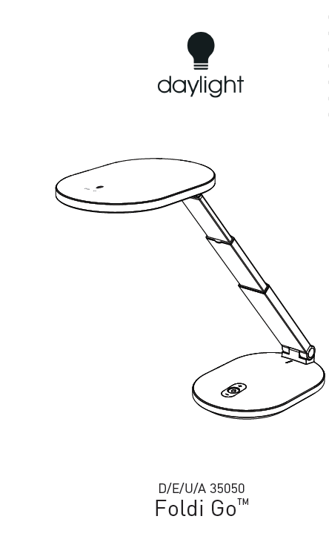

IMPORTANT SAFETY INSTRUCTIONS – PLEASE SAVE FOR FUTURE REFERENCE
Thank you for purchasing this Daylight product. To ensure correct and safe operation please read the following and retain for future reference.
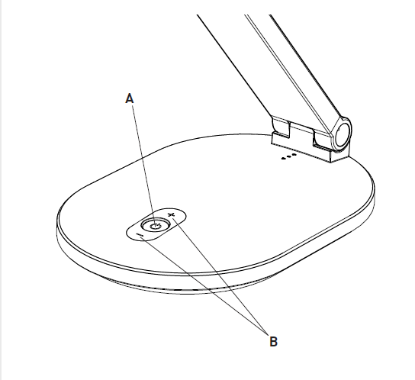
SET-UP AND OPERATION 2
CLEANING 3
MAINTENANCE 3
SAFETY 3
DAYLIGHT GUARANTEE/WARRANTY 4

SET-UP AND OPERATION
NOTE: PLEASE FULLY CHARGE THE INTERNAL LITHIUM BATTERY BEFORE USE
- Remove all packaging from around the lamp.
- The internal lithium battery will require charging before use. To charge the lamp, connect the USB-C cable to the rear of the base and plug the USB Adapter into a suitable electrical socket. CAUTION: Only use the USB Adapter (rated output 2.1A) supplied with the lamp. USB adapters with a rated output of less than 2A will not provide the required current and may damage the internal electronics.
- While charging, the blue indicator LEDs will start to flash. The charge time for a fully depleted battery is approximately 6 hours. When all three indicator LEDs are lit the lamp is fully charged. The lamp can be used while the battery is being charged, it will not affect the charging of the internal battery.
- To operate the lamp, rotate the shade CLOCKWISE, then lift and extend the arm to the required height. IMPORTANT: Do not force the lamp arm or shade past its movement limits as this could damage the joints and mouldings, which will not be covered by the lamps Guarantee.
- Once fully charged, remove the USB cable from the lamp. To operate the lamp, press the ON/OFF button (A).
- The brightness can be increased or decreased to the desired level by pressing the (+) or (-) buttons (B). There are 4 brightness levels and when the lamp is switched off the last brightness level is stored.
- While the lamp is illuminated the blue indicator LEDs display the battery charge level. When operated on maximum brightness, there is approximately 20 minutes of battery power remaining once the last indicator LED starts to flash.
- When not in use the lamp can be stored inside the protective carry case.
CAUTION: DO NOT CHARGE THE LAMP WHILE INSIDE THE CASE
CAUTION: DO NOT LOOK DIRECTLY AT THE LEDS.

CLEANING
BEFORE CLEANING MAKE SURE THE LAMP IS DISCONNECTED FROM THE ELECTRICAL SUPPLY.
If the lamp requires cleaning simply wipe with a damp cloth. Do not use large amounts of liquid or spray cleaners as they may enter the lamp and affect electrical safety.

MAINTENANCE
No maintenance is required. The LEDs are not user or service replaceable as they are designed to last for the lifetime of the product. The internal lithium battery cannot be replaced, it is designed to operate for the life of the product.

SAFETY
FOR INDOOR USE ONLY
CAUTION: DO NOT LOOK DIRECTLY AT THE LEDs.
CAUTION: If the cable of this luminaire becomes damaged, it should be exclusively replaced by a suitably qualified person in order to avoid hazard.
IN CASE OF DOUBT CONSULT A QUALIFIED ELECTRICIAN
ESP

DAYLIGHT GUARANTEE/WARRANTY
This product is guaranteed against mechanical and electrical defects. For full Daylight guarantee Terms & Conditions please refer to the Daylight website. Faulty products should be returned to the place of purchase and proof of purchase must be presented. Please quote the model number in all correspondence. Returned products damaged by poor packaging are the responsibility of the sender. During the guarantee period, Daylight will repair or replace the product free of charge provided the fault was not caused by misuse, improper handling, negligence, normal wear and tear, accidental damage, or by any modifications made by the purchaser. The guarantee does not cover consumables such as bulbs, tubes or batteries. This guarantee does not affect your statutory rights.

