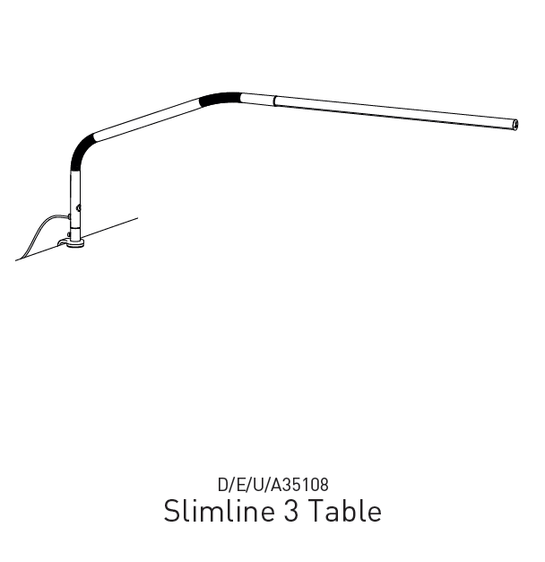
IMPORTANT SAFETY INSTRUCTIONS – PLEASE SAVE FOR FUTURE REFERENCE
Thank you for purchasing this Daylight product. To register your purchase and read more information about your guarantee, please go to www.daylightcompany.com
To ensure correct and safe operation please read the following and retain for future reference.

GENERAL INFORMATION 2
ASSEMBLY AND OPERATION 2
ALTERNATIVE MOUNTING OPTIONS 3
SCREW-ON MOUNT 3
CLEANING & SAFETY 4
DAYLIGHT GUARANTEE/WARRANTY 4

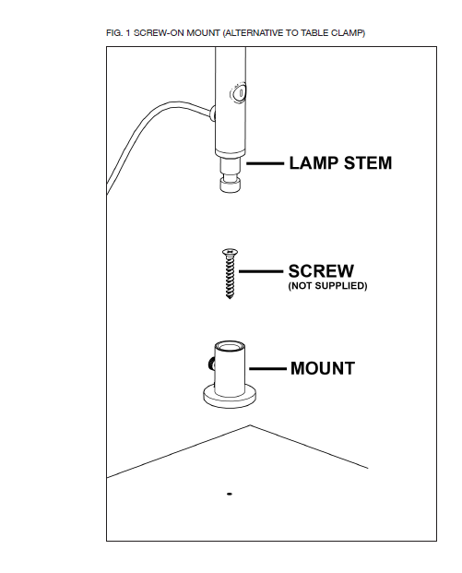

GENERAL INFORMATION
The lamp is fitted with Daylight LEDs that last the lifetime of the product.

ASSEMBLY AND OPERATION
- Carefully remove all packing from the lamp.
- Fit the clamp to the edge of a table or worktop and secure in place (NOTE: Please ensure that the lamp mount (the upper part of the clamp) is correctly seated onto the body of the clamp).
- Insert the lamp arm into the clamp and tighten the locking screw.
- Push-fit the LED shade into the lamp arm ensuring it is fully inserted.
- Plug the power supply jack into the lamp connector and then plug the power supply into a convenient electrical socket
- Switch on using the touch switch. The lamp will come on at full brightness. Subsequent touches of the switch give 3 lower levels of brightness. Touch again to turn off.
CAUTION: DO NOT LOOK DIRECTLY AT THE LEDs.

ALTERNATIVE MOUNTING OPTIONS
The supplied table clamp can be converted to a screw-on mount – see below for further details.
Alternatively, the lamp can be fitted directly to an integral mounting hole found on some tables/workstations.
An optional Slimline Table Base™ is also available separately.

SCREW-ON MOUNT
The table clamp that is supplied with the lamp can be converted to a screw-on mount.
This is particularly useful if the table you wish to mount the lamp to does not have a lip around it, or if you wish to mount the lamp away from the edge of the table. To convert the table clamp to a screw-on mount (suitable for any solid table, desk or worktop) please proceed as follows (PLEASE ALSO REFER TO FIG. 1):
- Unscrew the long thread approximately 4cm (1.5”) from the clamp body
- Remove the stem locking screw from the side of the lamp mount and the slide the mount out of the clamp body.
- Refit the stem locking screw to the side of the mount
- Put the clamp body in a safe place in case you wish to use it in the future
- Place the mount onto a table/desk/worktop in the position that you wish the lamp to be and using a pointed object (such a sharp pencil) make a mark through the centre of the mount onto the table (the pencil will have to pierce the felt pad on the bottom of the mount)
- The mount can then be screwed to the table using a Countersunk Wood Screw, 5mm diameter x 2.5cm long (No. 10 x 1”) NOTE: SCREW NOT SUPPLIED. Depending on the hardness of the table/desk/worktop a small guide hole may need to be drilled before fitting the screw.

CLEANING & SAFETY
BEFORE CLEANING MAKE SURE THE LAMP IS DISCONNECTED FROM THE ELECTRICAL SUPPLY by removing the power supply from the electrical socket. Wipe with a damp soft cloth and dry off. Do NOT USE spray cleaners and ensure that liquid does not enter the lamp housing as this may affect electrical safety and could damage the lamp.L SAFETY
The lamp will become warm in use due to internal electronics. This is quite normal.
CAUTION: DO NOT LOOK DIRECTLY AT THE LEDs.
CAUTION: Do not open or tamper with the lamp other than as advised in these instructions. You could expose yourself to high voltages or other risks.
CAUTION: Only use the plug-in power supply that came with the lamp. Use of another type will invalidate your guarantee and may damage your lamp.
CAUTION: If the lamp cable becomes damaged it should only be replaced by a suitably qualified person in order to avoid any hazard.
IN CASE OF ANY DOUBT PLEASE CONSULT A QUALIFIED ELECTRICIAN

DAYLIGHT GUARANTEE/WARRANTY
This product is guaranteed against mechanical and electrical defects. For full Daylight guarantee Terms & Conditions please refer to the Daylight website. Faulty products should be returned to the place of purchase and proof of purchase must be presented. Please quote the model number in all correspondence. Returned products damaged by poor packaging are the responsibility of the sender. During the guarantee period, Daylight will repair or replace the product free of charge provided the fault was not caused by misuse, improper handling, negligence, normal wear and tear, accidental damage, or by any modifications made by the purchaser. The guarantee does not cover consumables such as bulbs, tubes or batteries. This guarantee does not affect your statutory rights.

