KNFB Reader ES0208

Product Instructions

General description
The easy-to-use KNFB Reader app converts any text to speech or Braille instantly and accurately. Its text-to-speech and text-highlighting tools make it valuable for blind, low-vision, dyslexic, and other print-disabled users.
How does it work? Simply take a photo of any text, from PDFs to packages to books. Listen to the text read aloud or turn it into Braille.
Save or share your documents.

What KNFB Reader Can Do
KNFB Reader can read a wide variety of document types you may encounter throughout the day. It performs particularly well for reading printed memos, reports, fliers, and virtually any other kind of document typically printed from a personal computer. It will also read many professionally printed items of various sizes, colours, and styles, including:
• books.
• magazines.
• most restaurant menus.
• utility bills.
• printed mailing addresses.
• class or conference handouts.
• hotel bills.
• printed receipts.
• airline boarding passes.
• labels on packaged foods showing contents and nutrition information.
• transit brochures and schedules.
• CD labels.

What KNFB Reader Cannot Do
KNFB Reader has been developed to recognize and process a wide variety of type styles, printing formats, and lighting conditions. However, because it is computer software, the app is not quite as adaptable as the human brain. You can expect some printed matter to be read accurately with very high reliability, but in other instances performance with a print or item may not meet your needs. In general, you should give KNFB
Reader a try with things you need to read. This will help you to learn best what to expect. KNFB Reader is not designed for use with handwriting or scrolling text on a screen or sign. Accuracy for
household product containers (food boxes, tea bags, milk containers, detergent bottles, etc.) may vary, especially if the written information on these containers is artistically presented or is surrounded by
pictures and graphics.

Circumstances that may decrease accuracy include
• text printed on cylinders with warped or incomplete images (such as soup cans or medicine bottles).
• LED and LCD screens with refreshing text (such as digital clocks, computer screens, and cell phone
screens).
• vending machine buttons and instructions.
• engraved print (such as serial numbers) on machines.
• very large printed text.
• posted signs, such as signs on transit vehicles and signs in shop windows.
• conventional, analog clocks.

Factors Affecting Accuracy
As with human vision, performance of KNFB Reader will vary depending on several factors, including:
• surface reflection and glare (such as on a computer screen or a slick magazine page).
• distance between the camera and the target text.
• text size and variation.
• text layout.
• curvature of the target text.
• wrinkles and creases.
• background images and colours.
• ambient lighting.
• shadows.
• obstructions (such as cords, fingers, or neckties) between the camera and the target text.
Except for obstructed images, the app can generally adjust to a normal amount of variability with each of these factors. Nonetheless, some attention should be given to minimize the impact of any of these variables when taking a picture.

Basic Use – Take a Picture, Display and Read Text
When first starting KNFB Reader, you will be placed in the Camera tab, with focus on the “Take Picture” button.
Hold your device such that the camera is at a height of approximately 10 to 13 inches or 27 to 32 cm above the document. The camera should be centered over the document—keeping in mind that the camera on most iOS devices is in the upper-right-hand corner when held in portrait orientation. Check your camera periodically to make sure that the lens is clean and unobstructed. Be sure that no portion of a finger or your hand is close enough to the camera to block the view.

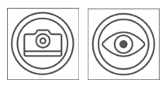To take a picture, activate the “Take Picture” button which is designated by the Camera icon. To improve the positioning of your device, use the “Field of View Report” button. This feature is especially useful for blind users when learning how to take better pictures.

Once you have taken a picture there are two options, depending on the Camera Settings in KNFB Reader Settings. If the “Show crop, rotate and edit options” switch is in OFF position, which is the default for VoiceOver users, then the image is immediately processed for text. If the switch is in ON position you will get a button “crop, rotate and edit” in the Camera view. If that button is set at manual, then a next screen is presented in which you can crop or rotate the image. After cropping and rotating you can also edit the image in order to exclude some parts of the picture from text recognition. Tapping on Edit will bring you to the edit image screen. Tapping on Finish will start text recognition.

Reading Text
The image is then processed for text. If any is found, the text is displayed automatically and read aloud as the Reading tab opens. How the text is displayed depends on the setting “default file type for recognized documents” in the Camera Settings. If set to KNFB, you will get a reflowable TXT view. This is the default setting for VoiceOver users. If set to PDF, you will get a PDF view with double highlighting.

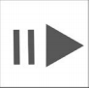 To pause or resume reading, activate the “Play/Pause” button, which is located near the bottom center of the screen.

To navigate the text, use the navigation controls located at the bottom of the screen.

Save a Document
To save the document, activate the “Save” button located at the top of the Reading tab just above the displayed text area. The file name defaults to the current date and time. You can edit this file name if you choose. You can also choose in which format the document will be saved (KNFB or PDF). The default is the view you are using for reading at the time you are hitting the Save button. If you are in KNFB view and you choose to save in PDF view, then saving will demand some extra time for creating the PDF out of the KNFB document.

To take another picture, return to the Camera tab by selecting the Camera icon on the lower-left-hand corner of the screen.

Picture-taking Tips
Sharp pictures are essential for optimal performance. Be sure to adjust your camera to a height which captures all the text. For best results, place the text you want to read on a flat surface cantered under your camera. Flatten the document as much as possible. Fill the screen with the view of the document you want to capture.

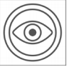 To confirm your camera position. Use the Field of View Report button. You can then adjust the position of the page and repeat the process as needed.
The goal is to have camera close to the document but still far enough away so all four edges of the document are in the field of the view.

Practice will help in the beginning. Use a familiar document printed in clear type on an 8.5 by 11-inch (letter format) or 21 by 29.7 cm (A4 format) white sheet of paper for your initial practice sessions. Place the document on a flat surface having a plain dark matte (not shiny) finish. After some practice with positioning and taking pictures, you will begin to know how KNFB Reader responds. You will also be better prepared to analyze and correct conditions you can control when performance does not measure up. A little practice and persistence can greatly improve performance.

Reading Electronic Documents
One of the most common uses of KNFB Reader is recognition of otherwise inaccessible PDF documents. PDF, PNG, and JPG files can be imported in to KNFB Reader using the Share function or can be opened directly in a Cloud folder. If you have an image-based PDF, or JPG file that you know contains text, importing or opening the file in to KNFB Reader will enable you to rapidly process the file, extract any text, and have the contents read aloud and available in Braille. ePub documents can also be read with KNFB Reader. An increasing number of text books and other electronic books are produced in this format.

Reading Multi-Page Documents
One of the most unique features of KNFB Reader is our process for quickly capturing multiple pages of text. The Multi-page button on the Camera tab switches from single page recognition to multi-page or batch recognition. Rather than immediately recognizing an image, additional images can be added to the batch queue. Multi-page mode offers the option to remove the last image if necessary. The entire set of images is then recognized and the document is read.

A document scanning stand can greatly improve speed and accuracy. A discussion of using KNFB Reader in scanning stand mode can be found in the Picture Mode section.

Navigation Basics
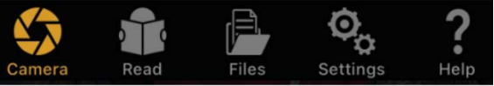

KNFB Reader groups related functions in tabs. The five tabs running across the bottom of the screen are: Camera, Read, Files, Settings and Help. For instance, to find previously saved documents, select the Files tab.

VoiceOver Compatibility
KNFB Reader is fully compatible with VoiceOver—the screen access solution freely available as part of all available iOS devices. Refer to the User’s Guide of your iOS device for more information regarding using VoiceOver. Remember that VoiceOver will change the touch interface of your device. Here are a few tips to get you started:
- Swipe Left and Right: A short, fast motion with one finger anywhere on the screen to the left or right will move to the previous or next element.
- Double-tap
Activate the currently selected item by double-tapping anywhere on the screen with one finger.
- Flick up and Down
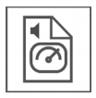A short fast motion with one finger anywhere on the screen up or down will change the value of certain controls. For example, the speed control on the Read tab will increase or decrease reading speed when flicking up and down respectively.

Additional Tips
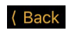
- Touch the screen and slide your finger to navigate spatially.
- Many screens can be closed by selecting the Back button, typically located on the upper-left-hand corner of the screen.

Layout and Description of Functions
KNFB Reader is designed with your productivity and ease-of-use in mind. The minimum number of controls and settings are presented on each screen to improve usability. Following is a detailed description of each of the app’s screens with an explanation of each control in reading order. This is typically left to right and top to bottom.

Camera Tab
KNFB Reader opens to the Camera tab. The other tabs are used for reading text and performing other functions in the app. Think of the Camera tab as the home screen for the app. The next few sections will discuss using the controls of the Camera tab in greater detail.
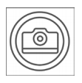

Voiceover focus is forced to the Take Picture button when moving to this tab, as this is the most commonly used function, so the conventional VoiceOver navigation is overridden.

Flash
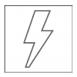Cycles the device’s flash among:
• On -- will use the flash for all pictures taken.
• Automatic -- will determine if the flash is necessary for taking a picture based on ambient light conditions (recommended)
• Off -- deactivates the flash for all pictures.

Multi-Page Mode On or Off
Activate Multi-Page Mode to capture documents spanning multiple pages, or several related documents. When toggled “On,” additional Multi-Page Mode controls appear on the Camera tab.
- Remove Page – will remove the most recently take image from the batch queue.
- Cancel Batch – discards all images in the batch queue and exits Batch Mode.
- Pictures Taken – counts the number of images in the Multi-Page queue. When activated, all images are processed and displayed on the Read tab.

Text Recognition Enabled or Disabled
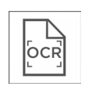When toggled “On,” KNFB Reader will recognize text from images. When deactivated, the images are displayed, but cannot be read. The typical behavior is to use KNFB Reader with text recognition enabled. An example of an exception would be capturing multiple images and saving them for recognition at a later time. Or if a user just wants to take a picture and save it in PDF format to share it with someone else.

Crop and rotate the image and allow editing
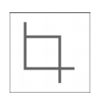Image cropping is the process of removing portions of an image. In the context of KNFB Reader, this is typically to remove unwanted background elements from an image for more suitable display or recognition purposes. Next to cropping the user can also rotate the image and edit the image (swipe out parts of the text).

Choose among three cropping options:
- Do not crop and rotate the image.
- Crop and rotate the image automatically.
- Crop and rotate the image manually and allow editing.

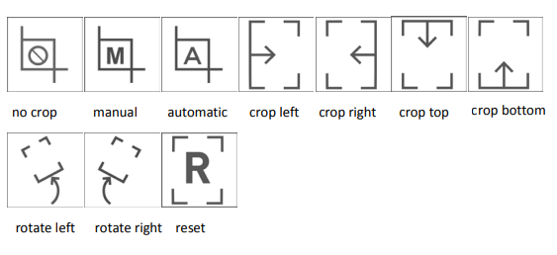

Tilt Guidance
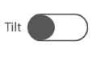When toggled “On,” the device will vibrate when not aligned with the horizontal plane. Vibration increases or decreases relative to the degree of tilt. Vibration ceases when the device is level. Note that not all devices offer this haptic feedback.

Take Picture
Acquires an image from the camera of the device. When Multi-Page mode is turned off, optional cropping and recognition phases are applied before moving to the Read tab for display. With Multi-Page activated, the Take Picture button will add another picture to the batch queue. The batch count indicator will increment to confirm the action.

Field of View Report
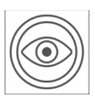The Field of View Report is available to help learn how best to align the camera with the document you want to read. Use the Field of View Report button to capture an image and announce the position of your camera relative to the document. Similar to capturing an image for text reading, the camera should be centered over the print material approximately 10 to 13 inches (letter format) or 27 to 32 cm (A4 format) away in order to have all four edges visible in the picture. An optimal Field of View Report is, "All four edges are visible, rotated zero degrees clockwise." This means that the entire document is visible in the frame and no text will be cut off. Practicing with the field of view report will help you understand how the camera sees various document sizes and works in different lighting conditions.

Text Recognition Language
Presents the list of user-selected languages to be recognized. This list is determined by the Select Recognition Languages option on the Settings tab. Select the desired language and choose the done button to close the selection.

Multi-Colum On or Off
When toggled “On,” recognized text is processed in columns rather than straight across the page from left to right. Newspapers and magazines are often laid out in columns wherein the text is read from the top of the column to the bottom. The next column to the right is then read.

Picture Mode
Pictures can be taken in three ways
- Manual -- will only take a picture when the Take Picture button is activated.
- Automatic mode -- determines if text is suitably in focus and takes a picture automatically.
- Picture from Stand -- is used in conjunction with a document scanning stand. After switching to this mode, place your device on a document stand with no reading material visible to the camera. Pictures are taken when text is detected. With Batch Mode active, many pages can be captured by simply placing the next page to be recognized in view of the camera.

Read Tab
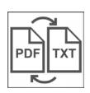Recognized text is displayed on the Read tab. Reading can be stopped and started via the Play/Pause button. Synchronized highlighting will denote the line and word currently being spoken. Characteristics, such as background and highlighting colors, font style, size of print distance between lines, speech voice, volume, and speed can be modified in the Settings tab under the Reader Settings section.

KNFB Reader now offers two ways of viewing documents. The original image can be displayed with the words being read aloud. This is distinctly separate from the traditional method of displaying recognized text. This approach creates a PDF document from the supplied image. The Switch Reader control will switch between the text and image view.

Save
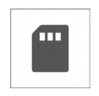The document being read will be discarded unless it is deliberately saved. When saving, the default document name is the current date and time. This can be modified as desired. You can also choose in which format the document will be saved (KNFB or PDF). The default is the view you are using for reading at the time you are hitting the Save button. If you are in KNFB view and you choose to save in PDF view, then saving will demand some extra time for creating the PDF out of the KNFB document. If you have linked your KNFB Reader to your preferred cloud service you will be able to choose between saving to the local folder or to your preferred cloud service. You can then select from an existing folder in which to save your document or create a new one. Finally select the Save button to finalize your choices.

Switch Reader
Switches between PDF View and text View. PDF view displays the actual image while being read. The Text View displays the reflowable recognized text for reading. The PDF view creates a PDF document which can be saved and exported as desired.

Reading Language
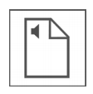This option changes the language of the reading voice. This is not to be confused with translation or changing of the recognition language. Switch among all the selected languages chosen from Select Reading Languages under Reading Options on the Settings tab.

Speed
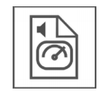Opens a selector for changing reading speed. Select Done when finished.

Add Page
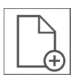
Choose Add Page to Append another page to the current document. You will first be asked to save the document. The Camera tab will become active and the new image will be added to the end of your document. Reading will begin after the new page is recognized.

Remove Page
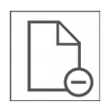Choose Remove page to remove the last page in a document.

View Image (only available when in TXT view)
This will display the actual image captured. Select the Back button to return to the reader.

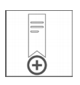Add Bookmark (only available when in PDF view)
A bookmark is added at the current reading position.

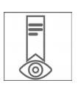View Bookmarks (only available when in PDF view)
A list with all bookmarks in the document is presented. Tap on a bookmark to go to that position in the document. Tap on Edit if you want to rename a bookmark or if you want to delete a bookmark.

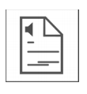Reading Unit
The text unit used to move through a document can be changed. This option switches among the available options. For example: Word, line or sentence. This selection determines the unit that will be read when using the Previous and Next buttons located near the bottom of the screen. For example--With Reading Unit set to Line, the previous button will move to the previous line.

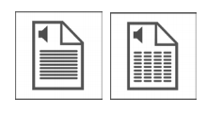Read Continuously/ Read Self-paced
Make a choice between reading the text without interruption or self-paced.

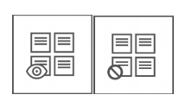View Zones (only available when in PDF view)
Tap this button to see the reading order zones, if available. Reading zones are only available in accessibility tagged PDF documents.

+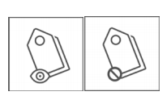View Language Tags (only available when in PDF view)
Tap this button to see the language tags in the document. Language tags are only available in accessibility tagged PDF documents.

Re-do Text Recognition
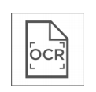Activate this control to reprocess and read the latest image captured in a different recognition language or in the opposite column mode. For example, with column mode on, all the items on a restaurant receipt might be read from top to bottom, rather than reading the item and the price from left to right.

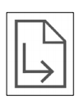Go to page
Tap this button to go to a certain page.

Previous
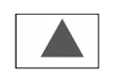Move to the previous reading unit.

Play/Pause
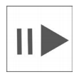Stop or start reading. VoiceOver users can also use the two-finger double-tap (or ‘Magic Tap’) to pause and resume reading.

Next
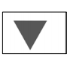
Move to the next reading unit.

Full screen
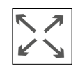To minimize distractions and maximize the amount of text viewable at any given time, the Full Screen option removes all the controls except for the Play/Pause and navigation controls at the bottom. Select Full Screen again to return to normal reading mode.

Files Tab
This tab is for document management. All saved or imported documents live here.
The Local and Cloud tabs near the bottom of the Files tab will switch between those documents saved on your device or living in various cloud services. Pictures previously saved in the Camera Roll of the device can also be accessed here.
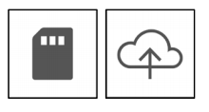

Import from Camera Roll
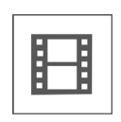Select images from the Camera Roll for processing with KNFB Reader.

Add Folder
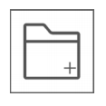Adds a new folder in the local folder tree.

Edit
Provides the following operations for working with selected documents and folders: Rename, Move, Share and Delete.

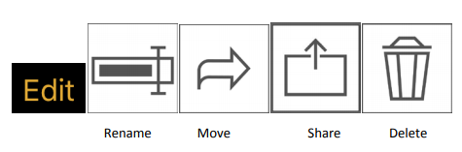

The Share option will offer file conversion options for KNFB documents. Currently, these are: KNFB format, Text, Rich-Text and HTML. After conversion, the standard iOS Share Sheet will appear which will allow you to send the exported file to various services and apps. For example, a KNFB file could be emailed to a colleague for reading in KNFB Reader, or a text document could be sent to a local app for editing. When sharing a PDF or ePub document, format conversions are not currently available.

Local
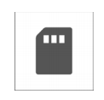Switches to the list of documents and folders stored in KNFB Reader.

Cloud
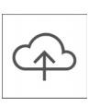Switch to the available cloud services. These are: Google Drive, OneDrive and DropBox.

Settings tab
Here is where you can control the behaviour of KNFB Reader. There are options for changing how documents look and sound when being read. Even the appearance of the app itself can be changed. The first two options on the Settings tab will change many KNFB Reader options at one time.

• “Apply default settings for users of the VoiceOver Screenreader” will configure KNFB Reader with the appearance and behaviour expected by many VoiceOver users. The cropping tool is hidden, while the text is displayed in the traditional text view style.

• “Apply default settings for all other users” will configure the app to work in a fashion more suited to those wanting a highly visual experience. For instance, the Field of View Report and Tilt Guidance control vanish from the Camera tab and the image view is used in the Read Tab. Recognized images are automatically saved as PDFs. This feature set may be more suited to those with certain learning disabilities or foreign-language learners. When tapping on the button to select one of the options an overview is presented of the settings that will be affected. All the settings changed with these two options can be individually configured to suit your specific needs in the sections below.

Camera Settings
Flashlight always on
When toggled on, the camera’s lamp will remain active as long as you are on the Camera tab. This is turned off by default. You may notice significant power expenditure when this setting is activated.

Field of View Landscape Mode
Reports the top of the page properly when the device is used in landscape orientation. This would place the camera of an iOS device in the upper-left-hand corner. Without this option, Field of View information would be 90 degrees out of phase.

Field of Viw Reports Visible Corners
Reports corner information in addition to edge information. This is especially useful when configuring for use with a document scanning stand, as the environment for capturing many perfectly aligned images can be created.

Use Volume buttons to take picture or provide field of view report
When set to ON, use the volume up button to take picture, use volume down button to provide field of view report.

Default File Type for Recognized Documents
Switches between PDF and KNFB as the default file type for saving documents.

Select Recognition Languages
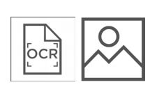Rather than presenting the entire list of thirty-three available recognition languages in the Language Selector on the Camera tab, a sub-set of languages may be selected here. Choose your most commonly recognized languages for fast switching when taking pictures.

Show Text Recognition Button
Show or hide the Text Recognition control on the Camera tab

Show crop, rotate and edit options
Show or hide the Cropping control on the Camera tab.
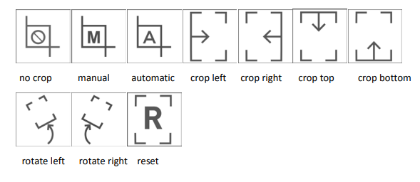

Show Tilt Button
Show or hide the Tilt Guidance control on the Camera tab.

Show Field of View Button
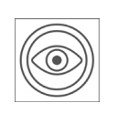Show or hide the Field of View Report button on the Camera tab.

Reader Settings
Automatically Start Reading
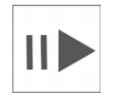Reading will not begin when a document is displayed if this is switched off. The Play/Pause control can be used to control reading. Those who prefer to read recognized text with VoiceOver, especially Braille readers, may also prefer this approach.

Allow Reading in Background
When activated, reading will continue even if the device is locked. This behaviour is similar to the playing of music or listening to an audio book.

Adjust Speech Volume
Sets the default volume level for the reading voice.

Adjust Speech rate
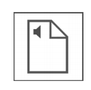Sets the default speech rate for the reading voice.

Select Speaking Language
Presents the entire list of voices currently installed on the device. A sub-set of these languages can be selected to appear in the Reading Language control on the Read tab.

Text Display Settings for KNFB Files
The Font Type, Font Size, Font Color, Background Color, and Line Distance can all be changed to suit your preferences.

Highlight Settings
Determine the style and colour of the various forms of highlighting available.
- Word Highlighting distinguishes the word currently being spoken.
- Reading Unit Highlighting shows the current reading unit being read in a different colour from the word highlighting.
- Highlight Text Color is available in KNFB format only.
- Highlight background colour.

File Settings
- Confirm on Delete prompts for confirmation before a document or folder is removed.
- Display File Type shows the file format of each document in the folder structure.
- In the File Settings you also have the option to choose one out of three cloud services as your default cloud service: Dropbox, Google Drive or OneDrive.

