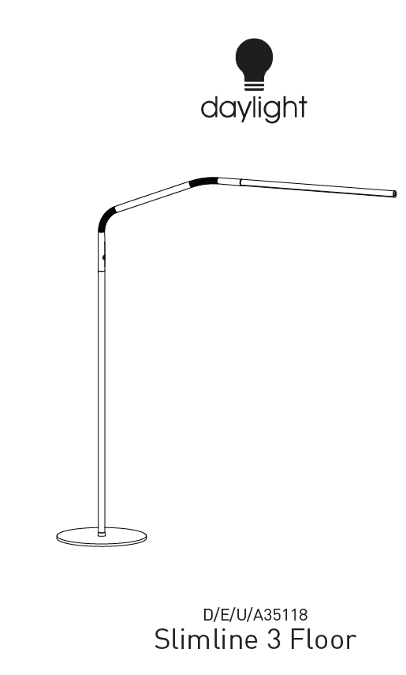
ENGLISH
IMPORTANT SAFETY INSTRUCTIONS – PLEASE SAVE FOR FUTURE REFERENCE
Thank you for purchasing this Daylight product.
To register your purchase and read more information about your guarantee, please go to www.daylightcompany.com
To ensure correct and safe operation please read the following and retain for future reference.

ASSEMBLY AND OPERATION 2
INFORMATION ON DAYLIGHT LEDs 3
CLEANING 3
SAFETY 3
DAYLIGHT GUARANTEE/WARRANTY 3

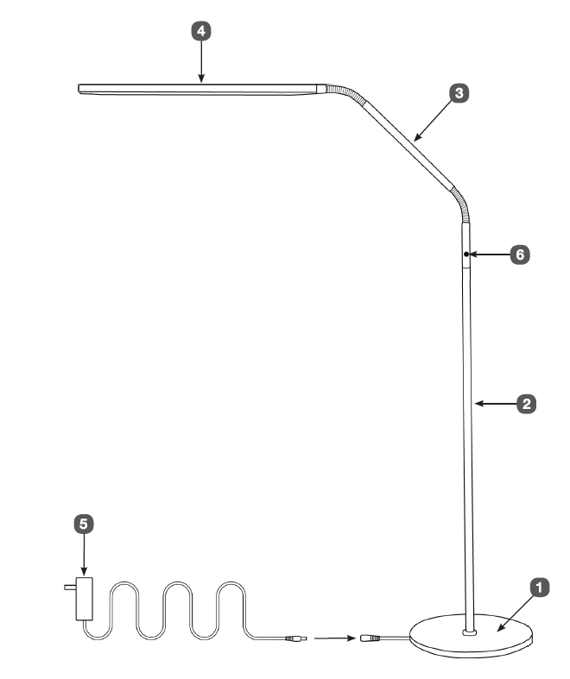

ASSEMBLY AND OPERATION
ASSEMBLY AND OPERATION
- Carefully remove all packing from the lamp
- Place the Base (1) on the floor.
- Feed the cable from the centre of the Base through the Pole (2) until the connector comes out. This is sometimes easier to do with the pole horizontal.
- Holding the connector, screw the Pole on to the Base and tighten firmly.
- Plug the connector into the socket at the BOTTOM of the Flexible Arm (3) ensuring it is fully inserted.
- Gently push any excess cable into the top of the Pole and then screw the Flexible Arm onto the Pole and tighten firmly.
- Push the LED Shade (4) into the end of the Flexible Arm (3) ensuring it is fully inserted.
- Insert the power supply jack (5) into the cable on the edge of the base and then plug the power supply into a conveniently located electrical socket.
- Switch on using the touch switch (6). The lamp will come on at full brightness. Subsequent touches of the switch give 3 lower levels of brightness. Touch again to turn off.
CAUTION: DO NOT LOOK DIRECTLY AT THE LEDs
INFORMATION ON DAYLIGHT LEDs

INFORMATION ON DAYLIGHT LEDs
The unit is fitted with LEDs which will last the lifetime of the lamp.
CLEANING

CLEANING
CAUTION: BEFORE CLEANING UNPLUG THE LAMP FROM THE ELECTRICAL SUPPLY.
The lamp does not need special maintenance. If the lamp requires cleaning wipe with a dampened cloth containing a mild soap solution and then dry. Do not use spray cleaners or large amounts of liquid.
SAFETY

SAFETY
The Shade may become warm in use (due to internal electronics). This is quite normal.
CAUTION: DO NOT LOOK DIRECTLY AT THE LEDs.
CAUTION: Do not open or tamper with the lamp other than as advised in these instructions. You could expose yourself to high voltages or other risks.
CAUTION: Only use the plug-in power supply that came with the lamp. Use of another type will invalidate your guarantee and may damage your lamp.
CAUTION: If the lamp cable becomes damaged it should only be replaced by a suitably qualified person in order to avoid any hazard.
IN CASE OF ANY DOUBT PLEASE CONSULT A QUALIFIED ELECTRICIAN

DAYLIGHT GUARANTEE/WARRANTY
This product is guaranteed against mechanical and electrical defects. For full Daylight guarantee Terms & Conditions please refer to the Daylight website. Faulty products should be returned to the place of purchase and proof of purchase must be presented. Please quote the model number in all correspondence. Returned products damaged by poor packaging are the responsibility of the sender. During the guarantee period, Daylight will repair or replace the product free of charge provided the fault was not caused by misuse, improper handling, negligence, normal wear and tear, accidental damage, or by any modifications made by the purchaser. The guarantee does not cover consumables such as bulbs, tubes or batteries. This guarantee does not affect your statutory rights.

