CLOVER 5
Handheld Video Magnifier
User Guide

Contents
Precaution 1
Quick Start 3
Overview 3
Compositions 5
Accessories 8
Battery and charging 9
Writing stand 14
Operation 15
Power Button 15
Beep Type 16
Magnification 18
Color Mode 19
Brightness 23
Lighting 26
Freeze 26
TV Connection 28
Memory 30
Auto power saving 30
Restore 31
Troubleshooting 32
The unit does not turn on 32
Black screen or White screen 32
The image does not change 33
Smudges or blemishes on the screen 34
Specifications 35

Precaution
Before using CLOVER 5 for the first time, you must charge its battery. Refer to Charging the battery section for more details.
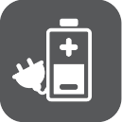

Al ways operate the unit in a place where the temperature is between 10°and 35°C(50°and 95°F).

Keep the unit away from wet areas, rain, and other sources of liquids. Do not submerge the unit.

Do not attempt to repair the unit. Any unauthorized attempt will void the product warranty. Contact your distributor to service.

Use the supplied power adapter.

Quick Start
Overview
Thank you for purchasing CLOVER 5.

CLOVER 5 is a portable, handheld video magnifier with a 5 inch widescreen LCD display, providing sharp, clear images that are easily viewed in various magnification level and color mode.

The unit allows you to put the magnifier on or close to the object for continuous zoom or freeze the image for further viewing. It also has an integrated fold-away writing stand. This unit is ideal for viewing labels, books, newspapers and more.

Compositions
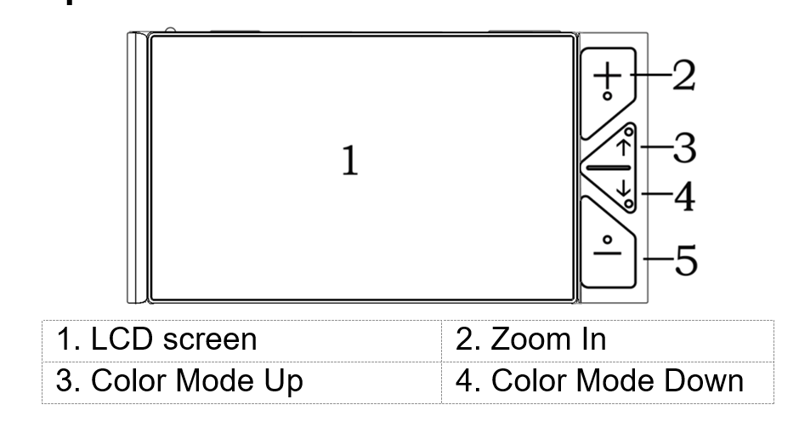

Zoom out
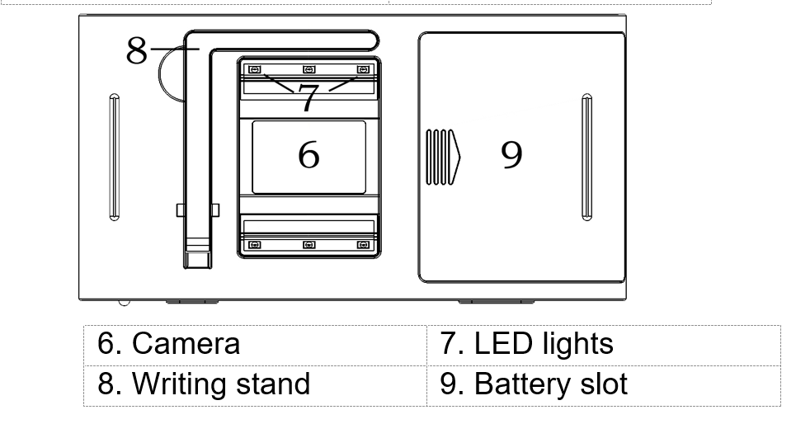

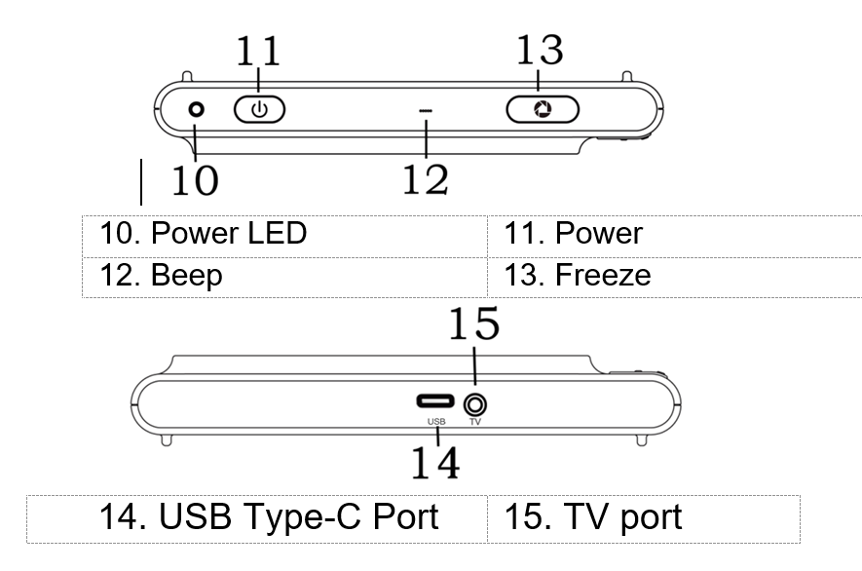
Accessories
- User Manual
- Power Adapter
- Cleaning Cloth
- Carrying Case
- Battery
- USB Cable
- TV Cable

Battery and Charging
Battery installation
- Turn the unit to make the back face up
- Press the arrow icon on the battery cover and slide outward to open the battery cover
- Insert the battery to the right position in battery slot
- Place and slide back the battery cover
Charging the battery
- Connect the supplied USB cable to the power adapter
- Connect the supplied USB cable to the micro USB port on the unit
- Plug the power adapter into an AC outlet and start charging

The status of Power LED indicator
- Charging when the unit is off, the power LED will be green, and then auto turn off when fully charged. A fully Charging will take about 5 hours, and will support the unit working continuously for about 3 ~ 3.5 hours
- Charging when the unit is on, the power LED will be green
- When the unit is on and the power adaptor is not connected, the power LED will be green when the battery is high and will be red when the battery is low. When the red light starts to flash, you will need to charge the battery
- You can also check the battery status by pressing the power button; refer to the following instructions for more details

Writing stand
Open the writing stand as the following figure shows. And you can write under the camera.

Power Button
- Press and hold the Power button for 3 seconds to turn on the unit when it is off
- Press and hold the Power button for 3 seconds to turn off the unit when it is on
- Press the Power button to check the current status of battery capacity, color mode, freeze mode , and beep
- Press other button when holding the power button will make combo function, refer to the following instructions for more details

Beep Type
- Unit on/off beep
- Button beep
- Threshold beep
- Low battery beep

Beep Control
- Press and hold the Freeze button for 3 seconds to turn on/off the beep

Magnification
- Press the Zoom in button to increase magnification, holding the Zoom In button for continuous increasing.
- Press the Zoom Out button to decrease magnification, and holding the Zoom Out button for continues decreasing
Colour Mode
A color mode is a pre-defined color combination. Full color mode is suitable for picture, map viewing, and enhanced contrast mode is combined with different foreground and background colors and can help to read clearly.
- Press the Color Mode Down button to cycle in one direction through the color combination list
- Press the Color Mode Up button to cycle in the other direction through the color combination list
- Press the Color Mode Up button and the Color Mode Down button at the same time to quick switch between Full color mode and current enhanced contrast mode
- Holding the Color Mode Up button and the Color Mode Down button at the same time for 5 seconds to switch between the Simplified Color Combination List and the Integrated Color Combination List (factory default)

The Simplified Color Combination List
- Full Colour
- White on Black
- Black on White
- Yellow on Black
- White on Blue
- Yellow on Blue

The Integrated Color Combination List
- Full Colour
- White on Black
- Black on White
- Yellow on Black
- Black on Yellow
- White on Blue
- Blue on White
- Yellow on Blue
- Blue on Yellow
- Green on Black
- Black on Green
- Violet on Black
- Black on Violet
- Blue on Black
- Black on Blue
- White on Green
- Green on White
- White on Red
- Red on White
- Red on Black

Brightness
Adjust the display brightness for Full color mode and Enhanced contrast mode. Factory default value will be highlighted green.
- Combo: Holding Power button and Slide the Zoom & Mode button rightward to increase the brightness.
- Combo: Holding Power button and slide the Zoom & Mode button leftward to decrease the brightness

Two-Colour Tuning
By fine adjusting the combination of foreground and background color in Enhanced contrast mode, the tuning will improve the adaptability for viewing different materials. Factory default value will be highlighted green.
- Combo: Power button and Colour Mode Up button, more background colour
- Combo: Power button and Colour Mode Down button, more foreground colour.

Lighting
Combo: Holding Power button and click the Freeze button to turn on/off the LED lighting.

Freezing
Freezing an image on the LCD screen can be useful for further reading, and also further zooming in or zooming out or changing the color mode for a better view. The brightness adjusting is not allowed when freezing.
- Press Freeze button to lock the active image
- Press again Freeze button to release
- When increase the magnification of the locked image, you can use the following combo button to navigate
Power & Color Mode Up navigate upward
Power & Color Mode Down navigate downward
Power & Zoom In navigate leftward
Power & Zoom Out navigate rightward

TV Connection
Connect to your TV for a better and larger viewing.
- When plugging in the TV Cable to the TV port on the unit, you need to select the appropriate TV output mode (PAL or NTSC mode).
- Press Zoom In button or Zoom Out button to choose PAL or NTSC, then press Freeze button to confirm your selection and then the image shall be shown on TV
- After unplugging the TV cable, the image will automatically return to the LCD screen of the unit

Memory
The unit will memorize automatically the most recent settings such as color mode, magnification, beep when power off normally and use them in the next power on

Auto power saving
If no operation and no moving for over 3 minutes, the unit will turn off automatically.

Restore
Holding the Freeze button and Zoom & Mode button at the same time for 3 seconds to reset to the default factory settings. Auto power off when resetting is done.

Troubleshooting
The unit does not turn on
- Connect to the power adapter
- Charge the battery
- Reinstall the battery

Black screen or White screen
- If the unit is sitting on a flat pure surface, the screen may be black or white, Lift the unit off to ensure change happens
- Adjust the magnification
- Adjust the color mode
- When the unit is connected to TV, the screen is black
- Restart the unit
- Reinstall the battery

The image does not change
- If the unit enter the freeze mode, the image will not change
- Press power button to check the current status
- Restart the unit
- Reinstall the battery

Smudges or blemished on the screen
- Adjust brightness
- Clean the LCD screen and camera

Please contact your local distributor if problem is not solved

Specifications
- Display: 5 inch wide screen LCD
- Size: <=152*80*22mm
- Weight: <210 grams (Battery included)
- Color Mode: Simplified 6 modes; Integrated 20 modes
- Magnification：4x – 20x
- Battery: Rechargeable & detachable Li battery
Nearly 3~3.5 hours continuous use
- Power Adapter: USB port; input 110-240V; output 5V/1A

