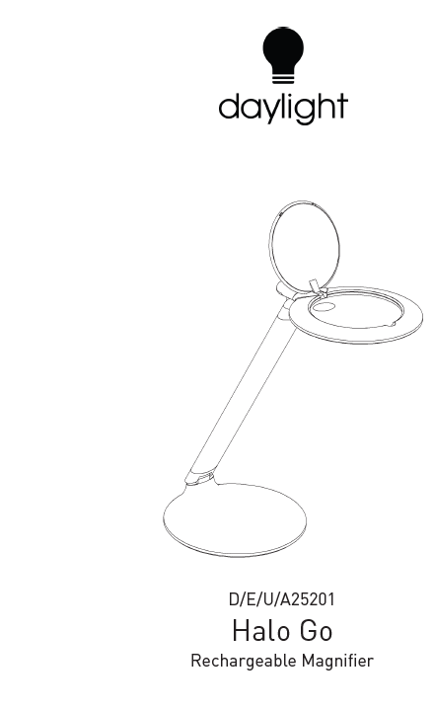

IMPORTANT SAFETY INSTRUCTIONSPLEASE SAVE FOR FUTURE REFERENCE
Thank you for purchasing this Daylight product. To register your purchase and read more information about your guarantee, please go to www.daylightcompany.com To ensure correct and safe operation please read the following and retain for future reference.

SET-UP AND OPERATION 2
CLEANING 2
MAINTENANCE 2
SAFETY 3
DAYLIGHT GUARANTEE/WARRANTY 3

SET-UP AND OPERATION
- Remove all packaging from around the lamp.
- The internal lithium battery will require charging before use. To charge the lamp, connect the USB Cable to the rear of the base and plug the USB Adapter into a suitable electrical socket. The blue indictor LEDs at the base of the arm will start to flash, indicating the lamp is charging. The charge time for a fully depleted battery is approximately 6 hours. When all three indicator LEDs are lit the lamp is fully charged. While the battery is being charged the lamp can be illuminated.
- Once charged, remove the USB cable. Switch on the lamp by pressing the button on the base.
- The lamp has 2 brightness settings. The first setting is the brightest and will provide up to 4 hours of constant Daylight. The second setting uses less energy and will provide up to 8 hours of constant Daylight.
- While the lamp is illuminated the blue indicator LEDs display the capacity of the battery. When operated on full brightness, there is approximately 20min of battery power remaining once the last indicator LED starts to flash.
- The lens can be rotated allowing the higher magnification inset lens to be positioned as required.
CAUTION: DO NOT LOOK DIRECTLY AT THE LEDS.
CLEANING

CLEANING
BEFORE CLEANING MAKE SURE THE LAMP IS DISCONNECTED FROM THE ELECTRICAL SUPPLY.
If the lamp requires cleaning simply wipe with a damp cloth. Do not use large amounts of liquid or spray cleaners as they may enter the shade and affect electrical safety.
MAINT
ENANCE & SAFETY

MAINTENANCE
No maintenance is required. The LEDs are not user or service replaceable as they are designed to last for the lifetime of the product.

SAFETY
FOR INDOOR USE ONLY
CAUTION: NEVER LEAVE THE LENS UNATTENDED IN DIRECT SUNLIGHT OR WHERE LIGHT CAN SHINE THROUGH IT - THIS CONSTITUTES A FIRE HAZARD. WHEN THE MAGNIFYING LAMP IS NOT IN USE PLEASE CLOSE THE LENS COVER FITTED TO THE LAMP.
CAUTION: DO NOT LOOK DIRECTLY AT THE LEDs.
CAUTION: Only use the power adapter supplied with the product. Use of a different adapter could damage the lamp and invalidate the guarantee.
CAUTION: Take care not to get the flexible cable tangled around the base.
CAUTION: If the cable of this luminaire becomes damaged, it should be exclusively replaced by a suitably qualified person in order to avoid hazard.
IN CASE OF DOUBT CONSULT A QUALIFIED ELECTRICIAN

DAYLIGHT GUARANTEE/WARRANTY
This product is guaranteed against mechanical and electrical defects. For full Daylight guarantee Terms & Conditions please refer to the Daylight website. Faulty products should be returned to the place of purchase and proof of purchase must be presented. Please quote the model number in all correspondence. Returned products damaged by poor packaging are the responsibility of the sender. During the guarantee period, Daylight will repair or replace the product free of charge provided the fault was not caused by misuse, improper handling, negligence, normal wear and tear, accidental damage, or by any modifications made by the purchaser. The guarantee does not cover consumables such as bulbs, tubes or batteries. This guarantee does not affect your statutory rights.

