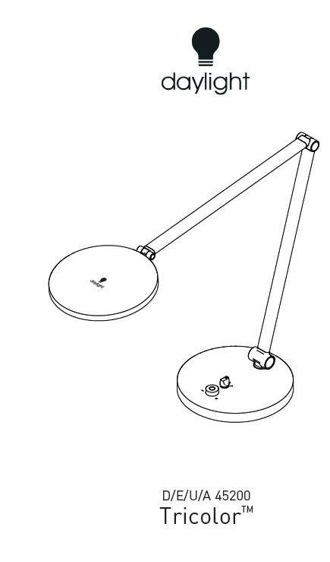
IMPORTANT SAFETY INSTRUCTIONS – PLEASE SAVE FOR FUTURE REFERENCE
Thank you for purchasing this Daylight product. To ensure correct and safe operation please read the following and retain for future reference.

SET-UP AND OPERATION 2
CLEANING 3
MAINTENANCE 3
SAFETY 3
DAYLIGHT GUARANTEE/WARRANTY 3

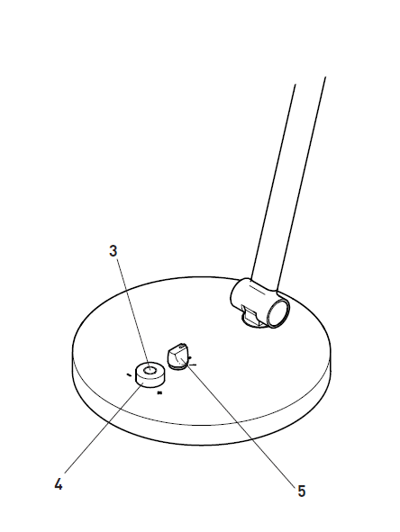ISH

SET-UP AND OPERATION
- Remove all packaging from around the lamp.
- Connect the adapter to the base of the lamp.
- Press the red button to switch the lamp on and press again to switch off.
- Turn the red button clockwise to increase brightness, or anti-clockwise to decrease brightness.
- Use the black switch to change colour temperature. Option 1 is daylight (6,000 K), option 2 is cool light (4,000 K) and option 3 is warm light (2,700 K).
- IMPORTANT: Do not force the lamp arm or shade past its movement limits as this could damage the joints and mouldings, which will not be covered by the lamps Guarantee.
CAUTION: DO NOT LOOK DIRECTLY AT THE LEDS

CLEANING
BEFORE CLEANING MAKE SURE THE LAMP IS DISCONNECTED FROM THE ELECTRICAL SUPPLY.
If the lamp requires cleaning simply wipe with a damp cloth. Do not use large amounts of liquid or spray cleaners as they may enter the lamp and affect electrical safety.

MAINTENANCE
No maintenance is required. The LEDs are not user or service replaceable as they designed to last for the lifetime of the product.

SAFETY
FOR INDOOR USE ONLY
CAUTION: DO NOT LOOK DIRECTLY AT THE LEDs.
CAUTION: If the cable of this luminaire becomes damaged, it should be exclusively replaced by a suitably qualified person in order to avoid hazard.
IN CASE OF DOUBT CONSULT A QUALIFIED ELECTRICIAN

DAYLIGHT GUARANTEE/WARRANTY
This product is guaranteed against mechanical and electrical defects. For full Daylight guarantee Terms & Conditions please refer to the Daylight website. Faulty products should be returned to the place of purchase and proof of purchase must be presented. Please quote the model number in all correspondence. Returned products damaged by poor packaging are the responsibility of the sender. During the guarantee period, Daylight will repair or replace the product free of charge provided the fault was not caused by misuse, improper handling, negligence, normal wear and tear, accidental damage, or by any modifications made by the purchaser. The guarantee does not cover consumables such as bulbs, tubes or batteries. This guarantee does not affect your statutory rights.

