**How to SWITCH ON the Envoy Connect**

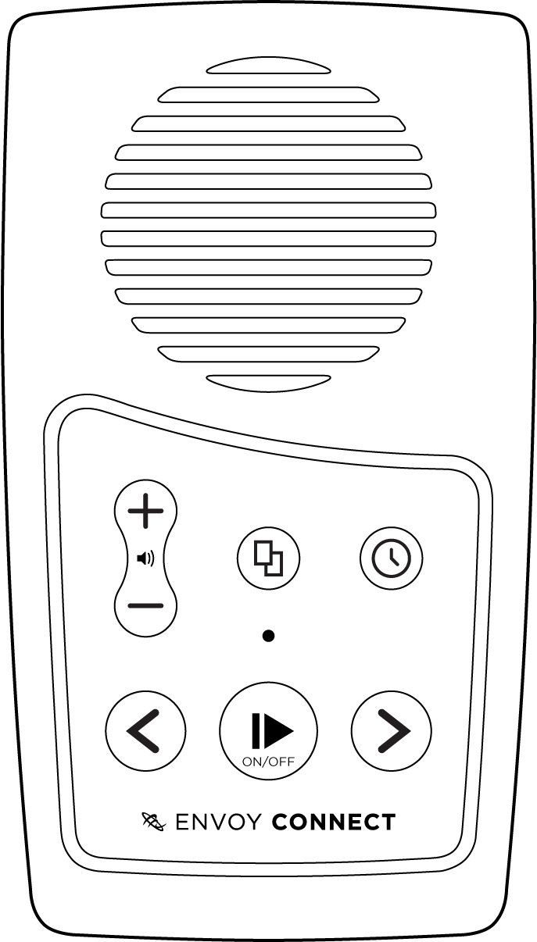

Press and Hold this Button

for 3 Seconds.

P