**How to CHOOSE BOOKS**

**on the Envoy Connect**

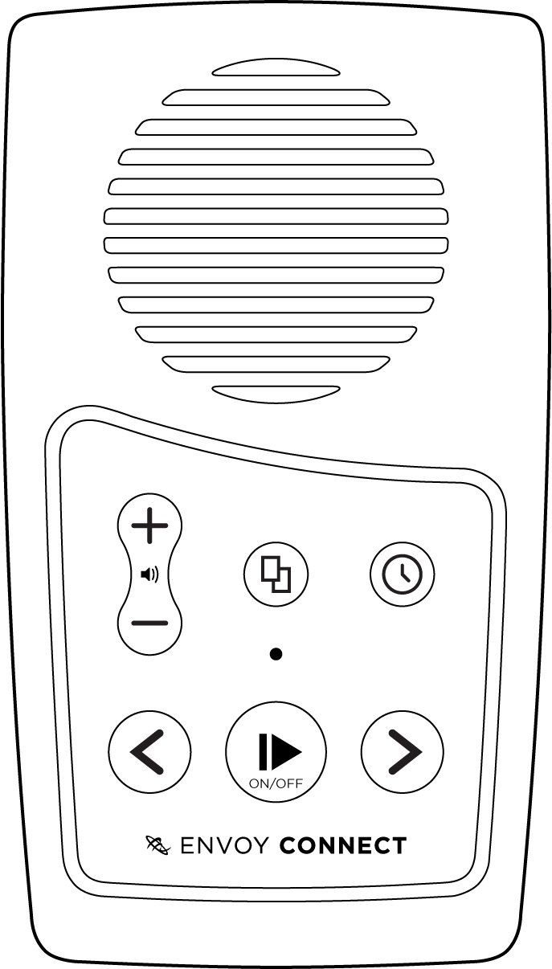

Briefly press this button when player is paused. Press it again to select another book

P asdfdsfasdfasdfasdfasdfasdfasdfasdfasdf