EasyMate 2

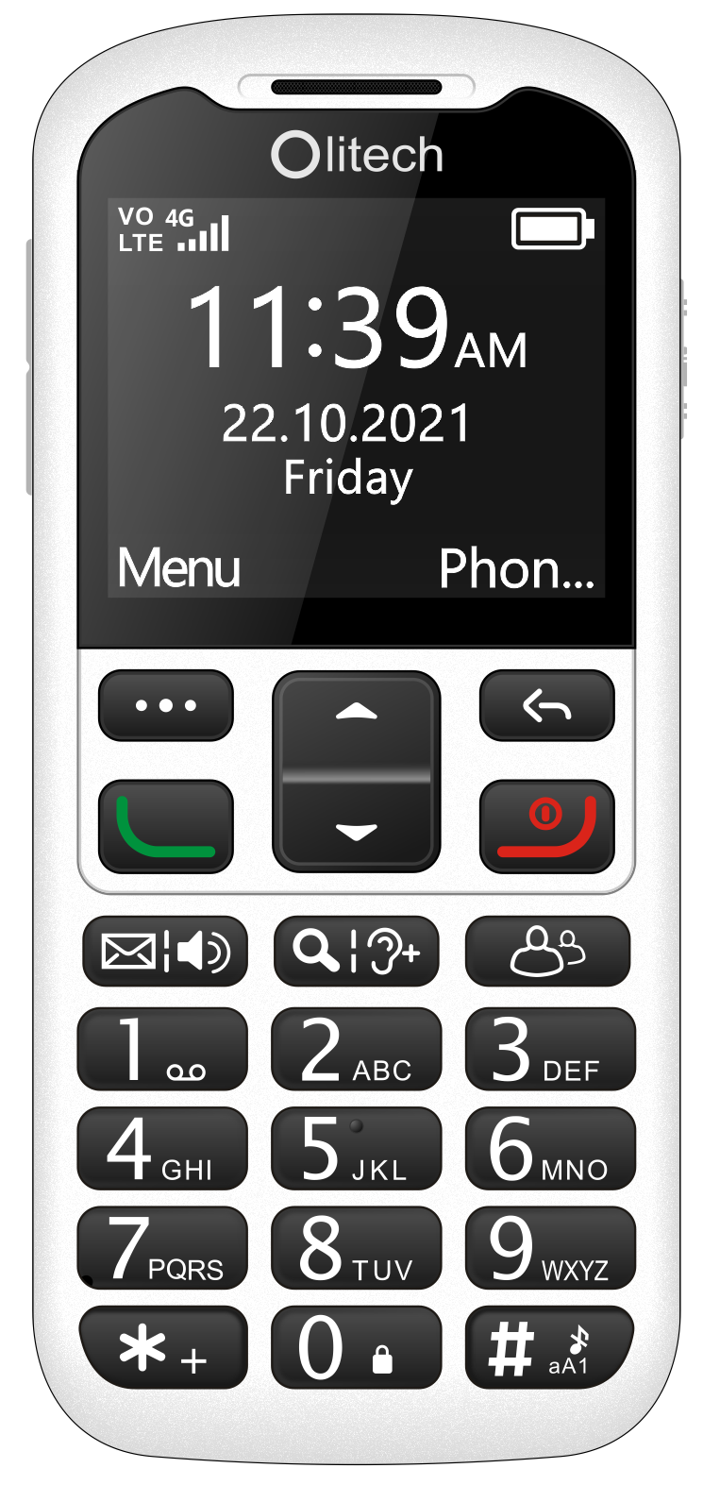

Quick Set-Up Guide V1
Model number: OLT2914V2

Contents

SIM insertion 3
Powering on/off 3
Lock/unlock keypad 4
Save contacts to phonebook 5
Photo/speed dial 6
Ringtone 8
Volume key status 9
Loudspeaker 9
Voice guidance 10
Amplify receiver volume 10
Emergency key setup 11
Share location 12
Low battery notification 13
Auto answer 14
Menu visibility 14
Alarm and Calendar reminders 15
Use camera and view images 15
Complete factory reset 16
Resources 16

Sim insertion

The EasyMate 2 uses a nano sized SIM card to connect to the mobile network. This is the smallest size SIM card and is 8.8 mm X 12.3 mm. Prior to SIM insertion, Olitech strongly advise that users review the SIM insertion instructions in the EasyMate 2 User Manual (pages 10 – 13) and/or the instructional videos on Olitech’s website https://www.olitech.com.au/pages/ easymate2videos. Please obtain assistance to insert the SIM if you are not confident with SIM insertion.

Powering on/off

To power the EasyMate 2 on, press and hold the red “end call” key for 5 seconds. The start-up process takes approximately 10-20 seconds. To power the phone off, when on the home screen, press and hold the red “end call” key for 5 seconds.

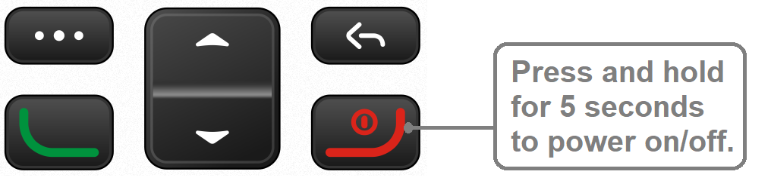
Lock/unlock keypad

It is recommended to lock the keypad on the EasyMate 2 when the phone is not being actively used. Locking the keypad prevents keys from being accidently pressed and functions being unintentionally activated.

To lock/unlock the keypad, when on the home screen press and hold the 0 (zero) key for 3 seconds. A message will briefly appear on screen confirming the lock status.
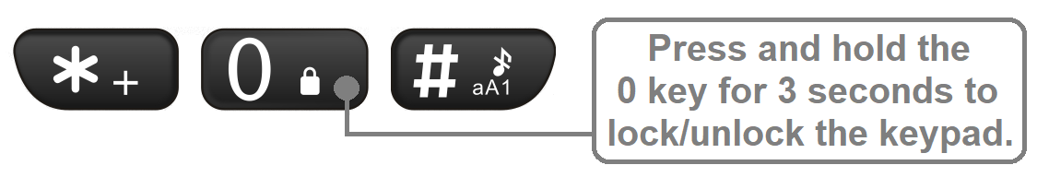
Additional methods of locking the phone can be programmed. These include Auto keypad lock and Lock screen by end-key. See pages 73 - 74 in the EasyMate 2 User Manual for additional information.

Note: When the keypad is locked, the following functions can be performed without unlocking the keypad first:
- calls can be answered/rejected;
- the emergency key can be activated;
- 000 or 112 can be dialled; and
- the torch can be activated/deactivated.

Save contacts to Phonebook

- Press the top right key to select Phonebook
- Press the top left key to select Options
- Scroll to and select New
- Select Phone or SIM (storage location)
- Edit name and phone number (required); and add photo and/or change ringtone (optional; only present when saving to Phone).
- Select Save

Additional information:
- A voice recording can be created and used as a ringtone. The enables the contact’s name to be sounded when receiving an incoming call from them (e.g.: “Ryan’s calling”). See pages 25 - 26 of the EasyMate 2 User Manual for additional information.
- When typing the name and phone number, press the # key to change the input method (letter settings or numbers). Additional information regarding input methods can be found on page 34 of the EasyMate 2 User Manual.

Photo/speed dial

Eight photo/speed dial phone numbers can be programmed to the number keys 2-9; the number 1 key is reserved for voicemail. These programmed numbers can be dialled via three different methods. The dialling method used depends on what screen is present when the call is initiated:

Dialling method one: When on the home screen, press and hold the allocated number key for 3 seconds to initiate call.

Dialling method two: When Photo dial is accessed by pressing the dedicated photo dial key (contacts displayed 4 per page), press the allocated number key (single press) to initiate call.

Dialling method three: When Photo dial is accessed via the main menu, i.e.: press Menu Photo dial, use the navigation keys to scroll through contacts (contacts displayed 1 per page). When the contact you want to dial is visible on screen, press the green key (single press) to initiate call.

Additional information:

- In both the 4 contact per page and single contact per page photo dial screens, use the navigation keys to scroll through contacts.
- If having multiple methods of dialling is not suitable for the user, photo dial can be set up in the main menu and then the photo dial option hidden from the main menu (via Menu visibility). In this way, photo dial can only be accessed via the direct access speed dial key and only dialling methods one and two are available.

Photo/speed dial numbers are programmed through the Photo dial settings in the main menu. To programme photo dial:

- Press the top left key to select Menu
- Scroll to and select Photo dial
- Select Options
- Select Add from phonebook to add a saved contact OR Enter details to manually enter details (name, phone number, photo and ringtone) and select Save.

Ringtone

Ringtones and other alert sounds can be changed in the EasyMate 2’s Audio settings. To change the ringtone:
- Press the top left key to select Menu
- Scroll to and select Settings
- Scroll to and select Audio settings
- Scroll to and select Normal
- Scroll to and select Settings
- Select Ring settings
- Select Caller ringtone
- Select Fixed ringtone
- Scroll to and select your preferred ringtone

Additional information:
- Audio files (voice recordings or audio files transferred to the EasyMate 2) can be used as a ringtone. To programme an audio file as a ringtone, at step 8, select More ringtones. A list of audio files saved on the phone will now appear. Scroll to and select desired audio file. Refer to Connecting to PC (page 46) and Recorder (page 50) in the EasyMate 2 User Manual for additional information regarding transferring and recording voice files.
- To change a message ringtone, select Message ringtone at step 7.
- Key tone, low battery alert tone and dial tone can be activated/deactivated by selecting Other alert rings at step 6.

Volume key status

To avoid the volume settings being changed unintentionally, the volume keys can be activated/deactivated in the phone’s settings. To change the volume key status:

- Press the top left key to select Menu
- Scroll to and select Settings
- Scroll to and select Volume key status
- Select On/Off

Loudspeaker

The loudspeaker can be activated/deactivated by pressing the direct access loudspeaker key (key above number 1) or the top right key during an active call. Call audio can also be programmed to always divert to loudspeaker. To do so, when in Settings:
- Scroll to and select Loudspeaker always on
- Select On

Note: When this setting is on, audio cannot be transferred back to the earpiece speaker by pressing the Loudspeaker key or the top right key during a call.

Voice guidance

The EasyMate 2 is programmed to speak the function of number and symbol keys, e.g.: “2” and “#” (hash); and main menu headings, e.g.: “phonebook”.
To deactivate/activate this function:
- Press the top left key to select Menu
- Scroll to and select Settings
- Scroll to and select Voice guidance
- Select either Key voice output or Main menu voice output
- Select Deactivate/Activate

Amplify receiver volume

The volume of the ear speaker can be boosted an additional 25db by pressing the Amplify receiver volume key (key above number 2) during a call. When pressed during a call, a message will temporarily appear on screen stating Receiver volume boost activated. Following the call, a red ear icon will be present along the top of the screen; this ear icon indicates amplify receiver volume is active. Amplify receiver volume will remain active for all calls until it is turned off. To turn off this function, during a call press the Amplify receiver volume key.

To use this function please ensure the Amplify receiver volume key is On in Settings (default setting is On). To do so, when in Settings:
- Scroll to and select Amplify receiver volume
- Select On

Emergency key setup

Information in regards to the functionality of the Emergency key can be found in the EasyMate 2 User Manual (pages 51 – 55).

To access the Emergency key settings:
- Press the top left key to select Menu
- Scroll to and select Safety
- Select Emergency key

In the Emergency key settings, the following can be programmed:
- Status (turn Emergency key On/Off)
- Emergency contacts (phone numbers to be contacted when the Emergency key is activated; phone numbers that can request the EasyMate 2’s location*)
- Activate/deactivate Send (text) message
- Customise Emergency (text) message
- Activate/deactivate Warning tone
- Turn Share location on/off

* Share location must be on in order for emergency contacts to request the EasyMate 2’s location. See Share location for more details.

Note: all programmed emergency contacts must have the length of their ringtone set to 15 seconds or more to ensure their voicemail cannot answer the emergency call.

Share location

The Share location function enables mobile phone numbers programmed in the Emergency contacts list (Emergency key settings) to receive a text message containing a Google Maps link showing the EasyMate 2’s location. This location link should be received within 5 minutes of:
- Activation of the emergency key; and/or
- Sending a text message (at any time) to the EasyMate 2 stating Location.

Please consult pages 55 - 56 of the EasyMate 2 User Manual for more information about the Share location function and factors that may impact its functioning.

Low battery notification

The low battery notification function allows up to 3 mobile phone numbers to receive a text message stating that the user’s phone battery is low. This message is sent when the phones battery drops below 10% capacity.

To set-up the low battery notification function:
- Press the top left key to select Menu
- Scroll to and select Safety
- Scroll to and select Low battery notification
- Select Status to On
- Select Notification contacts and add numbers (up to three mobile numbers can be added)
- To edit the notification text message, select Notification SMS, edit the message and select Save.

Auto answer

Auto answer enables incoming calls from programmed phone numbers to automatically answer. When the EasyMate 2 automatically answers it diverts audio to loudspeaker.

To set-up the auto answer function:
- Press the top left key to select Menu
- Scroll to and select Safety
- Scroll to and select Auto answer
- Select Status to On
- Select Auto answer contacts and add numbers (up to three phone numbers can be added)

Menu visibility

Menu visibility allows the following menu items to be shown or hidden from the main menu: Phonebook, Message, Call logs, Photo dial, Camera, Organiser, Multimedia and Safety.

Please note, if Message, Photo dial or Phonebook are hidden in Menu visibility, the functions are hidden from the main menu only; their allocated shortcut keys will still function and open the selected function.

To show/hide menu items:
- Press the top left key to select Menu
- Scroll to and select Settings
- Select Menu visibility
- Select menu items to show/hide

Alarm and Calendar reminders

Alarms and calendar events can be set in the EasyMate 2’s Organiser. A voice recording can be programmed to sound at the time of an alarm or event, thus creating a voice reminder. See pages 40 - 42 of the EasyMate 2 User Manual for details regarding the programming of alarms and calendar events.

Use camera and view images

To access the camera:
- Press the top left key to select Menu
- Scroll to and select Camera
Camera opens
- To take a photo press the magnifier key (key above number 2)

When the camera is open, captured images can be viewed by pressing the top left key to select Options select Image viewer. For additional information regarding use of the camera, see page 39 of the EasyMate 2 User Manual.

All images stored on the phone can be viewed in Menu Organiser My files Phone or Menu Multimedia Images. For additional information, see pages 32 - 33 of the EasyMate 2 User Manual.

Complete factory reset

- Press the top left key to select Menu
- Scroll to and select Settings
- Select Phone settings
- Scroll to and select Restore factory settings
- Input password 1234
- Select OK
- Confirm OK

Note: Restoring factory settings will erase all data stored on the phone.

Resources

- EasyMate 2 User Manual V1
- Instructional videos www.olitech.com.au/easymate2videos
- Customer service: support@olitech.com.au
03 9755 8885

