Smart Travel Lamp ES0195

Product Instructions

General description
This modern, portable and multi-purpose lamp delivers a battery life of up to 4 hours. This lightweight Smart Travel Lamp is the perfect travel companion, enabling you to see colours and details clearly while on the go. The internal rechargeable battery can be easily recharged by connecting the supplied USB cable to your laptop or phone charger.

Features
- Lightweight and portable
- Continuous dimmer switch
- Rechargeable up to 10 hours of light
- Bright daylight LEDs provide true colour matching
- Internal rechargeable battery (incl.)
- USB compatible
Important instructions
Thank you for purchasing this lamp. To register your purchase and read more information about your guarantee, please go to www.daylightcompany.com. To ensure correct and safe operation please read the following and retain for future reference.

Specification
- Light source: LED
- Lux output at 12": ....Lux
- Light colour temperature: 6,000°K
- Energy consumption: 4.5W
- Product colour: White
- Product Weight: 0.41
- Cable length: 1.2m (47.2")
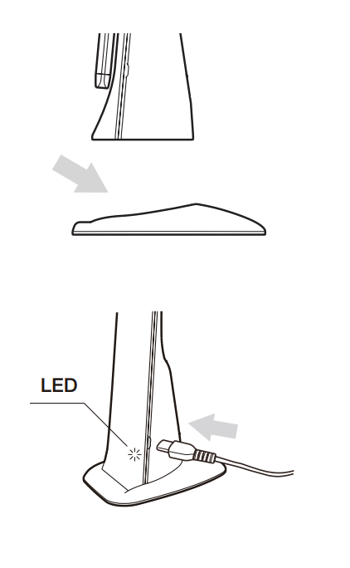

Set-up
1. Remove all packaging from around the lamp.
2. Fit the base to the lamp by sliding and clicking into place (see diagram)
3. To use the lamp from a USB device (e.g. computer) simply connect the USB cable between the lamp and the device.
4. The small LED on the base of the lamp will glow red indicating that the internal lithium battery is being charged. The LED will go out when the battery is fully charged (approximately 5-6 hours from fully discharged).
5. Switch the lamp on by touching the symbol on the lamp. The lamp will come on at the LAST light setting. Continue to hold the symbol to adjust the brightness level. Touch the symbol once again to turn the lamp off.
6. To use the lamp on the internal lithium battery simply unplug the USB cable from the lamp.
CAUTION: Do not look directly at the LEDS

Cleaning
Before cleaning make sure the lamp is disconnected from the electrical supply. If the lamp requires cleaning simply wipe with a damp cloth. Do not use large amounts of liquid or spray cleaners as they may enter the shade and affect electrical safety.

Maintenance
No maintenance is required. The LEDs and internal lithium battery are not user or service replaceable as they designed to last for the lifetime of the product.

Safety
For indoor use only.
Caution: Do not look directly at the LEDs.
Caution: Only use the Power Adapter supplied with the product. Use of a different adapter could damage the lamp and invalidate the guarantee.
Caution: Take care not get the flexible cable tangled around the base.
Caution: If the cable of this luminaire becomes damaged, it should be exclusively replaced by a suitably qualified person in order to avoid hazard. In case of doubt consult a qualified electrician.

