Audible Liquid Level Indicator ES0359

Product Instructions

General description
This audible liquid level indicator allows you to pour hot drinks with confidence. It alerts the user with sounds and vibrations when liquid touches the prongs of the device. Simply place the gauge on the side of a cup, glass or jug. Making a cup of tea or coffee has never been easier and safer. Battery not included. Requires one CR2032 battery.
Main Features
- Suitable for use with both hot and cold liquids.
- High and low probes with two different alert sounds. Therefore making a cup of tea or coffee with milk will be much easier.
- Liquid detection level adjustment – slide the metal prongs up and down to adjust the liquid level to be detected.
- Has built-in magnets, so the liquid level indicator can be easy stored on your fridge door.

Parts and Functions
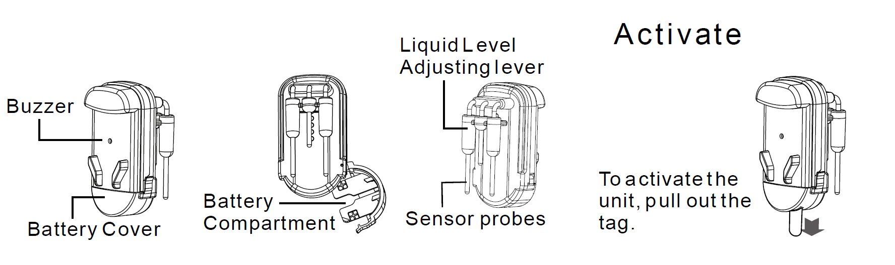

Battery Installation and Replacement
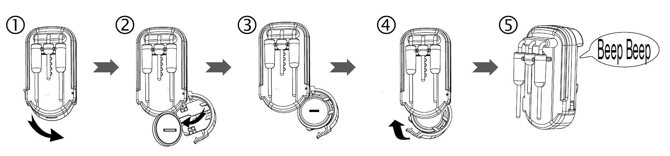
(1) Flip to open the battery cover.
(2) Take out the old battery.
(3) Insert a new CR2032 battery cell to the battery compartment.
(4) Flip to close the battery cove.
(5) The sensor will return two beep tone to indicate the battery is installed correctly.

Operation
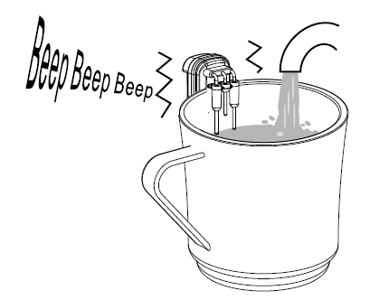

Hanging the sensor on the cup, add drinks, when drinks reach the level of the long p r o b e s (low liquid level probes), the buzzer will emit "beep..." sound and Sensor vibrates.

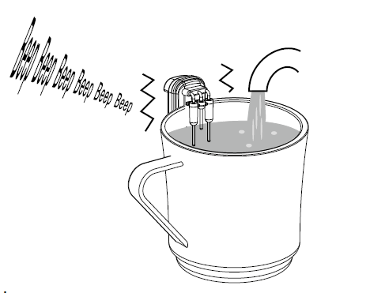
When levels reach short probe (High liquid level probe), beep sound and vibration will accelerate.

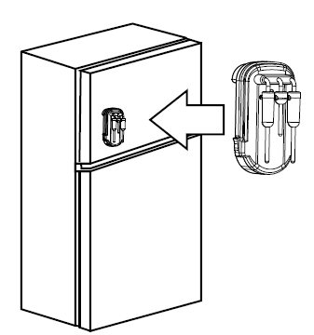
The sensor can be attached to the refrigerator or any magnetic surface when not in use.

Liquid Detection Level Adjustment
Slide the level up and down to adjust the liquid level to be detected.
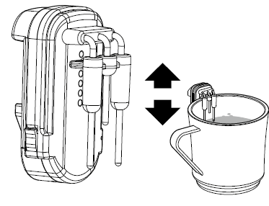

Low Liquid Level

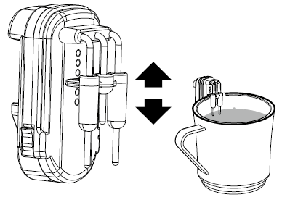
Mid Liquid Level

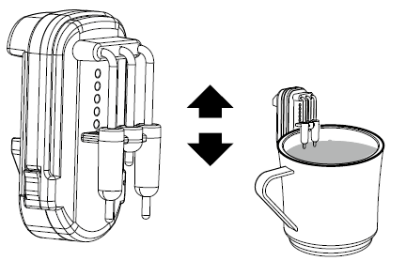
High Liquid Level

