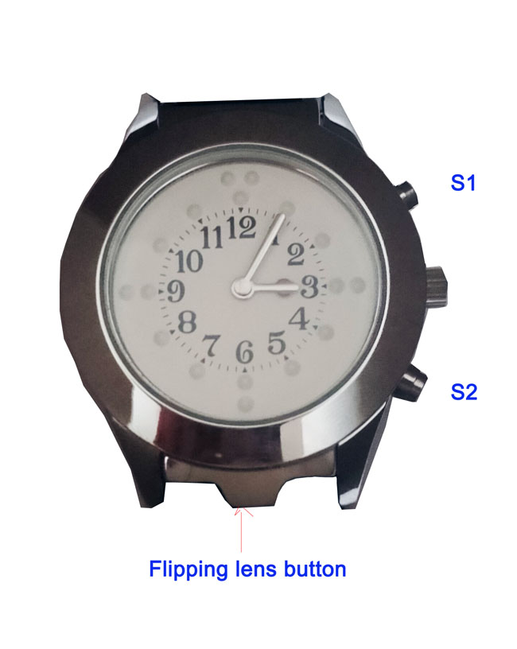
S1
S2

I. Tactile display
" The watch lid lifts up at the 6 o'clock position, allowing you to determine the current time by lightly touching the hands(not push hands) and dots on dial"

"The tactile markings around the dial help show exactly where the hands are pointing. When done, snap the lid back into place."

" To set the hands, pull out the stem at the 3 o'clock position. Rotate the stem clockwise until the correct time is reached, then press the stem back in."

II. Voice time talking
At two o'clock position, time and date speaking button: S1
At four o'clock position, mode button: S2
Features:
● Power saving mode
● 12 hours speaking: am, pm speaking, 24 hours customized
● Alarm
● Voice navigation for all settings

1. Sleep mode save battery power
Press and hold S1 button 5 sec enter power saving mode and hear continuously "Di Di" sound
Press hold S1 button 5 sec again return working mode and hear "Di Di---Di Di" sound

2. Time and Date speaking
Press S1 button once, it is time speaking, press S1 again, date speaking
3. Set Hour
Press S2 button, when hear "Set hour" announcement, press S1 set hour.
4. Set Minute
Press S2 button, until hear "Set Minute" announcement, press S1 set minute
5. Set Year
Press S2 button, until hear "Set Year" announcement, press S1 set year
6. Set Month
Press S2 button, until hear "Set Month" announcement, press S1 set month
7. Set Day
Press S2 button, until hear "Set Day" announcement, press S1 set day
8. Set Alarm Hour
Press S2 button, until hear "Set Alarm Hour" announcement, press S1 set alarm hour
9. Set Alarm Minute
Press S2 button, until hear "Set Alarm Minute" announcement, press S1 set alarm minute
10. Set Alarm On/Off
Press S2 button, until hear "Set Alarm" announcement, press S1, when hear "Alarm on" announcement along with slower "Di Di" sound, means alarm on.
Press S2 button, until hear "Set Alarm" announcement, press S1, when hear "Alarm off" announcement along with quicker "Di Di" sound, means alarm off.

